**Section C: Problem Solving**

1. Two mechanics use ropes to pull an engine out of a car. The ropes are at an angle of 45o to the horizontal according to the diagram below. Each man pulls with a force of 400 N.

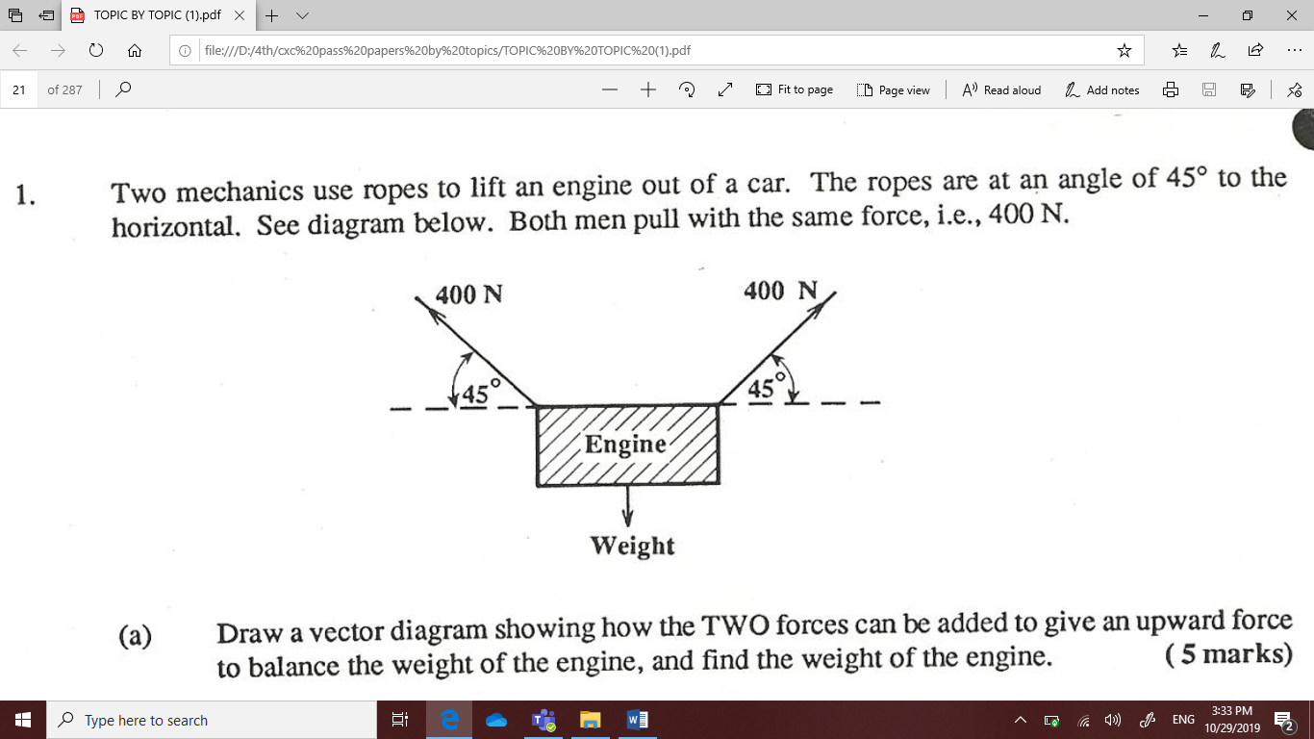

* 1. Draw a vector diagram how the two forces can be added to balance the weight of the engine. (2 mark)

* 1. Find the weight of the object. (3 marks)

1. A resultant of two vectors is shown below.

6 N

The angle it makes with the horizontal is 30o. Find the x and y components of the vector. (4 marks)

1. 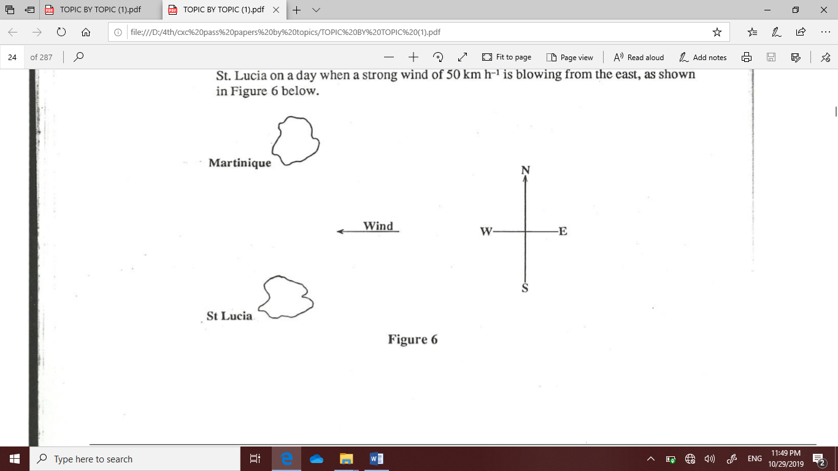St. Lucia is 80 km due south of Martinique. A small aeroplane flies from St Lucia to Martinique on a day where a strong wind of 50 km/hr is blowing from east as shown in the diagram

The pilot flies the plane at 80 km/h, due north relative to the air. Find the velocity and the direction the plane will travel. (6 marks)

1. A body of mass 30 kg is transferred from the earth (g=10 N Kg-1) to another planet where (g= 5 N kg-1). What is the body’s
2. Mass on earth. (1 mark)
3. Weight on earth. (2 marks)
4. Mass on the other planet. (1 mark)
5. Weight on the other planet. (2 marks)
6. A certain spring obeys Hooke’s law. A force of 25 N will stretch the spring by 15 mm. What will be the extension under a force of 80 N, assuming the law is obeyed at this value of load. (4 marks)
7. A Form Four student is investigating Hooke’s law. She attaches various masses to a spring of length 80 cm and measures the extension produced. She obtains the following data:

|  |  |  |  |  |  |  |  |  |
| --- | --- | --- | --- | --- | --- | --- | --- | --- |
| Mass/g | 10 | 30 | 50 | 80 | 100 | 150 | 180 | 200 |
| Weight/N |  |  |  |  |  |  |  |  |
| Extension/ cm | 0.4 | 1.2 | 2.0 | 3.2 | 4.0 | 6.0 | 7.2 | 8.0 |

1. Complete the table (g = 10 N/kg) (4 marks)
2. Plot a graph of weight against extension. (7 marks)
3. From graph, calculate the slope S. (3 marks)
4. What does the slope represent? Give its unit. (2 marks)
5. By drawing suitable lines on your graph, estimate:
6. The mass that was attached to the spring to produce a TOTAL length of 85.2 cm.   
   (2 marks)

ii. The extension of the spring when a mass of 60 g is attached to it. (2 marks)