This is the climate data for Phillip Gold area. (RETScreen)

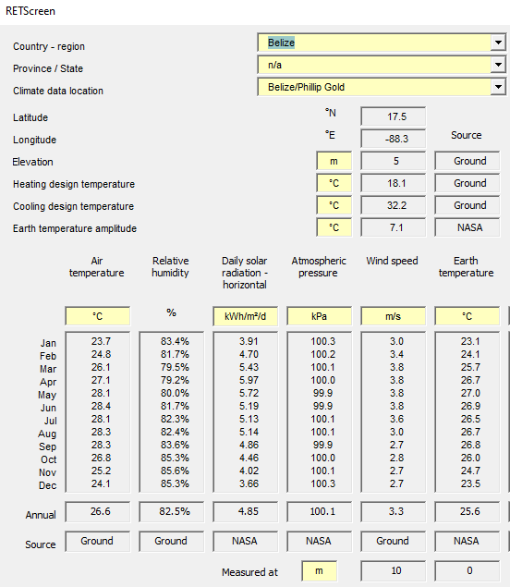

There is a column with “Daily solar radiation – horizontal” This is the energy that strikes an are of 1 square meter per day for each month.

Have a student pick a month and have them convert the kWh/m2/day to another form of energy (crude oil, wood energy). The students should be able to explain why there is a variance due to weather changes. Then have the yearly total.

This helps students compare the sun’s energy to other forms of energy.