LAB #1 – Radiation and Irradiance
PV 1 Solar Applications

To: Instructor
From: Name Goes Here
Program: Renewable Energy Course
Date: Thursday, October 31, 2013

Belize City
ITVET Campus
Renewable Energy

PV1 Solar Applications
Fall 2022
Lab #1

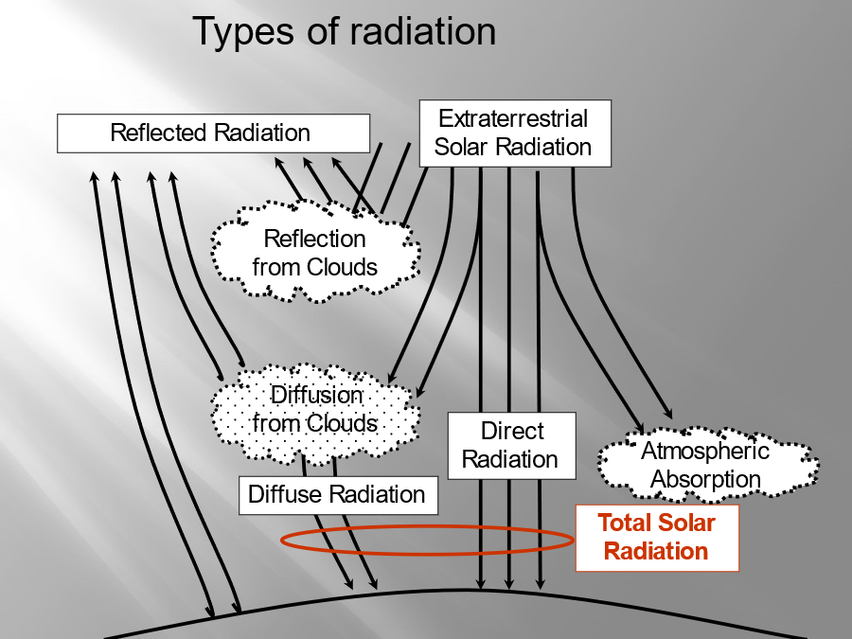

OBJECTIVES:

- To use the handheld pyranometer to measure irradiance.

- To observe various types of radiation and measure their effects.

- To measure shading for various sources.

DISCUSSION
The irradiance striking or reflecting from a surface can be measured with the a handheld pyranometer.
The irradiance is also effected by the type of radiation that it is influenced by. Shading is also another influence on the irradiance values.
The various conditions have been discussed in the lectures received and those conditions from shading to various radiations need to be measured.

A table describing the irradiance from these various conditions shall be created. A baseline referenced to direct radiation is good to have if possible.

INSTRUMENTS AND COMPONENTS
Handheld Pyranometer

PROCEDURE

- Select various locations around the campus to take irradiance reading using the handheld pyranometer.
- Include various distances from shading objects. Measure the size of shading and the distance away. Take multiple readings.
- Measure the effects from the various types of radiation. This may take multiple days to get the various weather conditions.
- Place the readings into a table. Explain each condition and what each effect had on the readings.
- Pictures are also good to describe the effects accompanied with the written explanation.
- Make a procedure list of each step to acquiring the values for each condition.
- Create a conclusion that captures the learning by explaining values and conditions that effected the irradiance measurements.

Conclusion:

