LAB #1A – Irradiance and Air Mass
PV 1 Solar Applications

To: Instructor
From: Name Goes Here
Program: Renewable Energy Course
Date: Thursday, October 31, 2022

Belize City
ITVET Campus
Renewable Energy

PV1 Solar Applications
Fall 2022
Lab #1A

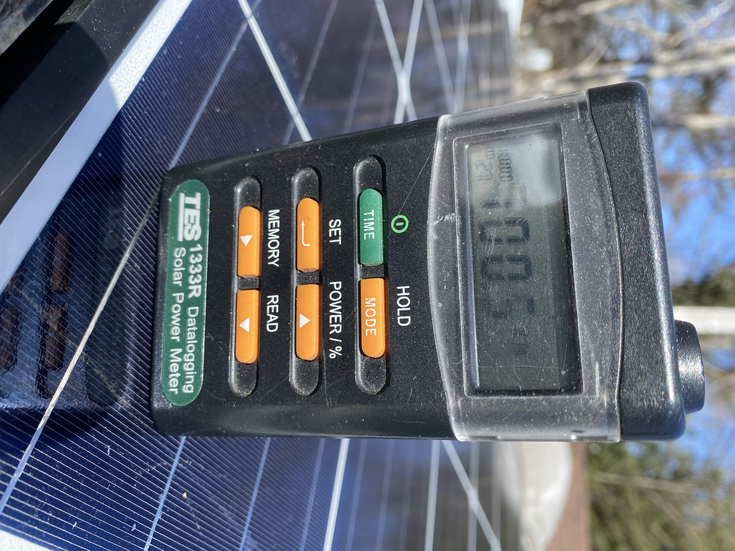

OBJECTIVES:

- To use the handheld pyranometer to measure irradiance.

- To observe the effect of air mass. Measuring the irradiance from early morning until sunset. This lab is best conducted when a clear day is forecasted. Reading should be taken in 30 minute intervals. Each reading shall be taken to record the highest irradiance value. Pointing the hand held pyranometer directly at the sun.

- Record the time, date and value of irradiance in W/m². Plot your values in Excel and keep file for further labs.

DISCUSSION
The irradiance will change from dawn to solar noon as the air mass is reduced. As the sun is further away from solar noon the air mass get larger and the irradiance is reduced. This lab will show a typical sunny day’s energy from dawn to dusk for a particular month. Doing this for every month will provide a database of insolation.
Place the data in Excel and plot the shape of the irradiance curve. Calculate the daily average.

INSTRUMENTS AND COMPONENTS
Handheld Pyranometer

PROCEDURE

- Select an unobstructed location around the campus. If need be one member of the lab can bring the handheld pyranometer home to get the early morning and dusk values.
- Place the readings into Excel and plot the curve and average. Explain the results and include air mass data per reading.
- Create a conclusion that captures the learning by explaining values and air mass that effected the irradiance measurements.

