LAB #2 – Solar Resource Energy Estimation
PV 1 Solar Applications

To: Instructor
From: Name Goes Here
Program: Renewable Energy Course
Date: Thursday, October 31, 2013

Belize City
ITVET Campus
Renewable Energy

PV1 Solar Applications
Fall 2022
Lab #2

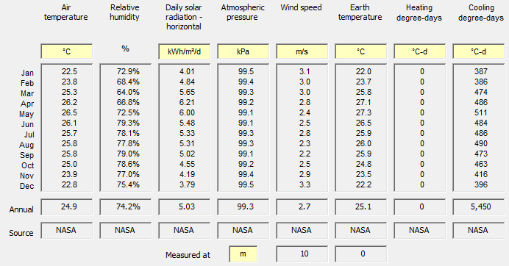

Objective:

To use RETScreen for a “Power” Project type on a “central grid” connected residential PV (Photovoltaic) system at Phillip Gold location estimate the following by using RETScreen analysis:

  - solar energy resource
  - annual energy production

Questions: Solar Energy Resource Estimation

- Provide the annual solar radiation (MWh/m²) on horizontal surface:
  - Explain your answer.

- Find the optimum tilt angle of a fixed PV array at which the annual solar radiation is maximum and the PV array is facing due south

- Calculate the annual solar radiation (MWh/m²) at an optimum tilt angle of a fixed PV system facing 30⁰ west of due south

- Compare and discuss your results calculated in questions 2 & 3

- Find the optimum tilt angle of a fixed PV array at which the solar radiation for summer months (June, July, August) is maximum and the PV array is facing due south

- Find the optimum tilt angle of a fixed PV array at which the solar radiation for winter months (December, January, February) is maximum and the PV array is facing due south.

- Compare and discuss your results calculated in questions 5 & 6.

- Calculate the annual solar radiation for a tracked (one axis, two axis and azimuth) PV system under the following conditions:

  - one axis tracking with PV array tilt angle of 15⁰

  - two axis tracking

  - azimuth tracking with optimum PV array tilt angle

- Compare and discuss your results calculated in question 8 (i), (ii) & (iii).

- In conclusion describe what you would do to get the most energy from this location and prove your finding from questions above.

Submit your report electronically with your name in the filename.

