LAB #3 – Shading and the Solar Pathfinder
PV 1 Solar Applications

To: Instructor
From: Name Goes Here
Program: Renewable Energy Course
Date: Thursday, October 31, 2013

Belize City
ITVET Campus
Renewable Energy

PV1 Solar Applications
Fall 2022
Lab #3

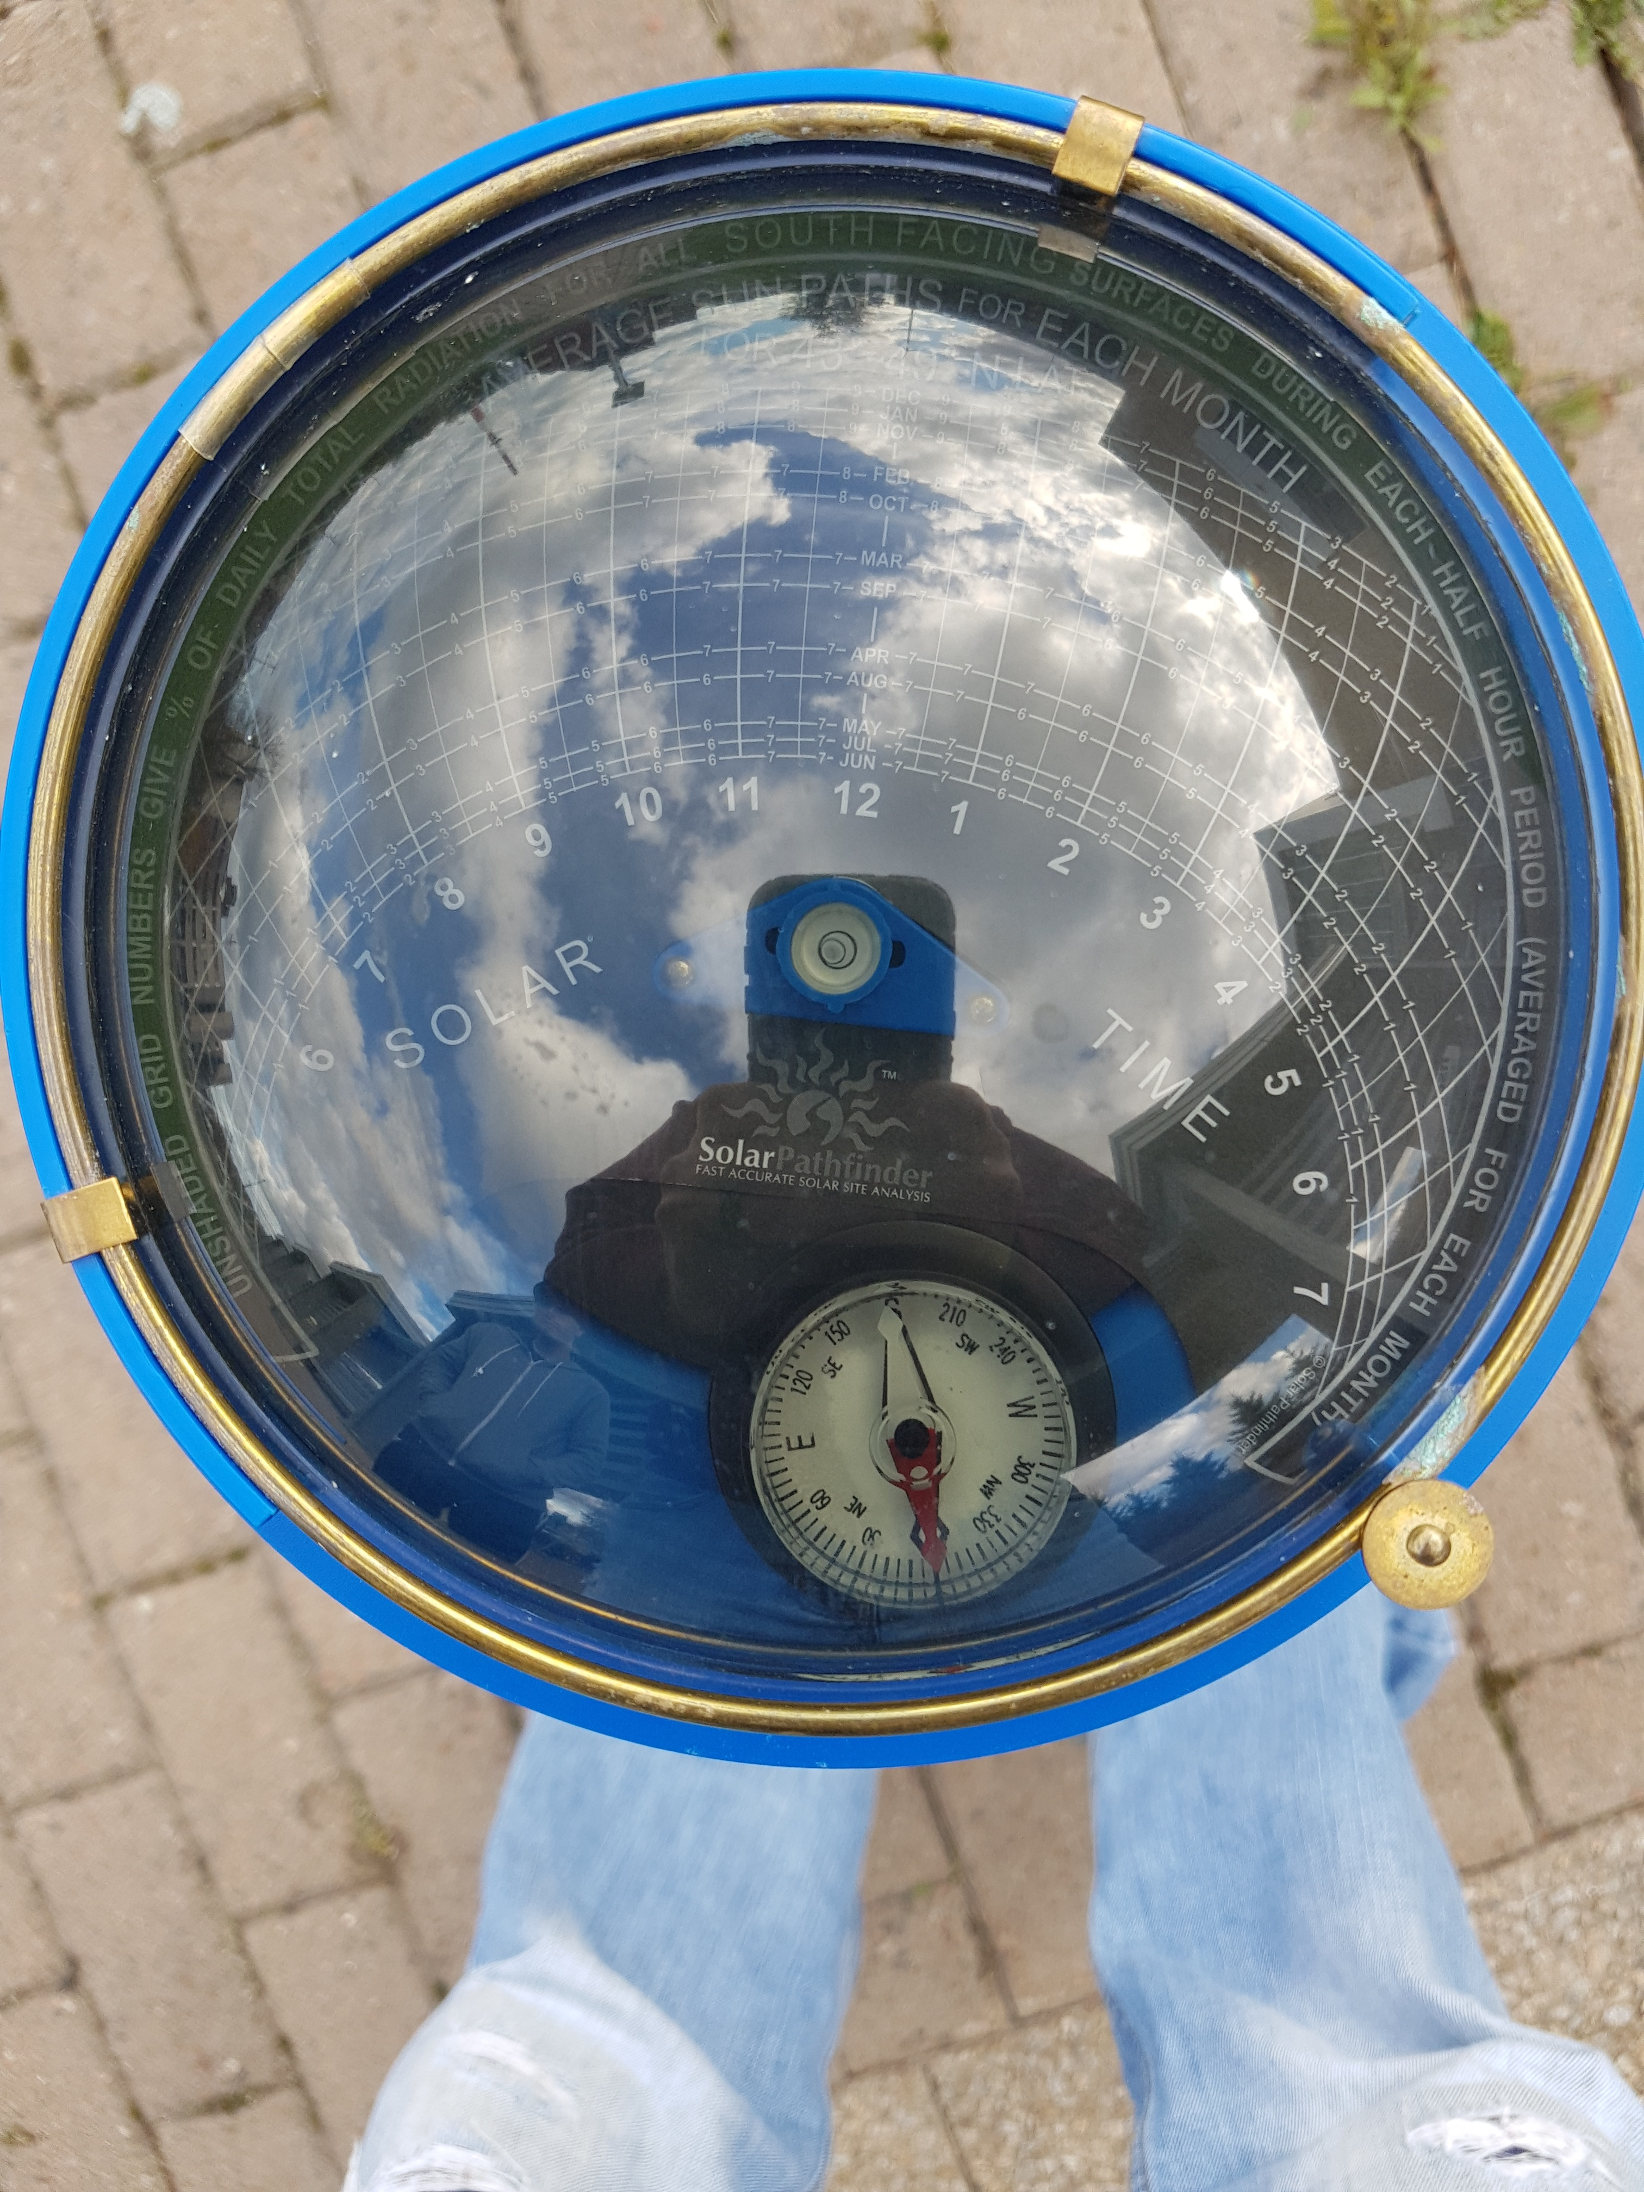

OBJECTIVES:

- To do a solar site assessment using the Solar Pathfinder.

- To calculate the insolation reduction due to shading using the Solar Pathfinder.

- To apply the reduction to the insolation data for each month.

DISCUSSION

A site assessment is required at most solar installations to predict the amount of solar energy that is available throughout the year.

This lab will be used to calculate the obstruction shading at the campus. Locations to be assessed shall have obvious shading of a building. This shading will be considered to be hard shading.

Using climate data from RETScreen apply the reduction due to shading and place in a table or spreadsheet.

INSTRUMENTS AND COMPONENTS

Solar Pathfinder
Solar Pathfinder manual
RETScreen climate data for Phillip Gold

PROCEDURE

- Each group is to select different location around the campus to take pictures of the solar pathfinder sky image.

- Make sure your magnetic declination is correct for Phillip Gold.

- A digital picture as per the instruction manual for the solar pathfinder is to be taken.

- Make sure that a building wall is partially shading in the image.

- Using a picture viewer or a program like Paint to mark out the shaded area. Then follow the manual to calculate the percentage of insolation reduced by the shading for each month.

- Apply the reductions to the climate data for each month. Place in a spreadsheet.

Conclusion:

Provide details in a summary of what was learned in this lab. Present in a formal write up complete with cover sheet. Your client is someone who has very little knowledge of the equipment. Submit your report electronically with your name in the filename.

