**Module A: Solar Insolation Characteristics**

Definitions introduced in this module:

* **Air mass (sometimes called air mass ratio)** — Equal to the cosine of the zenith angle-that angle from directly overhead to a line intersecting the sun. The air mass is an indication of the length of the path solar radiation travels through the atmosphere. An air mass of 1.0 means the sun is directly overhead and the radiation travels through one atmosphere (thickness).
* **Angle of Incidence** — The angle that a ray of sun makes with a line perpendicular to the surface. For example, a surface that directly faces the sun has a solar angle of incidence of zero, but if the surface is parallel to the sun (for example, sunrise striking a horizontal rooftop), the angle of incidence is 90°.
* **Azimuth Angle – The angle between true south and the point on the horizon directly below the sun.**
* **Blackbody radiation --** is an idealized object that absorbs all electromagnetic radiation that falls on it. No electromagnetic radiation passes through it and none is reflected. Because no light (visible electromagnetic radiation) is reflected or transmitted, the object appears black when it is cold. However, a black body emits a temperature-dependent spectrum of light. This thermal radiation from a black body is termed **black-body radiation**
* **Diffuse Insolation** — Sunlight received indirectly as a result of scattering due to clouds, fog, haze, dust, or other obstructions in the atmosphere. Opposite of direct insolation.
* **Direct Insolation** — Sunlight falling directly upon a collector. Opposite of diffuse insolation.
* **Energy** — The capability of doing work; different forms of energy can be converted to other forms, but the total amount of energy remains the same.
* **Equinox** — The two times of the year when the sun crosses the equator and night and day are of equal length; usually occurs on March 21st (spring equinox) and September 23 (fall equinox).
* **Full Sun** — The amount of power density in sunlight received at the earth's surface at noon on a clear day (about 1,000 Watts/square meter).
* **Incident Light** — Light that shines onto the face of a solar cell or module.
* **Infrared Radiation** — Electromagnetic radiation whose wavelengths lie in the range from 0.75 micrometer to 1000 micrometers; invisible long wavelength radiation (heat) capable of producing a thermal or photovoltaic effect, though less effective than visible light.
* **Insolation** — The solar power density incident on a surface of stated area and orientation, usually expressed as Watts per square meter or Btu per square foot per hour.
* **Irradiance** — The direct, diffuse, and reflected solar radiation that strikes a surface. Usually expressed in kilowatts per square meter. Irradiance multiplied by time equals insolation. It is a measure of power and is an instantaneous value.
* **Joule** — A metric unit of energy or work; 1 joule per second equals 1 watt or 0.737 foot-pounds; 1 Btu equals 1,055 joules.
* **Orientation** — Placement with respect to the cardinal directions, N, S, E, W; azimuth is the measure of orientation from north.
* **Peak Sun Hours** — The equivalent number of hours per day when solar irradiance averages 1,000 w/m2. For example, six peak sun hours means that the energy received during total daylight hours equals the energy that would have been received had the irradiance for six hours been 1,000 w/m2.
* **Power** -- The **watt** (symbol: **W**) is the SI derived unit of power, equal to one joule of energy per second. It measures a rate of energy conversion.
* **Pyranometer** — An instrument used for measuring global solar irradiance.
* **Solar Azimuth Angle** — The angle between true south and the point on the horizon directly below the sun. The angular displacement from south of the projection of the beam radiation on the horizontal plane. The symbol is **αs**
* **Solar Constant** — The average amount of solar radiation that reaches the earth's upper atmosphere on a surface perpendicular to the sun's rays; equal to 1353 Watts per square meter.
* **Solar Elevation Angle** -- The angle between the horizontal and the line to the sun. The symbol is **γs**
* **Solar Energy** — Electromagnetic energy transmitted from the sun (solar radiation). The amount that reaches the earth is equal to one billionth of total solar energy generated, or the equivalent of about 420 trillion kilowatt-hours.
* **Solar Irradiation** – is the total amount of solar energy that accumulates on an area over a given time. It is usually measure in kWh/m2, and it is the primary measurement need to size a PV system.
* **Solar Noon** — The time of the day, at a specific location, when the sun reaches its highest, apparent point in the sky; equal to true or due, geographic south.
* **Solar Resource** — The amount of solar insolation a site receives, usually measured in kWh/m2/day, which is equivalent to the number of peak sun hours.
* **Solar Spectrum** — The total distribution of electromagnetic radiation emanating from the sun. The different regions of the solar spectrum are described by their wavelength range. The visible region extends from about 390 to 780 nanometers (a nanometer is one billionth of one meter). About 99 percent of solar radiation is contained in a wavelength region from 300 nm (ultraviolet) to 3,000 nm (near-infrared). The combined radiation in the wavelength region from 280 nm to 4,000 nm is called the broadband, or total, solar radiation.
* **Tilt Angle** — The angle at which a photovoltaic array is set to face the sun relative to a horizontal position. The tilt angle can be set or adjusted to maximize seasonal or annual energy collection.
* **Ultraviolet** — Electromagnetic radiation in the wavelength range of 4 to 400 nanometers.
* **Watt** — The rate of energy transfer equivalent to one ampere under an electrical pressure of one volt. It is the product of voltage and current (amperage). Also one watt equals 1/746 horsepower, or one joule per second.
* **Zenith Angle** — the angle between the direction of interest (of the sun, for example) and the zenith (directly overhead).

**1 Solar Insolation Characteristics**

**1.0 Solar Radiation**

The earth's atmosphere receives energy from the sun in the form of light or solar radiation. This energy is received at an average rate of 1370W/m2with a 3% variation as the earth moves further from and closer to the sun in its trajectory (Figure A5). The atmosphere absorbs some of this energy however, so the amount reaching the earth is reduced and is approximately 1000W/m2*.* This amount of energy (1000W/m2*)* has been defined as full sun power, or one sun, and is used as a universal reference. The amount of energy falling on a particular location changes with time of day and year because the earth's rotation, orbit and tilt change the relationship between the earth and sun. Fog, clouds and other meteorological features produce daily and hourly variations that can also increase or decrease the amount of radiation.

The **global radiation,** or total amount of radiation striking a surface on the earth, such as a

PV module can be divided into 3 components:

1. **Direct radiation** from the sun. This is strongly affected by atmospheric conditions including water vapour, dust, and other airborne particles which reflect or absorb solar radiation. The direct component is typically 40-60% of the global radiation.
2. **Diffuse radiation** from other parts of the sky that result from atmospheric scattering of sunlight from clouds, haze, and particles in the atmosphere.
3. **Reflected radiation** from the ground or surface features. Seasonal variations in the ground cover, such as snow and ice, can have a large impact on reflected radiation.

Reflected radiation can be very dependent on the tilt angle. A horizontal surface typically receives none or little reflected radiation.

Occasionally the diffuse and reflected radiation components are enhanced such that the energy density on a module is greater than 1000W/m2. Light reflected off water or other light coloured materials and or the leading edge of a cloud (Cloud burst) can result in 1200 or 1300W/m2 of radiation falling on the earth's surface. The latter effect can be observed on a summer day when the sky is filled with billowy cumulous clouds by observing how bright the edge of the cloud facing the sun is.

The spectral distribution closely matches that of a 5800 K blackbody. The total area under this blackbody curve is equal to 1.37 kW/m2, which is the solar insolation just outside of the earth’s atmosphere. This spectrum is made up of wavelengths of ultraviolet UV (7%), visible (47%), and infrared (46%). The visual range is ~400nm (Ultra Violet Blue) to 780nm (Infrared red). See Fig. A1.

**THE SOLAR RESOURCE**

**Figure A1. The sunlight spectrum in space as a function of wavelength.**

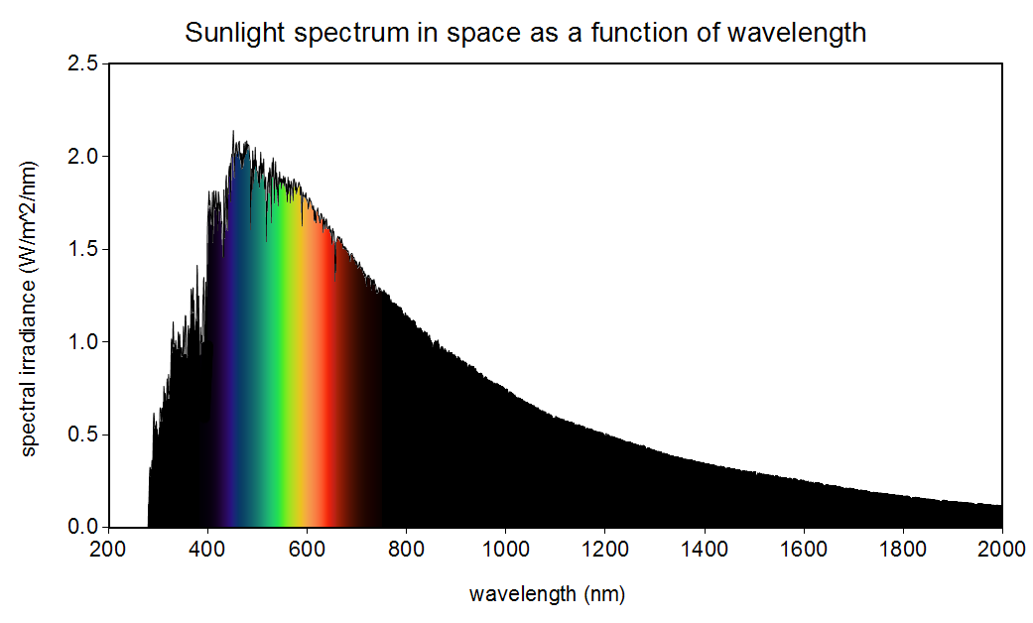

**Figure A1. Sunlight spectrum in space as a function of wavelength. Public Domain Image, image source: Christopher S. Baird, data source: American Society for Testing and Materials Terrestrial Reference.**

The sunlight in the visual band of frequencies provides enough energy to the silicon to allow free electrons to be raised to the conduction band to allow charged electrons to flow in an electric circuit. The energy required is called band gap where the electrons and hole transition from the valence band to the conduction band. Silicon has a band gap of 1.12 eV (electron volt).

Figure A2, show the spectral efficiency of silicon as it applies to PV panels. The important aspect of this figure is to know that only 49% of the sunlight is possible to provide enough energy to be effective as a band gap supplier.

Spectral Efficiency.

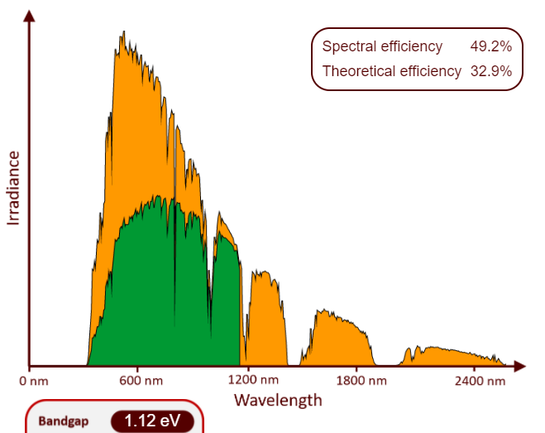

**Figure A2.This virtual instrument lets you change the bandgap of a semiconductor material while plotting the spectral utilization. When the bandgap is changed the spectral efficiency is calculated along with the theoretical efficiency limit. The virtual instrument is from Infinitypv.com and is used with the Creative Commons Attribution-NoDerivatives 4.0 International (CC BY-ND 4.0). https://infinitypv.com/learn/virtual-tools/b01.**

As the incoming solar energy travels through the atmosphere at higher air mass ratios the earth receives less of the solar energy, as seen in Fig A3.

**Figure A3. The air mass ratio *m* is a measure of the amount of atmosphere the sun's rays must pass through to reach the earth's surface. For the sun directly overhead, *m* = 1.**

**H1 is air mass length 1 and H2 is Length through atmosphere to ground.**

H2

H1

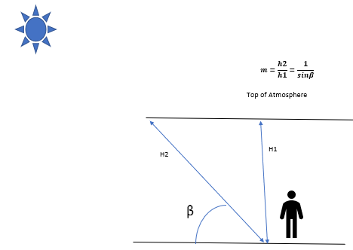

**Figure A3 showing the longer length the solar energy must travel and that relation to air mass (Curtesy Author).**

**1.1 Time of Day and Year**

The earth's rotation causes the amount of radiation at a point on the Earth's surface to charge during the day. Also, the earth's tilt changes the amount of solar radiation received at a given location throughout the year.

Absorption, scattering and reflection of solar radiation by the atmosphere is lowest when the sun is at its highest point in the sky - due south in the northern hemisphere and due north in the southern hemisphere. The distance that solar radiation must travel through the atmosphere is at a minimum at this time and is called "solar noon". A surface on earth receives its highest intensity of direct solar radiation at "solar noon".

In the summer the sun is higher in the sky than winter, which reduces the negative atmospheric effects on solar radiation, and the days are longer, which increases the total amount of radiation received on the surface. The effect of these seasonal differences is that the total amount of energy received on a horizontal plane is greater in summer than in winter.

Differences in climate through the year can also affect solar radiation by altering the characteristics of the atmosphere. The intensity of solar radiation during winter in cold climates, for example, is often higher than in summer because there is less water vapour and dust in the atmosphere.

**1.2 Calculating Zenith Angle**

The sun’s zenith angle for air mass calculations can be determined at any time by using a vertical stake or ruler of known height and measuring the length of the shadow cast. The ruler, shadow and rays of the sun form a triangle. Using trigonometry, the zenith angle can be calculated.

Zenith angle

θ

θz $=\arctan{\frac{Ls}{Lr}}$ Where Ls = length of shadow and Lr = length of ruler.

Figure A4 showing the calculation for the Zenith Angle (Courtesy Author).

Figure A5 showing the various types of radiation that effects the solar energy as it passes through the atmosphere.

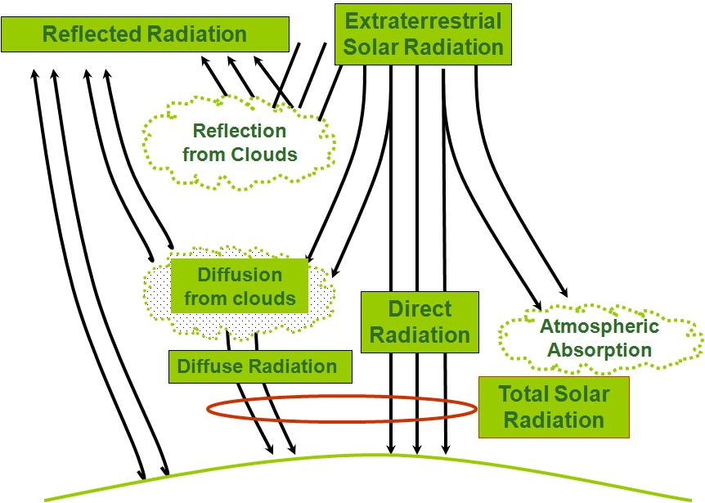

**Fig A5. Diffusion and radiation on solar energy (Curtesy Author).**

**Away from the equator and the tropics the solar window changes throughout the seasons. This window is much smaller in the winter months compared to the summer months.**

**Figure A6 demonstrates the summer versus winter months solar window differences. This example is for the northern hemisphere.**

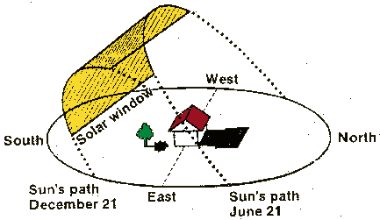

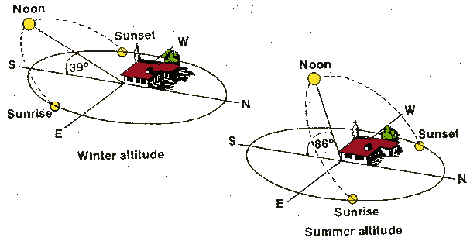

**Fig A6. The solar envelope. Away from the tropics in the northern hemisphere (Curtesy Author).**

**1.3 Radiation and Latitude**

The amount of energy reaching a particular location is strongly dependent on latitude. As latitude increases north of the equator or decreases south of the equator:

* summer days become longer but the sun is lower in the sky at solar noon
* winter days are shorter and the sun at solar noon is even lower

The result is that both the maximum intensity at solar noon and the total amount of solar radiation falling on a horizontal surface decrease as the distance from the equator increases (i.e. the magnitude of the latitude increases either positively / north or negatively / south). Figure A5 Demonstrates this solar envelope that exists with latitude between summer and winter.

**2 Solar Insolation**

**2.0 Solar irradiance** is the intensity of solar radiation that is received on a surface and is usually measured in watts per square metre (W/m2).Solar irradiance is considered to be zero at sunrise and reaches its maximum at solar noon.

**2.1 Insolation (or irradiation)** is defined as the amount of energy from solar radiation that a surface receives over a specified time period. The most common unit of measurement for insolation is "peak sun hours" which is the equivalent number of hours per day when the solar irradiance averages 1000 W/m2*.* A location with an insolation of 4 peak sun hours, for example, refers to the amount of insolation received over time, if the sun was shining for 4 hours at an intensity of 1000 W/m2*.* The actual insolation might be received over an 8 hour time period from sun rise to sun set with variations throughout the day as clouds and other atmospheric phenomena alter the insolation at the particular location.

Insolation is also expressed in kilowatt-hours per square metre (kWh/m2).

**2.2 Measuring Solar Insolation**

Sun data is collected using an instrument called a pyranometer. Inorder to obtain statistically significant insolation data, the solar-radiation must be recorded continuously at a site for a long period of time. Obviously every year does not produce the exact same insolation. Using a pyranometer may not be practical for most PV system designers due to the time it would take to collect a yearly snap shot of a locations insolation.

These sensors are relativity inexpensive and can be interfaced to data acquisition equipment to collect insolation over a given period of time. There are websites that hold data from a number of these sites. Fortunately, insolation data has been collected for many places in the world over a long time period and is available in a published form.

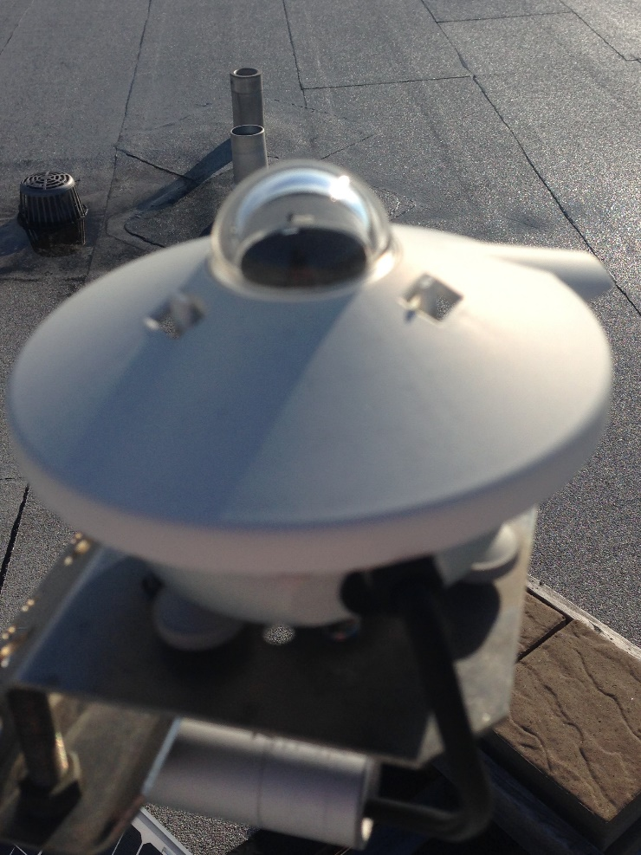

**Figure A7 Pyranometer used to capture solar radiation (Curtesy Author).**

**2.3 Insolation Tables and Charts**

There are many governments and private companies that publish insolation data in both printed and computerized versions for all parts of the world. Many PV design software programs include an insolation database and some also have the ability to provide detailed simulations.

NASA provides free insolation data for Canada at <http://eosweb.larc.nasa.gov> another place to gather insolation data is with the RETscreen program from Natural Resources Canada at [www.retscreen.net](http://www.retscreen.net) This Renewable Energy Technology (RET) program is a great tool for calculating the available solar energy for various locations in Canada.

NASA has a website for the gathering of insolation based on the longitude and latitude of a location. ( [Surface meteorology and Solar Energy Data Set](http://eosweb.larc.nasa.gov/cgi-bin/sse/grid.cgi?uid=3030) )

The PV designer must understand that insolation data is statistically based. There is no guarantee that the insolation value for a given time period will be achieved, although there is a high probability that the insolation will be approximately the stated value. You will see in the course of this work that PV systems requiring a high degree of reliability are oversized so that the

PV system will produce the required power even when weather negatively effects insolation.

**2.4 Using Insolation Data**

Now that we can get the insolation for a site, we must look at what radiation looks like at the specific site. As you can see from the figure below, we start off with maximum radiation before the atmosphere. We then loose radiation based on our latitude and climatically influenced conditions. The altitude plays a role in the air mass index that we calculated earlier as well.

Finally the landscape and obstructions will be the last filters in the removal of the solar radiation.

**Figure A8 showing the Reduction of Insolation**

Once the basic insolation data has been obtained, consider the many other factors that can impact the amount of radiation that is available at a particular location. Data from tables, charts, etc. provides the designer with some "raw" insolation data; however, this data may need to be adjusted to account for local site conditions. Site conditions can have a significant impact, both positively and negatively, on the performance of a PV array.

Ensure you determine any potential conditions that could impact solar radiation including:

* shading by trees, towers, poles, chimneys, hills, mountains, utility wires, buildings, etc.
* topographical features such as water bodies (ponds, lakes, streams, etc.) and ground cover (sand, dirt, snow, ice, grass, shrubs, etc.)
* localized fog, mist, haze, etc.
* other site characteristics that could impact solar radiation such as nearby buildings that could reflect light.

It is important to evaluate all of these conditions at different times of the year to determine the impact of seasonal variations on radiation levels. In cases where there is insufficient insolation data, additional solar modules are often added to compensate for potential inaccuracies.

**2.5 Solar Gain at a Site: Key Factors**

The basic calculations give a general location insolation result. Due to local influences on radiation, these basic calculations fall short of optimum performance. Special computerized data collection can provide more accurate insolation of the local site. The data may suggest tilt being adjusted to for these local conditions. Figures A9 show examples of how tilt affects insolation capture at specific local installations.

**2.6 Adjusting Horizontal Insolation Data for Tilted Surfaces**

Some insolation tables and charts list radiation data only for a horizontal surface. This data can be used to estimate the global radiation on a surface tilted at the same angle as the latitude using the following equation:

**Equation A2 $H∅ = \frac{HD}{\cos{(.85∅)}}$**

* H $∅$ is an estimate of the global insolation on a surface tilted at an angle of $∅$ to the horizontal and facing due south for sites above the equator and due north for sites below the equator
* HD is the global radiation falling on a horizontal surface
* $∅$ is the site latitude and the angle between the tilted surface and horizontal

The power incident on a PV module depends not only on the radiated energy from the sunlight, but also on the angle between the module and the sun. When the PV face and the sunlight are perpendicular to each other, the power density on the surface is equal to that of the sunlight. Ideally it would be best to keep the PV module perpendicular to the sun). However, as the angle between the sun and a fixed surface is changing during the day, the power density on a non-tracking PV module is less than that of the incident sunlight.

Itis also possible to estimate the global radiation falling on a tilted surface that is not equal to the site latitude. The mathematical equation and data are more complex and are beyond the scope of this course. Simulating software can calculate this tilted radiation / insolation. RETScreen is an example of such software. The basic equation given above is usually sufficient for estimating radiation on a tilted surface when working with horizontal radiation data. It also assumes that the majority of the insolation will happen with minimal diffusion from clouds or fog.

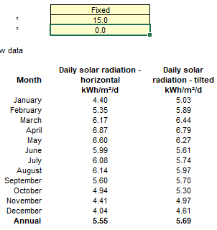

**Fig A9 is a screen capture from RETScreen showing such angular differences (Curtesy Author).**

The insolation data is from San Pedro Belize. Notice the radiation measured on the horizontal surface is 5.55 annually. If tilted 15 degrees downward from the flat horizontal position the annual radiation of the PV panel increases. Fig A10 shows how if the panel is tilted 90 degrees to be mounted on a wall surface the annual radiation drops to 2.84.

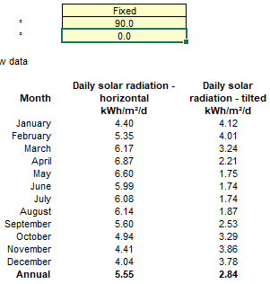

**Fig A10 is a screen capture from RETScreen showing such angular differences (Curtesy Author).**

Fig. A11 shows what happens with the 15 degree tilt downwards from the horizontal is also moved from due south by 180 degrees to due north..

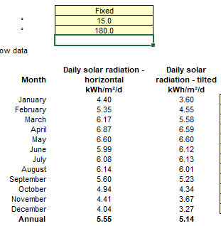

**Fig A11 is a screen capture from RETScreen showing such angular differences (Curtesy Author).**

Notice that the radiation is lower but not appreciably. This is because the 15 degree tilt is not a huge angle difference from the horizontal.

**Fig A12 shows a handheld pyranometer that has a diffused lens to allow for an angled based radiation measurement. (Curtesy Author).**

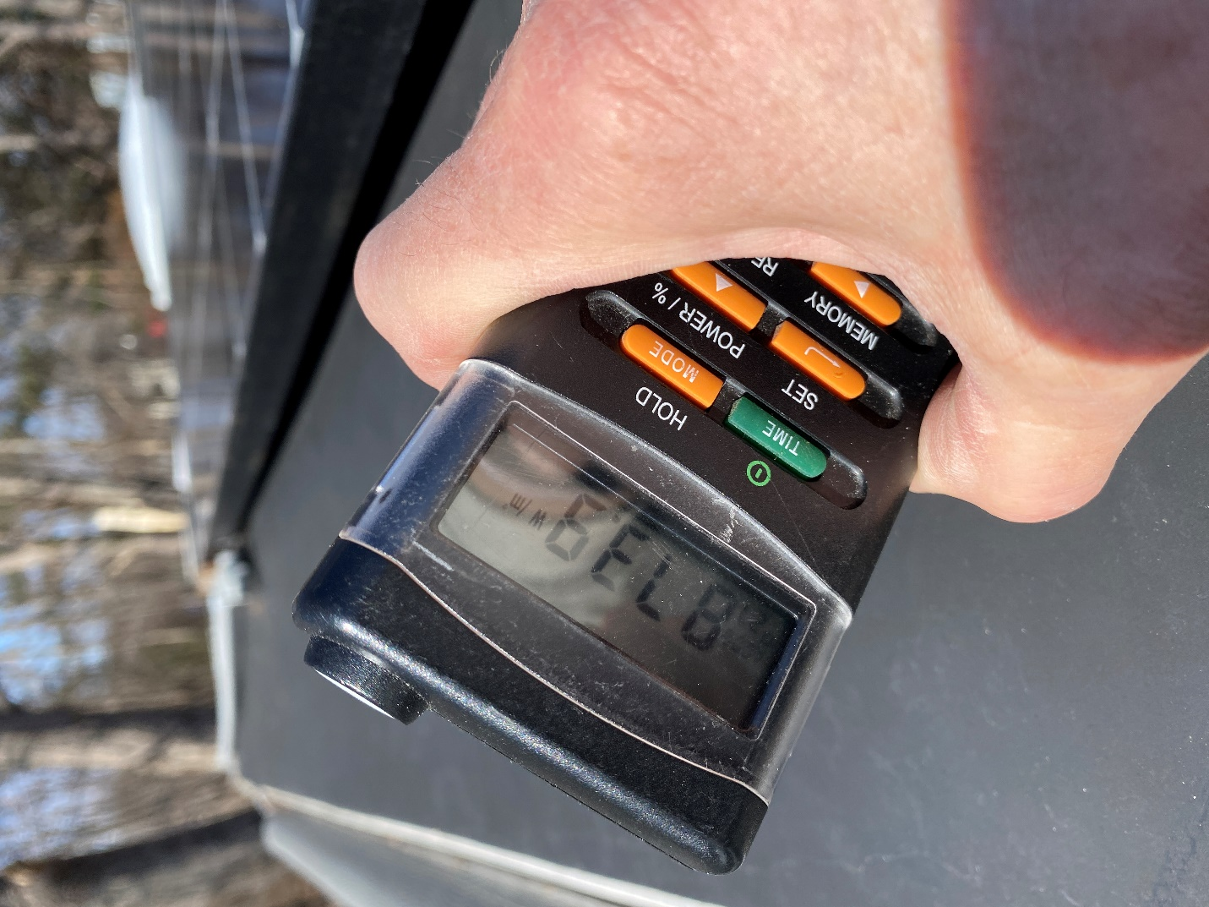

Using this type of pyranometer allows for the measurement of radiation at any time and direction during the day.

Assignments for Module A Insolation.

This can be an assignment either individually or as a group.

These questions can also be used as a test.

Describe the amount of energy present at the earth surface throughout the year.

Describe the various types of solar radiation.

Describe the frequencies of the solar radiation.

Describe Azimuth and the effect on solar PV panels.

Describe site specific variables that effect the solar resource.

Lab work Module Insolation:

Divide the class into as many groups as there are handheld pyranometers.

Divide the campus grounds into the same number of groups. Assign one area to each group.

Each group is to go to their designated area and measure the radiation from the handheld pyranometer.

The readings will be carried out at the same times everyday. Have as many readings spaced out each hour or whatever makes sense. Each group will take three reading each time they use the pyranometer.

1st reading is pointing at the sun directly and record the highest reading in Watts/meter2 .

2nd reading is pointing straight up into the air.

3rd reading is at the ground in front of where the sun is hitting the ground.

The readings shall be put into an excel spreadsheet and time stamped.

These readings will go on every week. The lab work is to be evaluated by the quantity and quality of the readings taken.

Students shall not shade their readings, this will need to be demonstrated to them.

A graph can be made for each week.

The instructor can mark the lab when they are confident that most students have mastered this technique.

The intent is to continue doing the reading for the school year and build a database for the students to use in other courses.