This is a sample corrected lab report. The scoring is out of 20 points. This example has lots of charts and tables. Also the conclusion reaffirms that the objectives were met. This is just a guide if you so choose to use it.

20
20

LAB #10 – Voltage and Current in AC
Course Descriptor

To: Instructor
From: Name Goes Here
Program: Renewable Energy Course
Date: Thursday, October 31, 2013

Belize City
ITVET Campus
Renewable Energy

Electrical Principles 1
Fall 2013
Lab #10

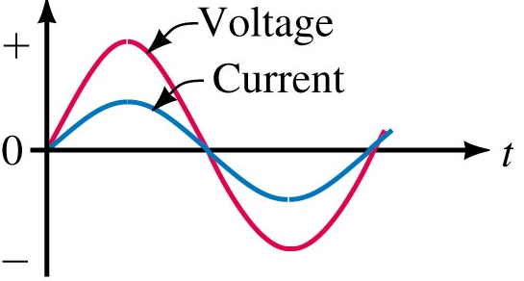

OBJECT:

- To use the labvolt current and voltage interfaces to read waveforms on the oscilloscope. This also includes using the scale that will be used to read values.

- To measure electrical sine waves. Checking values along the wave form.

- To measure the difference between different waveforms. Time and magnitude depending on the reference point.

- To measure the difference between voltage and current waveforms.

- To measure and describe the relationships between resistive, inductive and capacitive voltages and currents.

DISCUSSION
Using the Resistive, inductive and capacitive loads in labvolt, apply a voltage across each of them (one at a time) and measure the relationships between the sine waves of current and voltage.

Using your textbook chapters 19, solve timing relationships at the 60 Hz input of voltage to these components.

Use these curves to solve series and parallel circuits of inductors.

INSTRUMENTS AND COMPONENTS
Resistance Module EMS 8311
Inductor Module EMS
Capacitor Module
I and E input isolation module
HP Oscilloscope

PROCEDURE

- Using the components of each module EMS 83XX apply a voltage across the components (Figures 3, 6, and 9). The value of voltage and current shall be calculated first to ensure that the scaled input of the E and I module will function properly. After observing the relationship between the voltage and current waveforms, provide a formula that describes it.

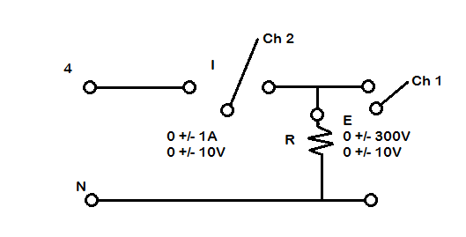

Fig 1 Isolator Module Diagram with Channels
Conversion Factors
Ch. 1 | Ch. 2
1 V = 10 A | 1 V = 30 V
Fig. 2 Conversion Factors of Isolator Modules

- AC Resistance Circuit

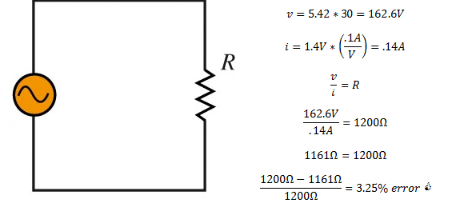
Fig. 3 AC Resistor Circuit with Calculations and Values

 | Resistor Circuit
 | Measured Value | Converted Value
Ch. 1 | 5.42 V | 162.6 V
Ch. 2 | 1.4 V | 0.14 A
Resist. (Ω) | 1200 | N/A
Fig. 4 Resistor Circuit Measured and Converted Isolator Module Readings
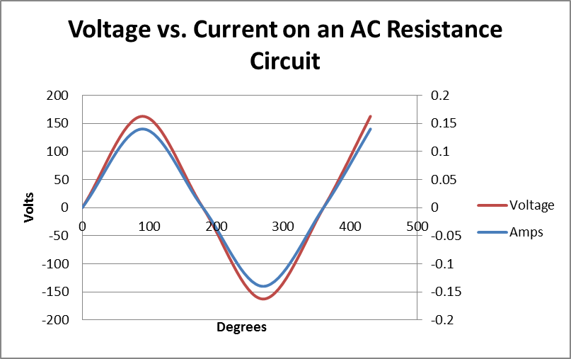
Fig.5 Voltage vs Current on an AC Resistance Circuit
Formula: Since we can say that for this circuit,
this describes the voltage throughout the circuit with respect to time, since current is in synch with voltage we can say that, 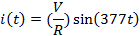 or
to describe the current throughout the circuit.

The AC resistance circuit was set up with the isolator modules and the values of resistance, voltage, and current were measured. Ohm’s Law, v=iR for AC circuits, as well as , were used to prove that the voltage and current were in synch, because there are no inductive or capacitive values.

- AC Inductor Circuit

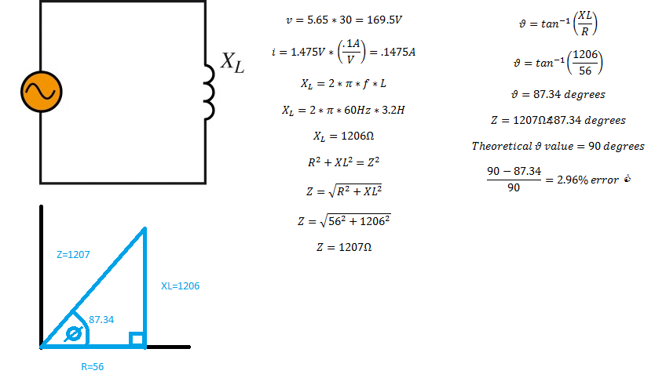
Fig. 6 AC Inductor Circuit with calculations and values

 | Inductor Circuit
 | Measured Value | Converted Value
Ch. 1 | 5.65 V | 169.5 V
Ch. 2 | 1.475 V | .1475 A
Resist. (Ω) | 56 | N/A
Induct. (H) | 3.2 | N/A

Fig. 7 Inductor Circuit Measured and Converted Isolator Module Readings
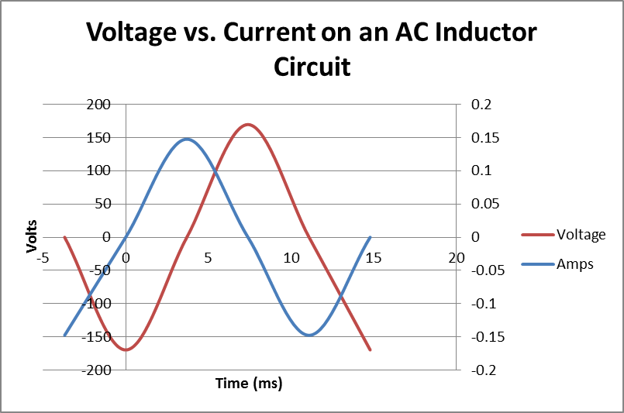
Fig. 8 Voltage vs. Current on AC Inductor Circuit

The AC inductor circuit was set up with the isolator modules and the values of resistance, voltage, and current were measured. The formulas of XL=2*π*f*L, Pythagorean’s Theorem, and, were all used to help prove that current leads the voltage by a shift of 90 degrees.

Formula: Since we can say that for this circuit,
, this describes the voltage throughout the circuit with respect to time, since current lags the voltage we can say that,
, or to describe the current throughout the circuit.

- AC Capacitor Circuit
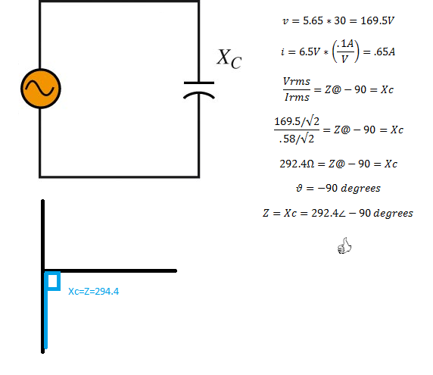
Fig. 9 AC Capacitor Circuit and Calculations
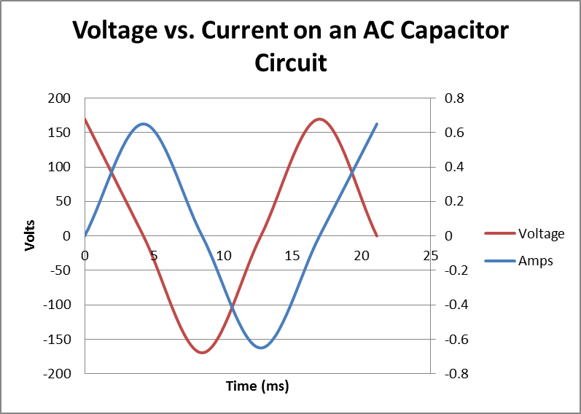
Fig. 10 Voltage vs. Current on AC Capacitor Circuit

 | Capacitor Circuit
 | Measured Value | Converted Value
Ch. 1 | 5.65 V | 169.5 V
Ch. 2 | 6.5 V | .65 A
Resist. (Ω) | N/A | N/A
Capac. (F) | 8.80E-06 | N/A
Fig. 11 Capacitor Circuit Measured and Converted Isolator Module Readings

The AC capacitor circuit was set up with the isolator modules and the values of resistance, voltage, and current were measured. The formulas of Vrms/Irms =Z, and Z=Xc, were all used to help prove that current leads the voltage by a shift of -90 degrees.

Formula: Since we can say that for this circuit,
, this describes the voltage throughout the circuit with respect to time, since current leads the voltage we can say that,
, or to describe the current throughout the circuit.
.
- Using your values measured in the step 1, Calculate R, L and C.

- 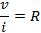
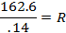

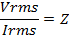
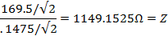
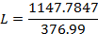


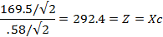
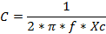
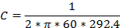


- Power can be calculated with the values measured. Show calculated from ideal components and your measured values.

AC Resistor Circuit Power – Measured Values
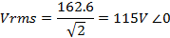
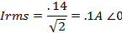
AC Resistor Circuit Power – Ideal Values

AC Inductor Circuit Power – Measured Values
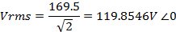
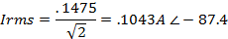

AC Inductor Circuit Power – Ideal Values
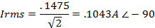

AC Capacitor Circuit Power – Measured Values
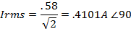

AC Capacitor Circuit Power – Ideal Values
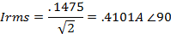

Conclusion

Laboratory Experiment 10: Voltage and Current in AC Circuits dealt with building AC circuits with resistance, inductor, and capacitor modules and measuring their voltages and currents, as well as calculating their power, via the oscilloscope and isolator modules.

In the first procedure three circuits were to be set up, shown in Figures 3, 6, and 9, the first of which was the resistor circuit (Fig. 3), the 1200Ω resistor was used. The current and voltage across the resistor were both measured with recorded values of:
 | Resistor Circuit
 | Measured Value | Converted Value
Ch. 1 | 5.42 V | 162.6 V
Ch. 2 | 1.4 V | 0.14 A
Resist. (Ω) | 1200 | N/A
Values were converted using the conversion factor of the isolator modules, where on Channel 1: 1 V = 30 V, and on Channel 2: 1 V = 10 A (show in Fig. 2). These values were proven to be true values through Ohm’s Law where the calculated value of v*i=R. Theoretically voltage and current wave forms are in synch when there are no inductive or capacitive components to the circuit. Since we can say that for this circuit, this describes the voltage throughout the circuit with respect to time, since current is in synch with voltage we can say that, or . These formulae describe the relationship between and the nature of the waveforms in the circuit.

The second circuit that was set up was an inductor circuit (Fig. 6), the 3.2H inductor was used in the circuit, which had a resistance of 56Ω. The recorded values of current and voltage were:
 | Inductor Circuit
 | Measured Value | Converted Value
Ch. 1 | 5.65 V | 169.5 V
Ch. 2 | 1.475 V | .1475 A
Resist. (Ω) | 56 | N/A
Induct. (H) | 3.2 | N/A

The formulas XL=2*π*f*L, Pythagorean’s Theorem, and, were all used to help find impedance and find the angle at which the current lagged the voltage. After setting up a right angle triangle the angle was found to be 87.34 degrees which, is very close to the theoretical value of 90 degrees. Since we can say that for this circuit,
, this describes the voltage throughout the circuit with respect to time, since current lags the voltage we can say that, , or . These formulae describe the relationship between and the nature of the waveforms of this particular circuit.

The third circuit was the capacitor circuit (Fig. 9), the 8.8µF capacitor was used. The recorded values of current and voltage were:
 | Capacitor Circuit
 | Measured Value | Converted Value
Ch. 1 | 5.65 V | 169.5 V
Ch. 2 | 6.5 V | .65 A
Resist. (Ω) | N/A | N/A
Capac. (F) | 8.80E-06 | N/A
The formulas of Vrms/Irms =Z, and Z=Xc, were all used to help prove that current leads the voltage by a shift of -90 degrees. Since we can say that for this circuit, , this describes the voltage throughout the circuit with respect to time, since current leads the voltage we can say that,
, or to describe the current throughout the circuit. These formulae describe the relationship between and the nature of the waveforms in the circuit.

The second procedure required that R, L, and C be calculated for each circuit using current and voltage. The RMS voltage and current for each circuit was found by dividing the peak values by the square root of two. The formulas Vrms/Irms=Z, Pythagorean’s theorem, , and , were used to help find the final value. All calculated values were within a 5% error, proving that the theoretical formulas and values work experimentally.

The power of each circuit was calculated for each circuit with both ideal and measured components. The formula V*A was used where both values were RMS. The power was successfully found at the right angles with measured values as they were very close the ideal values.

All objectives of Laboratory Experiment 10, to read and measure electrical sine waves, measure differences between waveforms, measure the difference between current and voltage waveforms and to describe the relationships between resistive, inductive, and capacitive voltages and currents, were met.

