Test 3 Questions Insolation: How is it measured

1. What are the 3 assumptions for STC?

Irradiance of 1000 W/m2 , Cell temperature at 25C and Air Mass at 1.5

1. Describe the angle of incidence.

The angle that light strikes the surface of the PV panel.

1. Describe the cosine effect?

The output of the PV panel is related to the angle of incidence following the cosine of the angle.

1. Describe the Air Mass ratio.

Relationship between the distance the sunlight travels in relation to the distance at the equator. What is reflected radiation?

1. Describe the Zenith angle?

Zenith is referred to the position of the sun during the daily position referenced to (the vertical) directly overhead.

1. Describe the Azimuth angle?

Azimuth is referred to the position of the sun referenced to the direction at which the PV panel is pointing.

1. In the northern hemisphere the sun is where?

South.

1. In the southern hemisphere the sun is where?

North.

1. Depending where you are on earth the sun path can move up and down the?

Horizon.

1. Draw The Air Mass ratio.

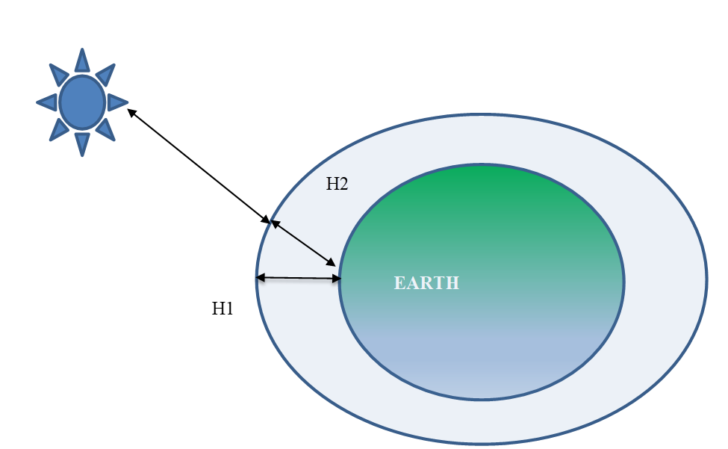

1. Draw the Zenith angle.

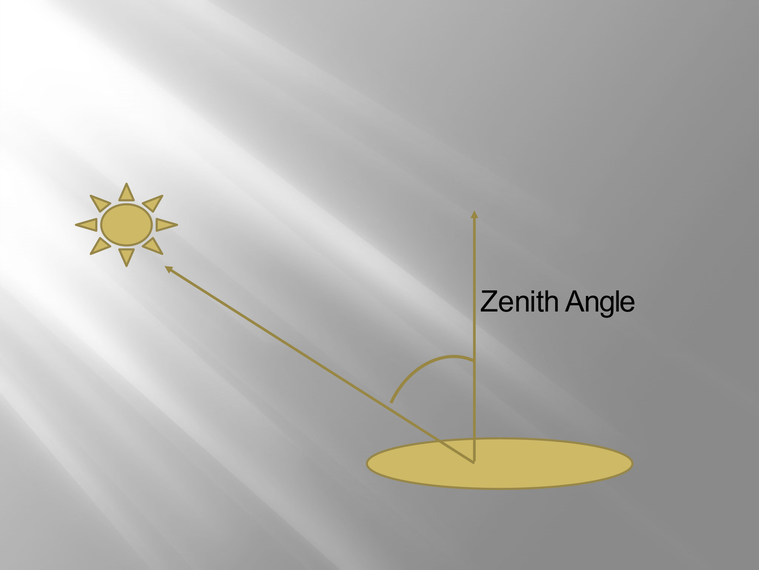

1. Draw the Azimuth angle.

