LAB #6 – Solar Panel Shading and By-pass Diodes
PV 1 Solar Applications

To: Instructor
From: Name Goes Here
Program: Renewable Energy Course
Date: Thursday, October 31, 2022

Belize City
ITVET Campus
Renewable Energy

PV1 Solar Applications
Fall 2022
Lab #6

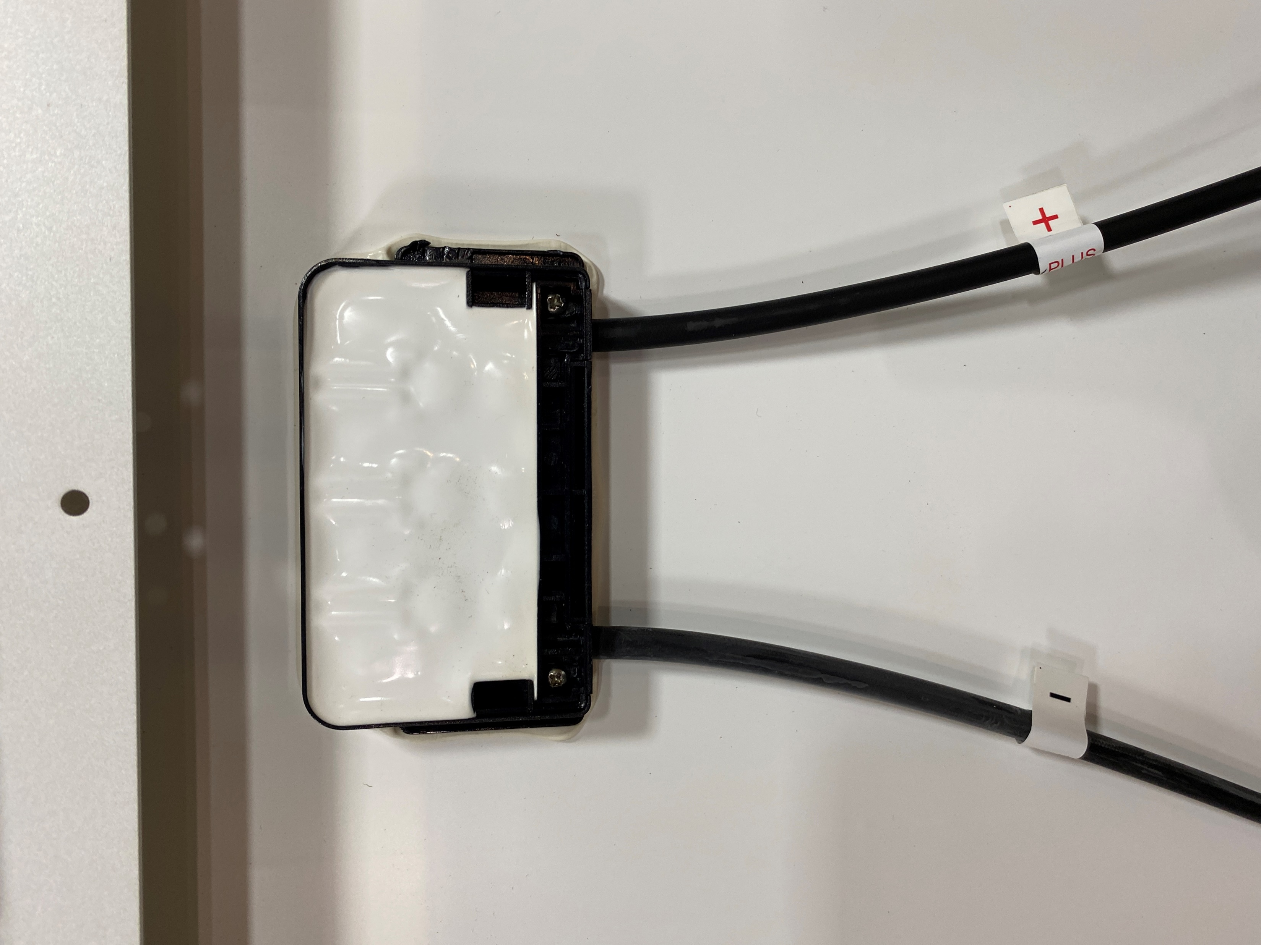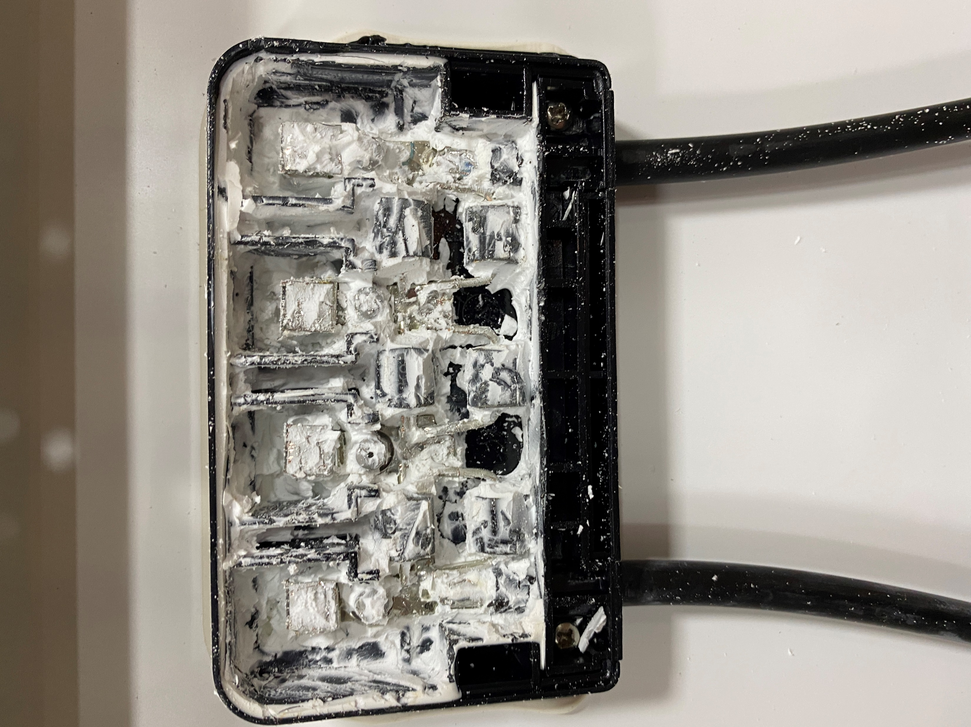

OBJECTIVES:

- To create a controlled shade on a PV panel for the purpose of activating the by-pass diodes.
- To measure the electrical output of the PV panel with and without by-pass diodes under controlled shading.
- To test a PV panel’s by-pass diodes.

DISCUSSION
Every PV panel should have by-pass diodes in the junction box. The diodes are used during shading to prevent back biasing the solar cells and having them go into reverse breakdown and fail. The diodes are placed across a group of diodes. This was covered 4 Module PV Panels in Power Point PV.
In this lab the number of cells and diodes in the panel used must be figured out.
The arrangement of the diodes needs to be figured out as well. The junction box at the back of the panel needs to be opened and the diodes exposed. This may take time to remove any waterproofing material.
The panel will be put into a controlled shade. The panel’s output will be recorded under the controlled shade and unshaded conditions. The by-pass diodes will be isolated and the output of the panel will be measured under these conditions. The diodes will also be removed and the panel’s output will again be measured.
Use a shorting jumper and not the MC4 connectors to short the panel.
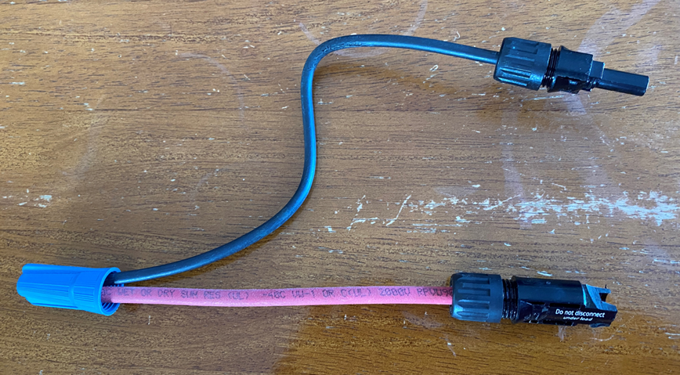
Fig. 1 Shorting wire. Use the mechanical fastener to make the short circuit and not the MC4 connectors.
INSTRUMENTS AND COMPONENTS
Handheld Pyranometer
Volt Meter
Ammeter
Shorting wire / connector (see picture below)
Shading device, opaque thick and dark.

PROCEDURE

- Measure the irradiance with the hand help pyranometer. Make sure the reading is at least 200 W/m²
- Record the panel’s STC information.
- Identify how many cells are in the panel and record.
- Open the junction box and make the by-pass diodes accessible.
- Determine how many cells are protected by each diode.
- Map out those cells so that a controlled shade can be applied to the desired group of cells. Provide a diagram.
- Measure and record the Voc and of each diode section.
- Place the shorting jumper on the panel. Measure and record, Isc and the voltage across each diode section.
- Place a controlled shade over one section of cells related to one of the by-pass diode sections. Measure and record the voltage across each diode section and the Isc.
- With the shade still in place remove electrically a by-pass diode section. Measure and record each diode section and the Isc.
- Place the by-pass diode back to normal, remove the controlled shade and connect a load to the panel. The load needs to be of such value to draw approximately 1/3 – ½ of the rated Isc.
- Measure and record each diode section and the load current.
- Place the controlled shade over the desired section of cells. Measure and record each diode section and the load current.
- With the shade still in place remove electrically a by-pass diode section. Measure and record each diode section and the Isc.
- Place the by-pass diode back to normal, remove the controlled shade.
- Simulate a failed shorted by-pass diode and demonstrate that it can be found. Measure and record the appropriate values explaining the results.
- Simulate a failed opened by-pass diode and demonstrate that it can be found. Measure and record the appropriate values explaining the results.
Place the recorded measurements in a table. Explain the reading taken.
Place in a report that includes a conclusion outlining what was learned.

