LAB Grid Connect
PV Installations

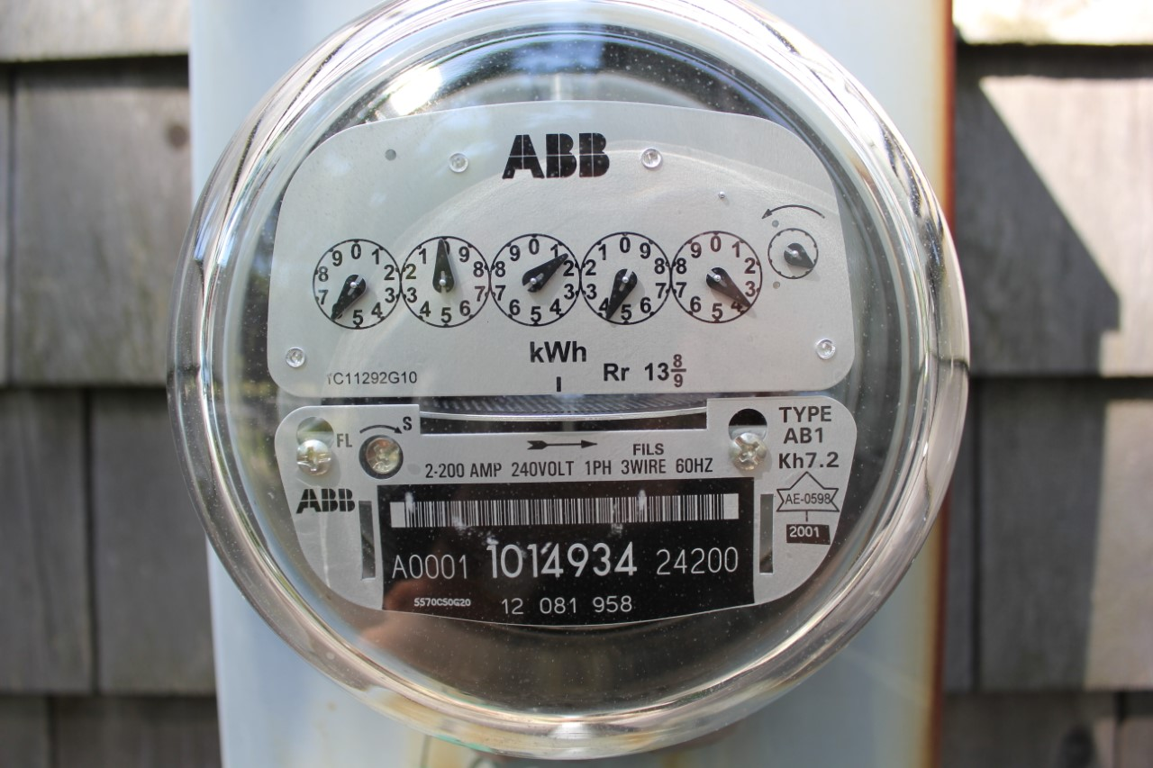

To: Instructor
From: Name Goes Here
Course: PV Installation
Date: Thursday, October 31, 2022
Belize City
ITVET Campus

PV Installations
Spring 2023
Lab Grid Connect

OBJECTIVES:

- To size and install microinverter output circuit conductors as per the NEC.

- To identify the disconnecting means at the point of connection.

- To measure the output current and voltage of the microinverter.

- Make a written procedure for commissioning the microinverter.

DISCUSSION:

At this point the modules and microinverters are mounted to the roof segment. The last part of installing the microinverters is to connect the microinverter output circuit wires to a point of connection in the lab area. The microinverter output circuit conductors need to be assessed for amperage, temperature and voltage drop. A disconnecting means needs to be established at the lab to control when the microinverters get energized. The commissioning of the microinverters and PV modules is an important step to validate that the equipment is connected and performing correctly. A document to prove the performance of the system is required for every installation.

INSTRUMENTS AND COMPONENTS:

Blue Sun BSM120P-36 PV Modules (2)
JA Solar JAP72S01-325/SC 325Watt Module
Enphase IQ7+ Data Sheet and Installation Manual
NEC sections pertaining to the inverter output circuit
Point of connection disconnection means
Inverter output circuit conductors
Clip on ammeter
Voltage meter
Handheld pyranometer

PROCEDURE

- Establish the disconnecting means at the point of connection.

- As per the NEC, assess the inverter output conductors for amperage, temperature and voltage drop. This includes knowing the length of the conductors from the microinverter junction box to the point of disconnection.

- Build a commission table to track the readings (last page).
- Set up the handheld pyranometer and start to track readings.
- Predict the expected output from the PV module to the inverter from the pyranometer readings. Also, the expected output from the inverters.
- When it is a safe time to energize the inverter output circuit, start taking the voltage readings at the inverter junction box.
- Record the indicator lights throughout the process and indicate if and when they change status.
- As per UL1741, the inverters will start to output power after 5 minutes of seeing a stable AC source. Record the time it takes for the inverters to start to output their power.
- Continue taking readings until the voltage stabilizes or at least 10 minutes.

Time | Irradiance | Inverter Voltage | Inverter Amperage | Inverter Wattage

