Ground mount anchorage test:

1. Name the 5 types of ground mount anchorage
   1. Screws
   2. Concrete
   3. Helical Screws
   4. Driven Piers
   5. Ballast
2. Which type does not penetrate the ground?
   1. Ballast
3. Using the following picture from Krinner what variable is selected in the catalogue number for:
   1. Thread fastening (Answer “G”)
   2. Torque (Answer “M”)

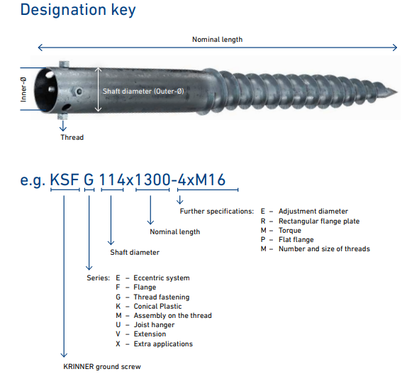

1. Name a weakness of helical screws.

(provide minimal resistance to lateral loads)

1. What type of anchorage has minimal impact on land drainage?

(Ground screws)

1. What type of anchorage requires special equipment and operators?

(Driven piers)

1. What type of anchorage requires excavation?

(Concrete piers)

1. What type of anchorage depends the most on gravity?

(Ballasted)

1. What two types of anchorage are the most complicated?

(Driven piers and helical screws)

1. What type of anchorage can have the L bracket built into it?

Concrete ballasted