<https://www.youtube.com/watch?v=cBa8YPJvTn0>

# How to draw a Gantt chart with more complicated predecessors

Engineer4Free

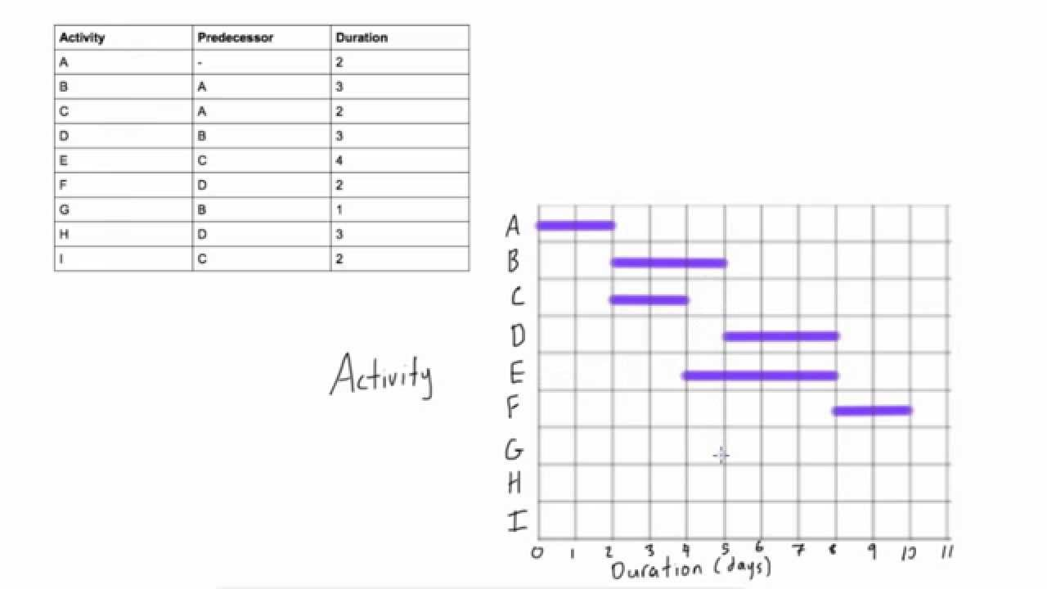

<https://www.youtube.com/watch?v=ZXSC71Cvznk>

# Advantages & disadvantages of Gantt charts

Engineer4Free

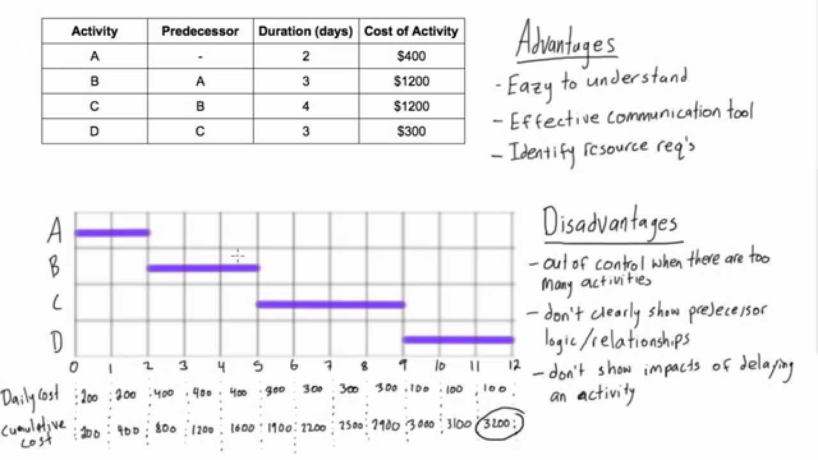

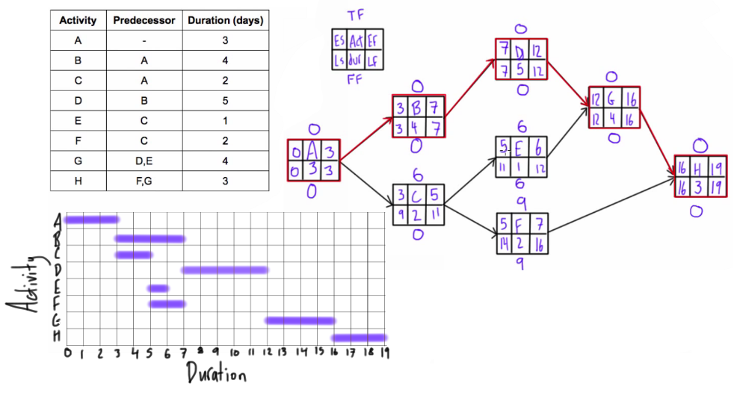

<https://www.youtube.com/watch?v=4oDLMs11Exs>

**Use forward and backward pass to determine project duration and critical path**

(Engineer4Free)

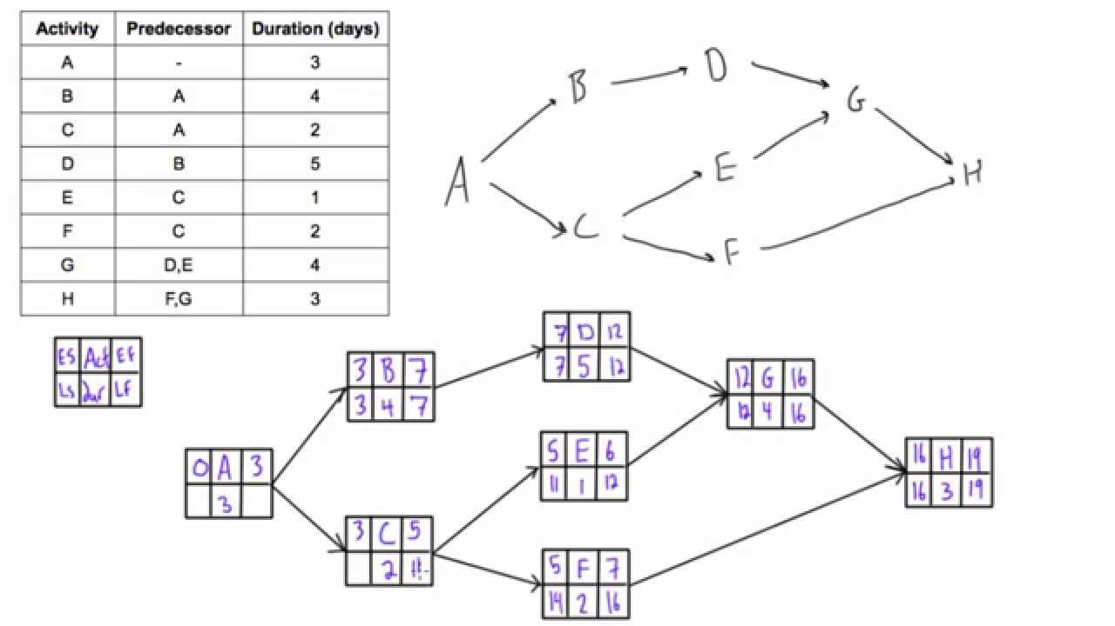

<https://www.youtube.com/watch?v=NDa-Fq5jeuM>

# Determine Total Float & Free Float (AKA "Slack") of activities in a network diagram

Engineer4Free

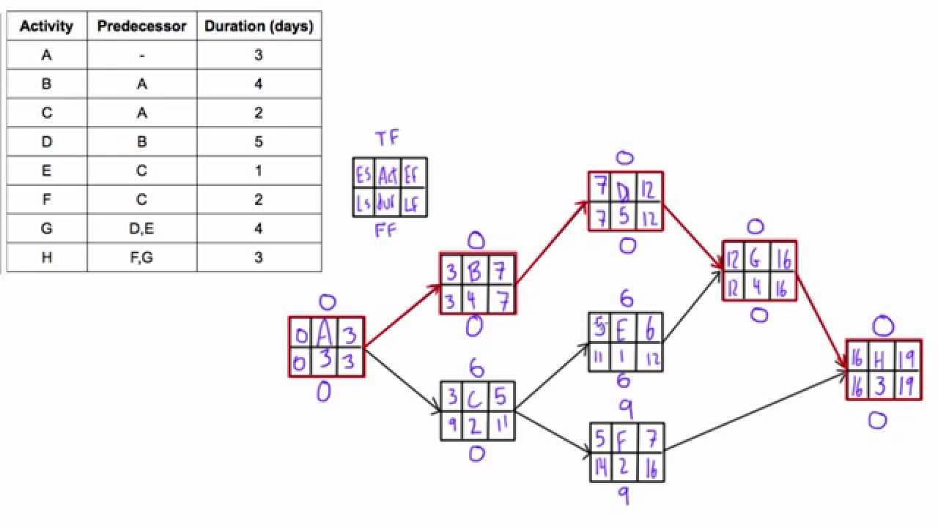



<https://www.pmcalculators.com/how-to-calculate-the-critical-path/>

# How to calculate the Critical Path with Examples

PM Calculators

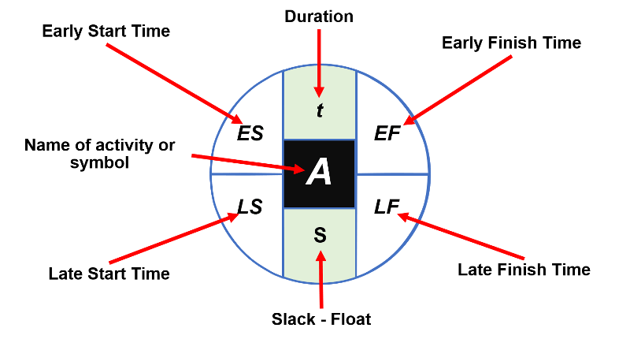

<https://www.youtube.com/watch?v=TDriHWnHkrE>

# Introduction to CPM network diagrams

Engineer4Free

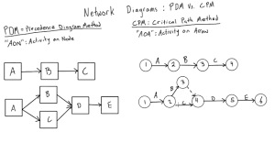

By Agarcialw - Own work, CC BY-SA 4.0, <https://commons.wikimedia.org/w/index.php?curid=95455697>

