Test Battery Based PV Installations

1. The first thing to know about batteries is they are?
   1. an energy source.
2. If short circuited across the terminals typically, within the first few microseconds how much current is flowing?
   1. None
3. The most common event that causes this short circuit Battery
   1. is the handling of tools and equipment
   2. Making sure that the voltmeter is on volts and not on amps or ohms is a common mistake.
4. Battery chemistry must be understood from a safe handling point of view. Manufacturers provide the necessary information in the form of?
   1. SDS Safety Data Sheets
5. Normally the SDS are put in a binder and?
   1. left with the client / system
   2. kept at the workplace for when service work needs to be done on the equipment in the field
6. When working on or near flooded batteries the minimum PPE is:
   1. Face shield / goggles
   2. Gloves
   3. Apron
7. Always have plenty of water and baking soda on hand in the event of?
   1. an acid spill during transport
8. Before signing acceptance of the shipment, remove the shrink-wrap from the pallet and inspect each battery for damage such as:
   1. cracks,
   2. dents,
   3. punctures,
   4. deformations,
   5. acid leaks
   6. or other visible abnormalities
9. In the event of a suspected leak or damage, do not?
   1. accept the shipment.
10. Flooded lead-acid batteries must be kept in an upright position at all times as electrolyte may spill if tilted more than?
    1. 20 degrees.
11. When receiving batteries from a shipment. Before charging what should be done?
    1. Inspect for physical damage,
    2. check polarity
    3. and electrolyte levels in each cell.
12. What is done if the plates are exposed?
    1. Add distilled water until all are just submerged.
13. Why is it important not to overfill each cell?
    1. The electrolyte level will rise during the charging process.
14. Define specific gravity:
    1. It is the ratio of the density of a substance to the density of a standard, usually water for a liquid.
    2. For flooded Lead acid batteries, it is the density of sulfuric acid in water (the electrolyte).
15. For flooded lead acid batteries, the electrolyte in a fully charged battery is usually?
    1. (1.260-1.280)
16. What instrument is used to measure the specific gravity?
    1. A hydrometer
17. Routine testing of specific gravity in flooded models provides an opportunity to quickly identify any notable changes in battery performance caused by charge-related issues such as?
    1. over/undercharging,
    2. sulfation buildup,
    3. capacity loss
    4. or cell/battery performance or failures.
18. A common cause of failure with Flooded battery banks is?
    1. Poor maintenance.
19. Failing to top up cells may result in?
    1. plate exposure,
    2. overheating
    3. and possible explosion
20. What water should be used in Flooded battery cells?
    1. distilled (preferred),
    2. deionized
    3. or reverse osmosis
21. If the battery cells require watering more than once every two (2) months what might be too high?
    1. the programmed charging voltages.
22. If a particular cell requires significantly more water than others this may be a sign of?
    1. charge imbalance in the battery bank caused by resistance (Terminal connection) and / or cell failure.
23. It is recommended that the batteries are separated how far apart to allow proper airflow, cooling and ease of maintenance?
    1. 2.5cm-7.5cm (1"-3”) inches
24. Interconnection cables (battery to battery) should be sized at?
    1. the same gauge
    2. and of equal length between connections
25. It is recommended that terminal connections are what as part of the regular maintenance routine?
    1. disconnected, cleaned
    2. and re-torqued periodically
26. Connections which have overheated and / or developed problems will often be?
    1. welded to the terminal.
27. As batteries are cycled and heat up during charge, under-torqued connections?
    1. may become loose over time as the terminals heat & cool, causing possible arching and a risk of spark.
28. Over-torqued connections may?
    1. indent,
    2. crack
    3. or bend the terminal
    4. and/or washers or terminal connectors.
29. Always move torque wrench setting to what after use?
    1. Zero
30. Depending on the manufacture and type, some batteries cannot be connected in series. What type is this?
    1. Lithium with a BMS
31. To increase capacity and voltage, connect the batteries in series parallel.

Explain the wiring in the circuit below.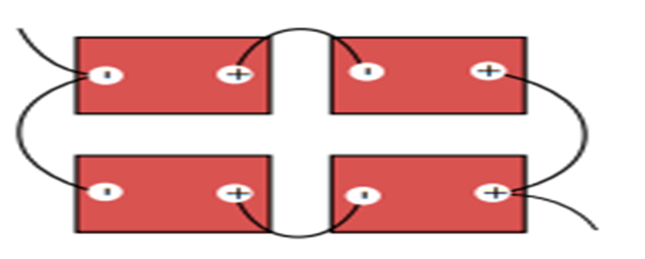

There are two batteries in series and those two batteries are in parallel with two other batteries in series. The wires leaving the battery bank are on opposite terminals for each string. That is the takeaway from this question. Note that the exiting negative and positive wires are from opposite batteries.

This encourages even current taken from both parallel strings.

1. Enclosures for Flooded models should be “What” with both positive and negative airflow installed to remove and replace any hydrogen gas generated during charging?
   1. actively ventilated
2. Every effort should be made to avoid hydrogen accumulation as concentrations in excess of what percentage that may ignite with electrical spark and are explosive.
   1. 2-4%
3. In Belize higher operating temperatures cause cell degradation which does what to the battery?
   1. Shortens the cycle life of the battery
4. The battery bank should not be installed where?
   1. in a living space.
5. If the battery enclosure is located inside a storage room or garage, the active ventilation system must?
   1. exhaust outside,
   2. away from windows, doors
   3. or fresh air intake
6. Batteries by location in a room, vault, or similar enclosure that is accessible only to?
   1. qualified persons
7. Most charge controllers and inverters use a battery temperature sensor to regulate charge voltage. This sensor should be mounted where?
   1. on the side of a battery case in the middle of battery bank
8. Place a check on the correct bolted picture.
   1. The bottom one

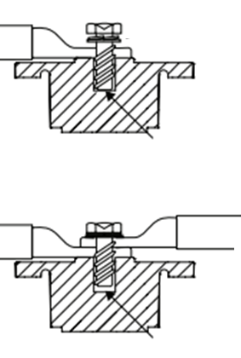

1. Terminal burnout is caused by:
   1. Discharge currents exceeding allowable limits
   2. Improper cable installation
   3. Improper cable sizing
   4. Improper terminal torque
2. Lithium LFP cells do not need maintenance charges like
   1. Equalization
   2. Pulse charge
   3. Overcharge
   4. Or any others typically recommended or required for lead acid batteries
3. DC coupling is when two or more DC inputs or outputs are connected together, provide 4 examples.
   1. PV to charge controller
   2. Charge controller to batteries
   3. Charge controller to DC loads
   4. Battery to DC input of inverter
4. AC coupling is when two or more AC inputs or outputs are connected together give 3 examples.
   1. Inverter to AC panel (loads)
   2. Inverter to generator
   3. Inverter to Utility or grid
5. Can an equalization can happen at any monthly maintenance inspection?
   1. Yes