Code and Regulations for RE

1. Give 3 examples of governing bodies that produce electrical standards?
   1. Canadian Electrical Code by CSA (Canadian Standards Council)
   2. BS 7671 is the British requirements for Electrical Installations
   3. IEC60364 is Europe's version.
   4. NEC National Electrical Code of the US.
2. Definition of Approved is?
   1. Acceptable to the authority having jurisdiction (AHJ). Belize Electricity Limited (BEL)
3. Definition of Identified?
   1. Recognized as suitable for the specific purpose, function, use, environment, application and so forth, where described in a particular Code requirement.
4. Definition of Labeled
   1. Equipment or materials to which has been attached a label, symbol or other identifying mark of an organization that is acceptable to the AHJ. (BEL)
   2. Manufacturer indicates compliance with appropriate standards or performance in a specific manner.
   3. It means that a label, symbol, or some identifying mark has been attached to the equipment or materials to indicate compliance with appropriate standards, like UL or CSA or ETL.

UL = Underwriters Laboratories

CSA = Canadian Standards Association

ETL = Intertek Electrical Testing Labs (ETL)

1. Definition of LISTED
   1. Equipment, materials, or services included in a list published by an organization that is acceptable to the AHJ and concerned with evaluation of products or services, that maintains periodic inspection of production of listed equipment or materials or periodic evaluation of services, and whose listing states that either the equipment or material, or services meets appropriate designated standard or has been tested and found suitable for a specific purpose.
2. Chapter 6 is called what?
   1. Special Equipment.
3. Article 690 – is for what?
   1. Solar Photovoltaic (PV) Systems.
4. Throughout the code there are “Information Notes” what are they?
   1. explain some details of a particular code.
5. Define Alternating-Current (ac) Module
   1. A complete, environmentally protected unit consisting of solar cells, inverter, and other components, designed to produce ac power.
6. Describe what an Array is.
   1. A mechanically and electrically integrated grouping of modules with support structure, including any attached system components such as inverter(s) or dc-to-dc converter(s) and attached associated wiring.
7. Describe an DC-to-DC Converter.
   1. A device installed in the PV source circuit or PV output circuit that can provide an output dc voltage and current at a higher or lower value than the input dc voltage and current.
8. An example of a DC-to-DC Converter is an?
   1. optimizer. A device that provides MPPT at the module level.
9. Explain a DC-to-DC Converter Source Circuit.
   1. Circuits between dc-to-dc converters and from dc-to-dc converters to the common connection point(s) of the dc system.
10. Draw an example of the DC-to-DC Converter Source Circuit
    1. 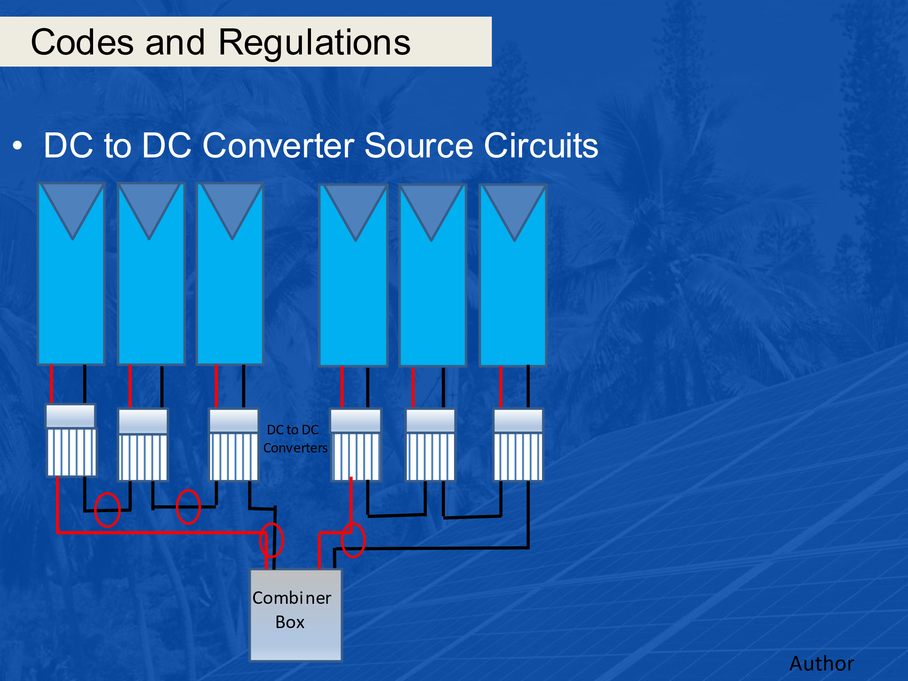
11. What is a Direct-Current (dc) Combiner.
    1. An enclosure that includes devices used to connect two or more PV system dc circuits in parallel (pictured next slide).
    2. Can be a combiner box or a junction box.
12. What is an Electronic Power Converter.
    1. A device that uses power electronics to convert one form of electrical power into another form of electrical power.
13. What are some examples of electronic power converters?
    1. inverters, dc-to-dc converters, and electronic charge controllers.
14. These devices have limited current capabilities based on what?
    1. The device ratings at continuous rated power.
15. Describe the PV Source Circuit.
    1. The dc circuit conductors between modules and from modules to dc combiners, electronic power converters, or a dc PV system disconnecting means.
16. Describe the PV System DC Circuit.
    1. Any dc conductor in PV source circuits, PV output circuits, dc-to-dc converter source circuits, and dc-to-dc converter output circuits.
    2. Not an ac circuit, just dc wiring anywhere in the PV circuit(s).
17. Article 110.7 – Wiring Integrity. Completed wiring installations shall be free of short circuits, ground faults, or any connections to ground other than as required or permitted elsewhere in this Code. What does this mean?
    1. Good Workmanship, professionally done.
18. Article 110.12 – Mechanical Execution of Work. What is meant by this?
    1. Electrical equipment shall be installed in a professional and skillful manner.
    2. Safety and cleanliness are included in this definition.
19. Article 110.14 - Electrical Connections. Terminals and connectors shall be identified for the material of the conductor and shall be properly installed and used. Name a few points about this article.
    1. Depending on the number of strands and size of the wire, different types of connectors / connections are required.
    2. Crimped versus terminal versus mechanical fasteners versus soldered.
    3. Connections and terminals for conductors more finely stranded than Class B and Class C stranding as shown in Chapter 9, Table 10, (next slide) shall be identified for the specific conductor class or classes.
20. Article 110.14 - (A) Terminals name something about this type of connection.
    1. Connections of conductors to terminal parts shall ensure a mechanical secure electrical connection without damaging the conductors and be made by means of pressure connectors (including screw type).
21. Article 110.14 - (B) Splices name something about splices.
    1. Conductors shall be spliced or joined with splicing devices identified for the use or by brazing, welding, or soldering with a fusible metal or alloy.
22. Article 110.21 - Marking.

(A) Equipment Markings. Describe product markings.

* 1. The manufacturer’s name, trademark, or other descriptive marking by which the organization responsible for the product can be identified or affixed onto all electrical equipment.

1. Article 110.21 - Marking.

(A) Equipment Markings. Describe other types of equipment markings.

* 1. Other markings for safety that indicate voltage, current, wattage, or other ratings shall be provided as specified elsewhere in this Code.

1. Article 110.22 - Identification of Disconnecting Means. What needs to be identified?
   1. Each disconnecting means shall be legibly marked to indicate its purpose.
2. Article 200 Use and Identification of Grounded Conductors. Define what the grounded conductor is.
   1. A system or circuit conductor that is intentionally grounded. This is the neutral conductor when connected to a split or multiphase system and carries current.
3. Define what a grounding conductor is.
   1. Grounding Conductor”, Equipment (EGC). A conductive path(s) that is part of an effective ground-fault current path and connects normally non—current-carrying metal parts of equipment together and to the system grounded conductor or to the grounding electrode conductor, or both.
4. What conductor carries current? A grounded conductor or a grounding conductor?
   1. Grounded conductor
5. What conductor does not carry current? A grounded conductor or a grounding conductor?
   1. Grounding conductor
6. In the picture below, which bus does the grounded conductor connect to? N or G
   1. N

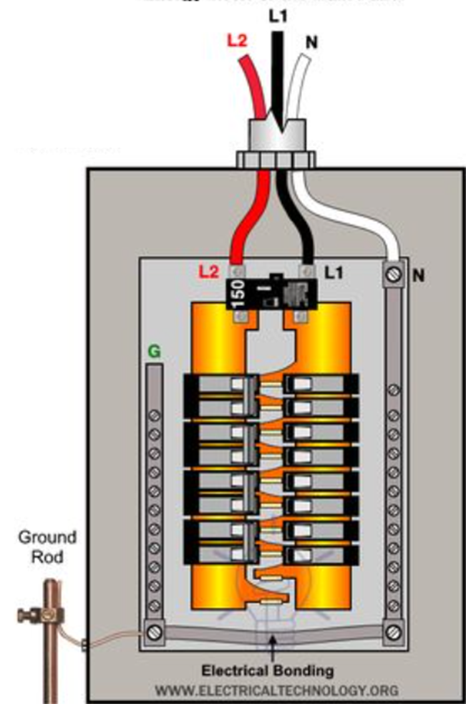

1. In the picture below, which bus does the grounding conductor connect to? N or G
   1. G

1. Article 200.6 – Means of Identifying Grounded Conductors. (How to tell if it is the Grounded Conductor) size #6AWG or smaller, List 3.
   1. A continuous white outer finish.
   2. A continuous grey outer finish.
   3. Three continuous white or grey stripes along the conductor’s entire length on other than green insulation.
   4. A single – conductor, sunlight – resistant, outdoor – rated cable used as a solidly grounded conductor in photovoltaic power systems.
   5. White tape placed at every end at terminations is permitted for the grounded conductor in in the above condition only.
2. Article 250.119:
3. Equipment grounding conductors shall be permitted to be bare, covered, or insulated. What colors are permitted for these grounding conductors?
   1. shall have a continuous outer finish that is either green or green with one or more yellow stripes.
4. 210.5(C) Identification of Ungrounded Conductors (Hot or live). What colors are normally used in AC circuits?
   1. Red, Black or Blue.
5. Positive Polarity, Sizes 6 AWG or Smaller. Where the positive polarity of a dc system does not serve as the connection point for the grounded conductor, each positive (hot) ungrounded conductor shall be identified by one of the following means: Describe the 4 options.
   1. (1) A continuous red outer finish
   2. (2) A continuous red stripe durably marked along the conductor's entire length on insulation of a color other than green, white, gray, or black
   3. (3) Imprinted plus signs (+) or the word POSITIVE or POS durably marked on insulation of a color other than green, white, gray, or black and repeated at intervals not exceeding 610 mm (24 in.) in accordance with 310.8(B)
   4. (4) An approved permanent marking means such as sleeving or shrink-tubing that is suitable for the conductor size, at all termination, connection, and splice points, with imprinted plus signs (+) or the word POSITIVE or POS durably marked on insulation of a color other than green, white, gray, or black
6. Negative Polarity, Sizes 6 AWG or Smaller. Where the negative polarity of a dc system does not serve as the connection point for the grounded conductor, each negative ungrounded (hot) conductor shall be identified by one of the following means: Describe the 4 options.
   1. (1) A continuous black outer finish.
   2. (2) A continuous black stripe durably marked along the conductor's entire length on insulation of a color other than green, white, gray, or red.
   3. (3) Imprinted minus signs (—) or the word NEGATIVE or NEG durably marked on insulation of a color other than green, white, gray, or red and repeated at intervals not exceeding 610 mm (24 in.) in accordance with 310.8(B)
   4. (4) An approved permanent marking means such as sleeving or shrink-tubing that is suitable for the conductor size, at all termination, connection, and splice points, with imprinted minus signs (—) or the word NEGATIVE or NEG durably marked on insulation of a color other than green, white, gray, or red
7. Define Wet Location:
   1. Installations underground or in concrete slabs or masonry in direct contact with the earth; in locations subject to saturation with water or other liquids, such as vehicle washing areas; and in unprotected locations exposed to weather.
8. Article 225.31 Disconnecting Means (Outside Branch Circuits and Feeders). Means shall be provided for:
   1. disconnecting all ungrounded conductors that supply or pass through the building or structure.
9. 225.31(B) Location. The disconnecting means shall be installed either:
   1. inside or outside of the building or structure served or where the conductors pass through the building or structure.
   2. The disconnecting means shall be at a readily accessible location nearest the point of entrance of the conductors.
10. 240.4 (D): Common wire sizes and their overcurrent requirements: List the overcurrent requirements for the three most common sized copper wire.
    1. 14 AWG Copper at 15 amperes.
    2. 12 AWG Copper at 20 amperes.
    3. 10 AWG Copper at 30 amperes
11. Circuit Breaker as Overcurrent Device. What does the circuit breaker need to do?
    1. Circuit breaker opens all of the ungrounded conductors both manually and automatically it can be used.
12. Article 240.24 – Location in or on Premises (Overcurrent protection). 240.24(A) Accessibility. Describe conditions for accessibility.
    1. Circuit breakers and switches containing fuses shall be readily accessible and installed so that the center of the grip of the operating handle of the switch or circuit breaker, when in its highest position, is not more than 2.0 m (6 ft 7 in.) above the floor or working platform.
13. Where can overcurrent protections not be located?
    1. Over stairs
    2. In Bathrooms
14. What is the trade size designation for the following imperial size ½”
    1. 16mm
15. What is the trade size designation for the following imperial size 3/4”
    1. 21mm
16. What is the trade size designation for the following imperial size 1”
    1. 27mm
17. What is the trade size designation for the following imperial size 2”
    1. 53mm
18. What is the trade size designation for the following imperial size 3”
    1. 78mm

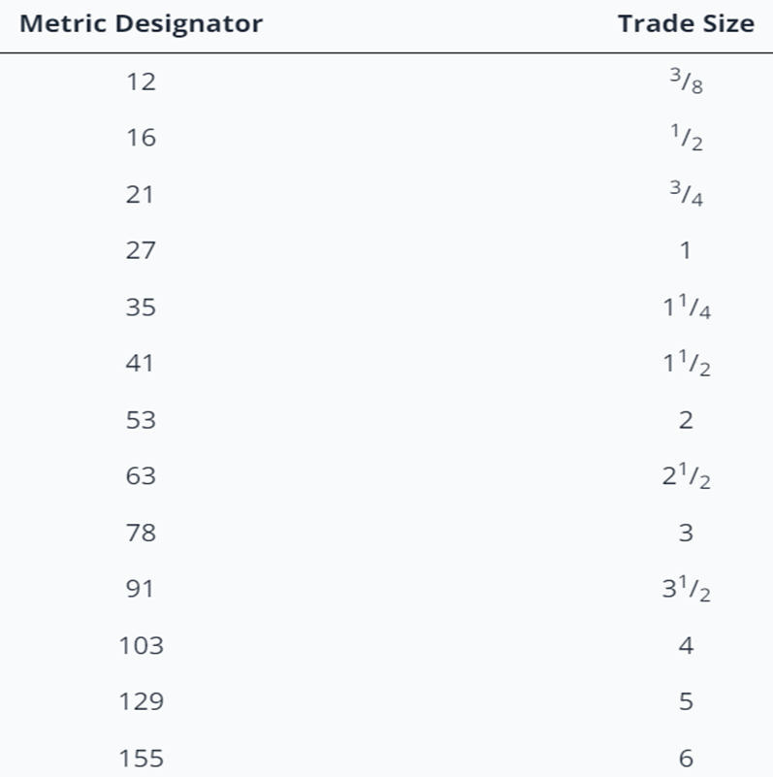

1. Article 310.15 (B) – Ambient Temperature Correction Factors.

310.15(B)(2) Rooftop. For raceways or cables exposed to direct sunlight on or above rooftops where the distance above the roof to the bottom of the raceway or cable is less than 19 mm (3/4 in.), What is the temperature adder for the conductor or raceway?

* 1. a temperature adder of 33°C (60°F) shall be added to the outdoor temperature.

1. Article 690.4 - General Requirements

(A) Photovoltaic Systems.

Photovoltaic systems shall be permitted to supply a building or other structure in addition to any other electrical supply system(s). True or False?

* 1. True

1. What does AHJ stand for?
   1. Authority Having Jurisdiction is the organization, office, or individual having statutory responsibility for enforcing the requirements of a standard.
2. 690.4(F) Electronic Power Converters Mounted in Not Readily Accessible Locations. Give an example of a Not Readily Accessible location.
   1. Behind panels
   2. On roofs, out of reach.
   3. Pole top mounting.
3. 690.7 Maximum Voltage The maximum voltage of PV system dc circuits shall be:
   1. the highest voltage between any two conductors of a circuit or any conductor and ground.

In a dc PV source circuit, the maximum dc voltage shall be calculated in accordance with one of the following two methods:

* The sum of the PV module-rated open-circuit voltage of the series-connected modules corrected for the lowest expected ambient temperature using the open-circuit voltage temperature coefficients in accordance with the instructions included in the listing or labeling of the module.
* For crystalline and multicrystalline silicon modules, the sum of the PV module-rated open-circuit voltage of the series-connected modules corrected for the lowest expected ambient temperature using the correction factors provided in Table 690.7(A)

Table 690.7(A)

* Table

  Description automatically generated

Data from Trina Solar PV Module

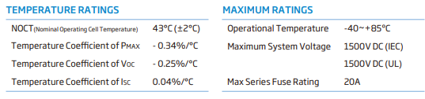

1. For the 390 Watt PV module mounted in Belize using Table 690.7(A) what is the Voc for calculations?
   1. 40.8V x 1.06 = 43.25V
2. For the 390 Watt PV module mounted in Belize using the first method what is the Voc for calculations?
   1. Voc at 10C = (((10C-25C) x -0.0025) x 40.8V) + 40.8V

Voc at 10C = 42.33V per module.

1. DC-to-DC Converter is a device that can provide an output dc voltage and current at a higher or lower value than the input dc voltage and current. Pick the correct statement.
2. a higher value than the input dc voltage and current.
3. a lower value than the input dc voltage and current.
4. a higher or lower value than the input dc voltage and current.
   1. a higher or lower value than the input dc voltage and current.
5. An example of a DC – DC Converter is:
   1. an optimizer that has an MPPT function.
6. For circuits connected to the output of two or more series-connected dc-to-dc converters, the maximum voltage shall be determined in accordance with?
   1. the instructions included in the listing or labeling of the dc-to-dc converter multiplied by the number of the dc-dc converters.
7. 690.7(D) Marking DC PV Circuits.
8. After calculating the highest DC PV voltage as per 690.7, have it permanently located in one of the following locations: (Name one)
   1. (1) DC PV system disconnecting means.
   2. (2) PV system electronic power conversion equipment (Inverter or charge controller).
   3. (3) Distribution equipment associated with the PV system (Disconnect or Combiner box).
9. 690.8(A)(1)(a) Photovoltaic Source Circuit Currents, How shall the maximum current be calculated?
   1. 690.8(A)(1)(a)(1) Maximum Isc of the PV modules connected in parallel multiplied by 125% (extra irradiance).

use the STC values for the modules.

Multiply by the number of strings of the same modules.

Finally allow for extra irradiance by multiplying by 125%.

1. 690.9(A)(1) Circuits Where Overcurrent Protection Not Required.

Overcurrent protective devices are not required if both of the following conditions are met: Describe one condition.

* 1. The conductors have ampacity for the maximum circuit current.
  2. The currents from all sources is not greater than the overcurrent protective device rating specified for the PV module or electronic power converter (manufacturer manual).

1. 690.9(A)(2) Circuits Where Overcurrent Protection Is Required on One End. Explain this code.
   1. A circuit conductor fed from a current limited supply (PV module or dc-dc converters for example), with the conductor rated for the maximum current from this supply, and also connected to sources that can impress currents greater than the conductor's ampacity, an overcurrent device shall be installed at the point of connection to the higher current source(s).
2. Article 690.11 Arc-Fault Circuit Protection (dc).

Arc-Fault protection is designed to detect a flow of current out from a conductor or module that is not intentional.

Explain with a drawing the three types of arc-faults.

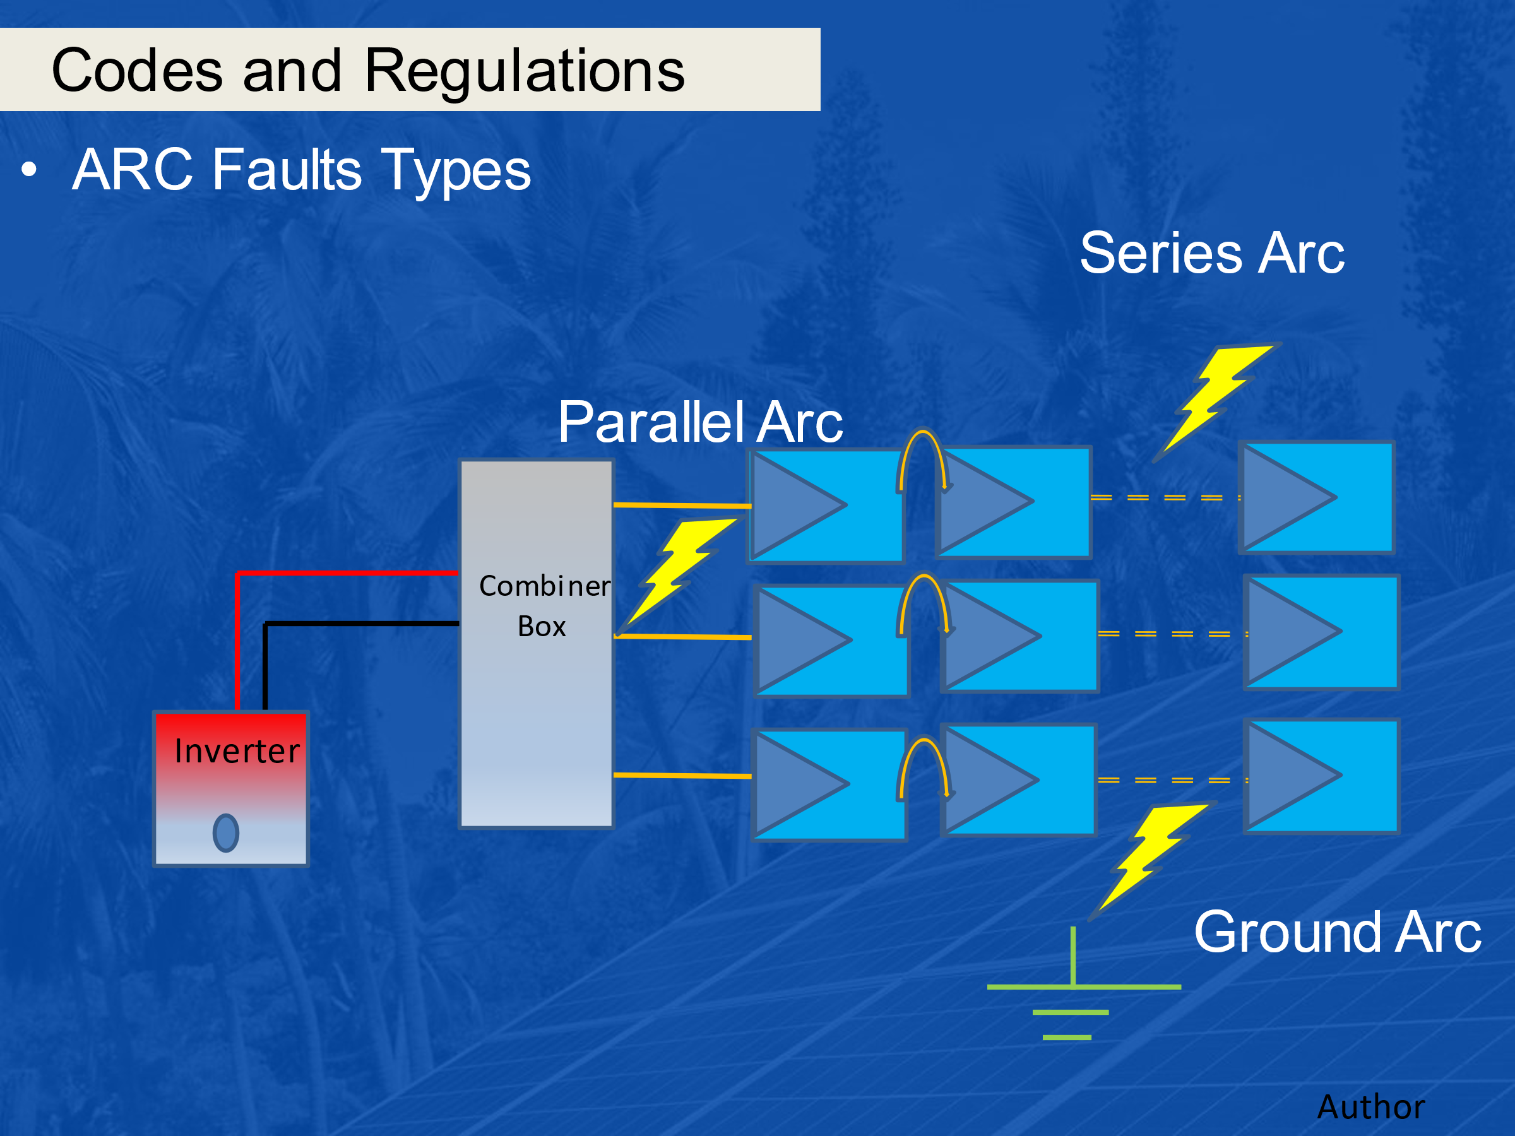

1. Article 690.12 – Rapid Shutdown of PV Systems on Buildings.

What is the main purpose of Rapid Shutdown?

1. Main purpose is for fire fighter safety as firefighters that go on a roof to fight a fire.