Core Rules Test #2

- What is the definition of “Disconnection Means”?
  - A disconnecting means is defined as a device, or group of devices, or other means by which the conductors of a circuit can be disconnected from their source of supply.
- Article 690.13 Photovoltaic System Disconnecting Means.
Question to ask if the disconnect in questions is the PV system disconnecting means is:
Is it disconnecting all the equipment required to convert solar energy into electric energy?

Which of the following locations would qualify for the Photovoltaic System Disconnecting Means

  - If straight from PV to dc-dc converter to inverter to main panel, then this disconnecting means is on the ac side of the inverter, (TRUE)
  - if there is a dedicated breaker in the panel it is it,(TRUE)
  - if there is a utility disconnect it is it, if there is a disconnect before the panel it is it also.(TRUE)
- Circle the correct Photovoltaic System Disconnecting Means for the diagram, there maybe more than one correct answer.
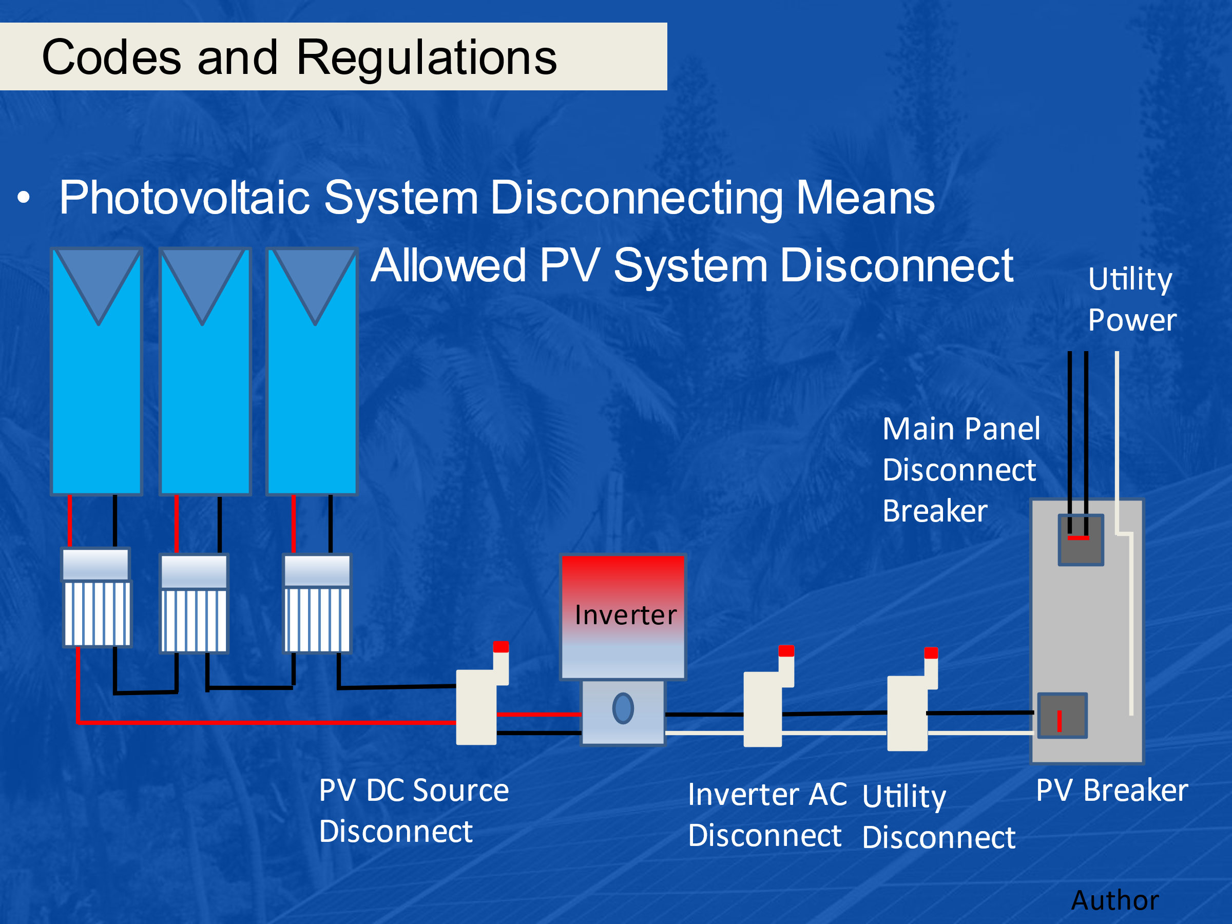
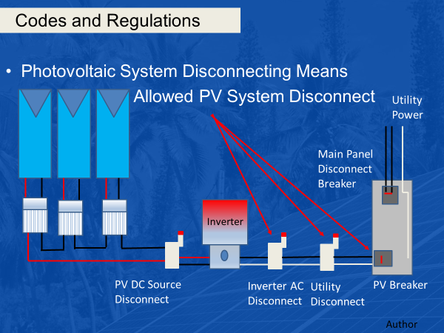

- Circle the correct Photovoltaic System Disconnecting Means for the diagram, there maybe more than one correct answer.
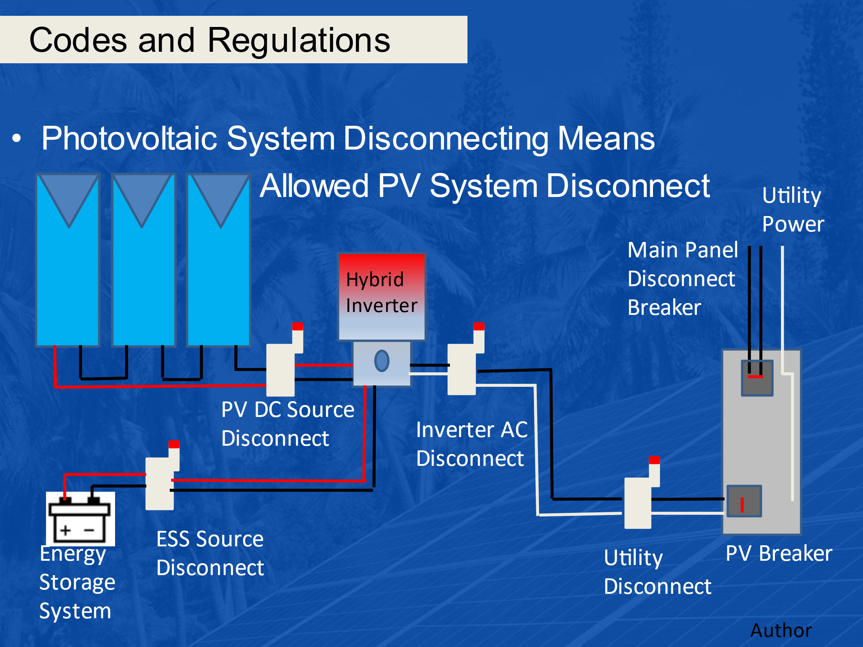

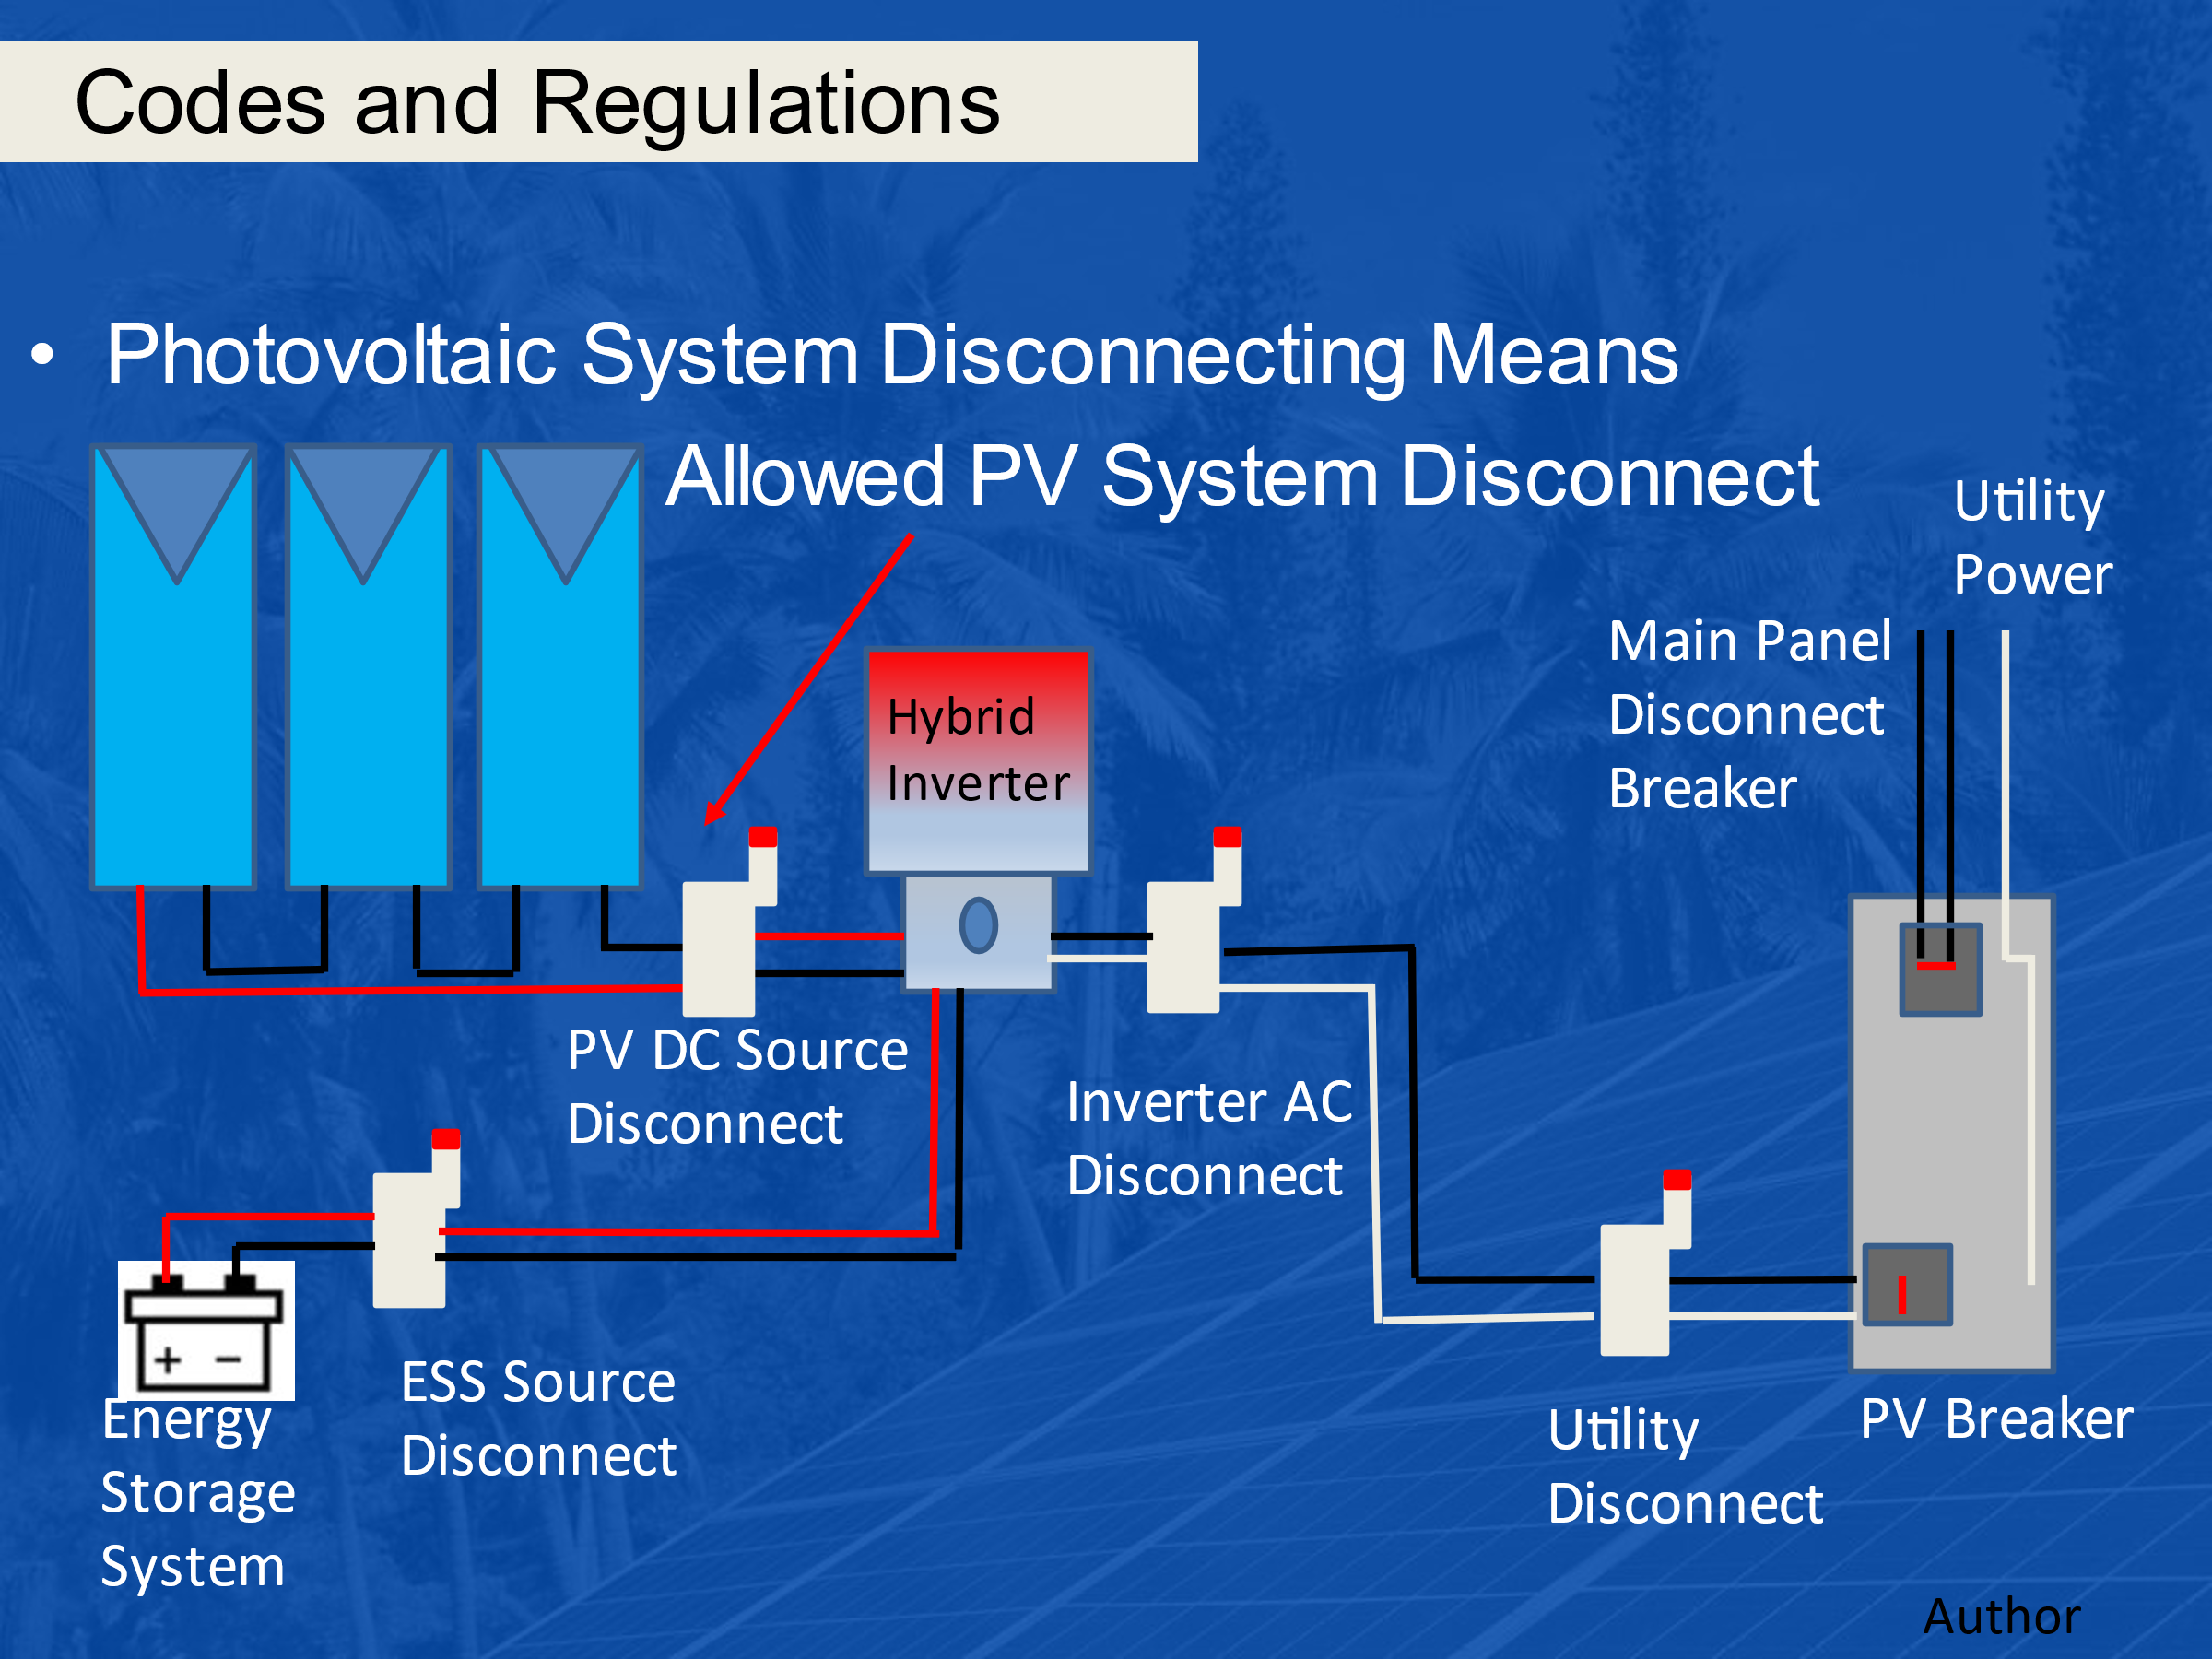

- 690.13(A) Location Photovoltaic System Disconnecting Means. Being readily accessible suggests that anyone can walk up to the disconnect. What safety measures are used to keep people safe?
  - Enclosure Doors and Covers. Being readily accessible indicates that unqualified persons have access, and therefore the cover or hinged door need to be locked or require a tool to open it.
- 690.13(D) Ratings. The disconnect need to be rated to handle what?
  - The maximum circuit current and available fault current.
- 690.13(E) Type of Disconnect. Must be able to open what?
  - the ungrounded conductors at the same time (simultaneously) from all conductors of other wiring systems.
- 690.13(E) Type of Disconnect. Must be able to be what?
  - Be able to be locked – Lockable Disconnecting Means.
- The PV system disconnecting means can be a manually operated switch or breaker. True or False.
  - True
- Article 690.15 – Disconnecting Means for Isolating Photovoltaic Equipment.
A disconnecting means so far has the ability to disconnect a circuit underload. What is different about this isolating device?
  - An isolating device does not necessarily need to break load current.
- Give an example of an isolating device.
  - A mating connector.
  - A finger safe fuse holder

- 690.31(B) Identification and Grouping.
(Conductors of Different Systems. If the voltage rating of any conductor is less than the circuit voltage of any other and occupies the same raceway, what is used to protect the conductors?
  - A barrier shall be used to separate them.
- 690.31(B)(3) Grouping.
When ac and dc wires are in the same junction box, pull box or raceway they need to be what?
  - grouped by cable ties or other means and when run together, they need to be grouped at intervals of not more than 1.8m (6ft).
  - Cable tie ac wires together and cable tie dc wires together.
- Article 690.33 Mating Connectors. Be of a latching or locking type. If over 30 volts dc or 15 volts ac will require a tool for opening. Give an example of this?
  - MC-4 for example
  - Microinverter connector.
- This circuit is of what kind of grounded system?
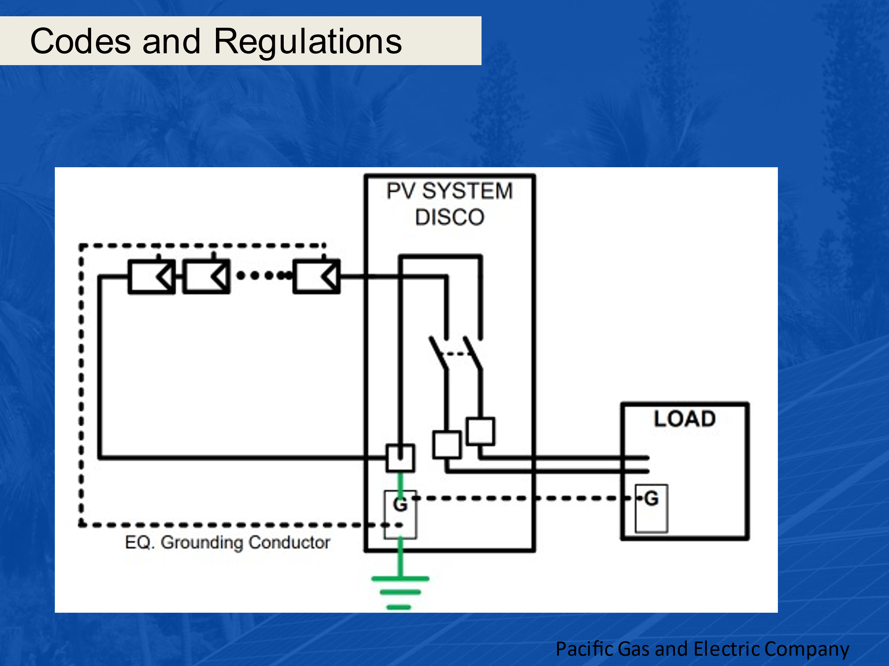
  - Solidly Grounded

- This circuit is what kind of grounded system?
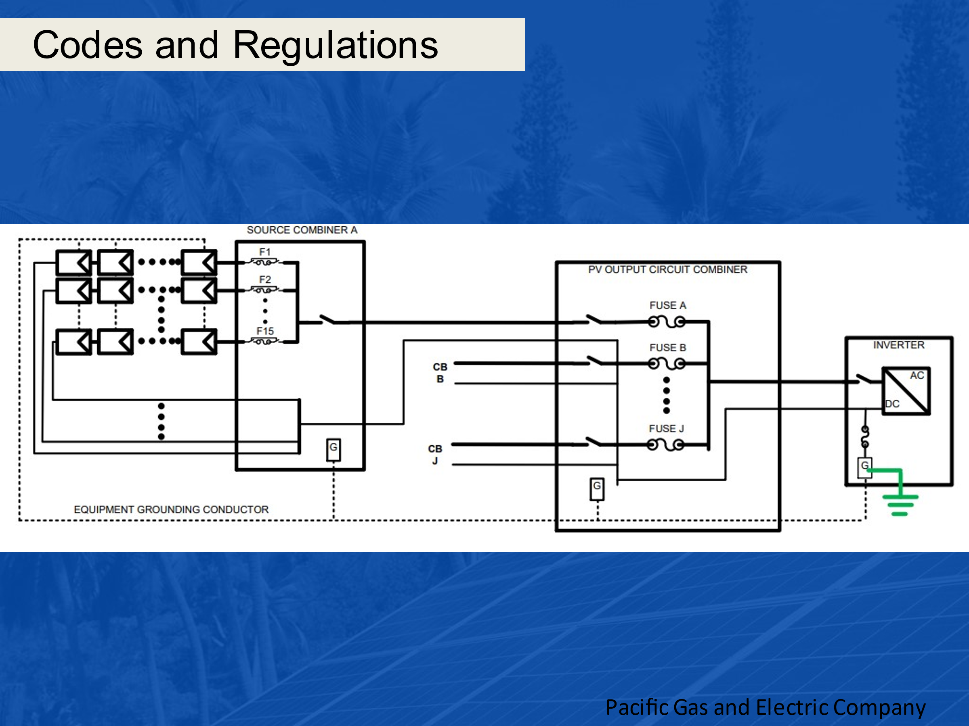
  - Functionally Grounded.

- Describe the function of this GFD circuit with respect to the breakers.
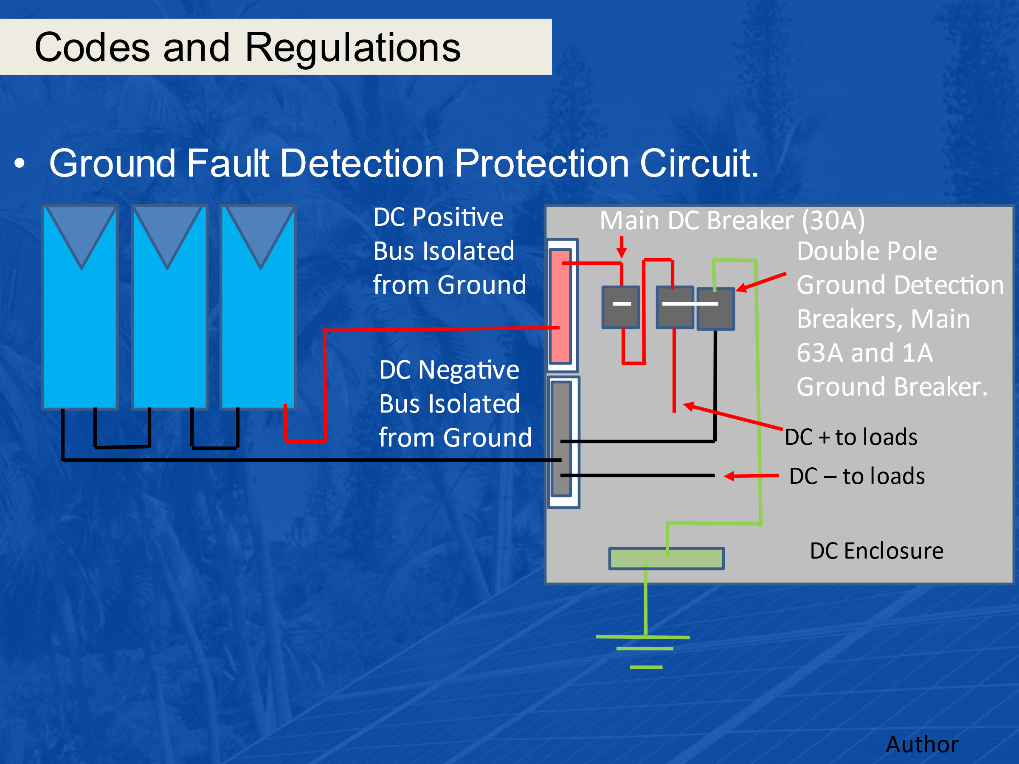
  - The ground fault system in the previous slide keeps both the DC + and DC – isolated from ground with isolated buses. The DC – is connected to ground through the 1 A breaker. The 1A breaker is ganged with the 63A breaker. If the 1A breaker sees more than 1A it operates, and trips open the 63A breaker removing the DC – from ground and stopping the fault current.

- What is the name of the piece of equipment that the arrow is pointing to?
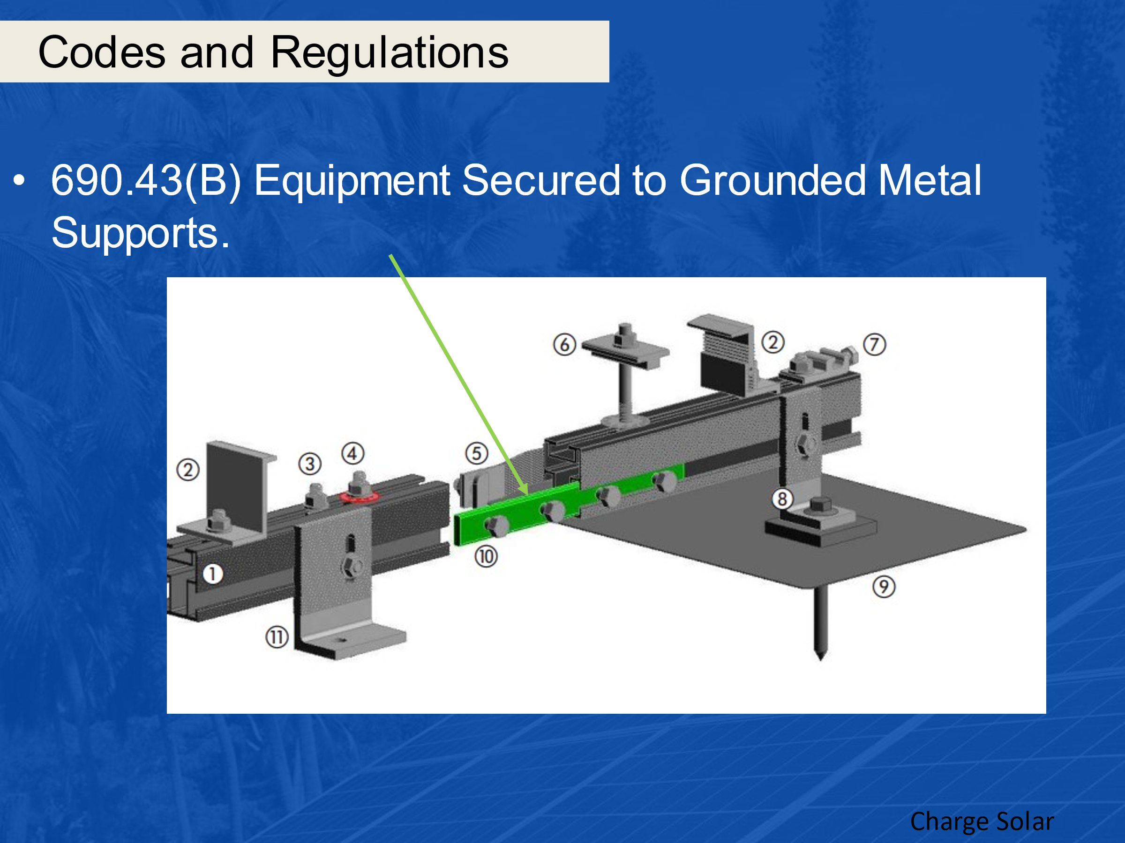
  - Bonding Jumper.
- What are the two types of cables pictured below?
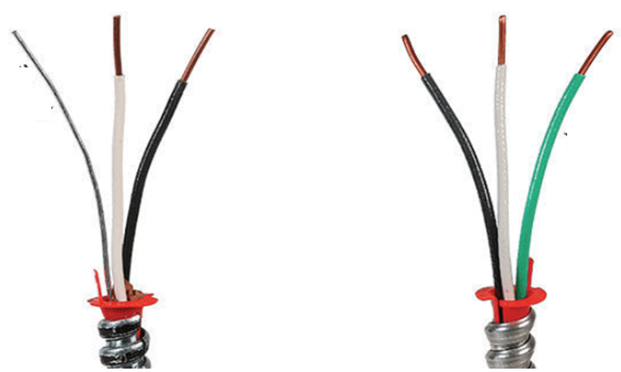
  - Armored Cable (AC) on left and Metal Clad Cable (MC) on right.

- What is the difference between Armored Cable (AC) and Metal Clad Cable (MC)?
  - The main difference between the AC wire and the MC wire is that the metal-clad cable has a standard ground wire, whereas the AC cable relies on a jacket in combination with a wire or thin strip to secure the grounding. The metal armor can also act as a part of the earth grounding in combination with the bonding wire. In type MC cables, the armor is not part of the grounding.

