Grid Interactive Inverter Test #2

What specifications are most important for a microinverter?
Maximum input voltage
Maximum input current
MPPT range
Start up range
Output power
Output voltage
UL1741 parameters

Explain the AC – DC Ratio.
It is the amount of DC input power that can be connected to the microinverter versus the output AC power that the microinverter can deliver.
The higher the ratio, the greater the low irradiance level is transferred to AC output.

Which have more design parameters?
Microinverters
String inverters

What needs to be determined to ensure the MPPT range is met?
- The string size (number of PV panels in series) needs to be determined so that Vmp of all the panels add up between the MPPT range.

What effect does temperature have on meeting the MPPT voltage range?
- The Vmp will be lowered as the temperature goes up. Possibly dropping the string voltage below the MPPT range.
What is the temperature range used for the cell temperature in Belize?
- Temperature range for Belize is 10C to 65C.

What curve is used for the upper temperature in Belize?

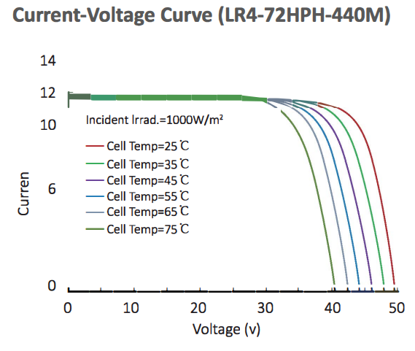
- Cell Temp = 65C

