Grid and the 2023 NEC Inverter Test #1

* This is the most common residential connection.

Split single phase 240V AC

* What is the role of the NEC and other standards?
  + is to reduce electrical hazards and fires.
* What is the section in the NEC that deals with solar PV?
  + Article 690 “Solar Photovoltaic (PV) Systems”
* When the word “listed” is used, what is it referencing?
  + That the item has been UL certified.
* Describe the DC to AC ratio. Also, what is an advantage of it?
  + The amount of DC input relative to the AC output.
  + Gathers more energy during lower irradiance levels.
* What are the temperature corrections for the module?
  + Voc low temperature
  + Vmp high temperature
  + Vmp low temperature
* What are the two temperature values in degrees Celsius for Belize?
  + 10C and 65C
* On a branch circuit what percentage of load current does the overcurrent device carry?
  + 80%
* In the following picture identify 1, 2, and 3.

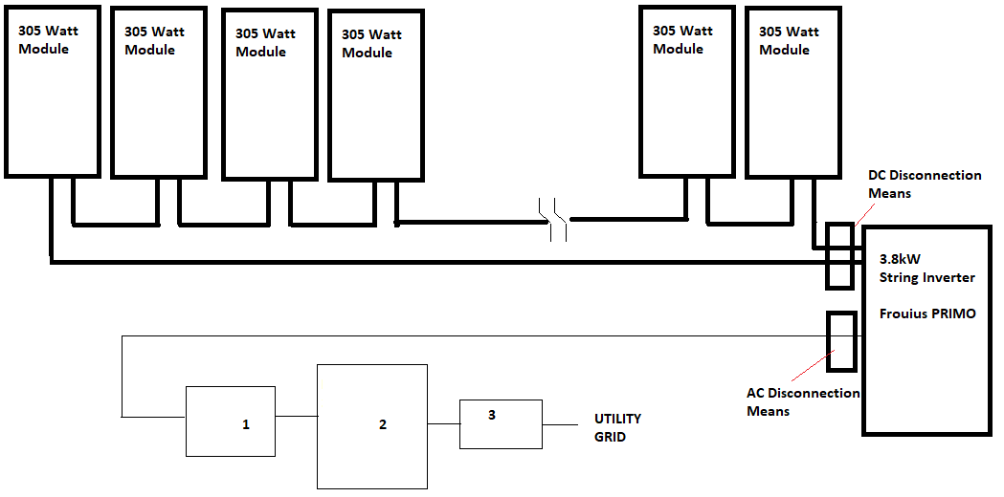

* + 1 Utility disconnect 2 main panel 3 NET meter
* PV system equipment and disconnection means are not to be installed in?
  + washrooms.
* Roofs are an example of this and are permitted for mounting.
  + Not Readily Accessible Locations.
* Exposed Non-Current-Carrying Metal Parts Are Connected to the?
  + Equipment Grounding Conductor
* What is this called? Means shall be provided to disconnect power source output conductors of electric power production equipment from conductors of other systems.
  + Source Disconnection Means
* The NEC definition for this is: A non-insulated conductor electrically connected to the source of supply and physically supported on an insulator providing a power rail for connection to utilization equipment.
  + Busbar
* Where two sources, one a primary power source (Utility), and the other power source (PV), are located at opposite ends of a busbar that contains loads, the sum of 125 percent of the power-sources output circuit current and the rating of the overcurrent device protecting the busbar shall not exceed 120 percent of the busbar rating. Calculate the breaker size of solar on a 100A panel with a 100A breaker.
  + 20A breaker
* Where two sources, one a primary power source (Utility), and the other power source (PV), are located at opposite ends of a busbar that contains loads, the sum of 125 percent of the power-sources output circuit current and the rating of the overcurrent device protecting the busbar shall not exceed 120 percent of the busbar rating. Calculate the amperage of the solar inverter output circuit.
  + 16A = 80% of 20A breaker
* A way to increase the capacity of the main panel is to get a higher amperage one.
* 60A box with a 50A main breaker,
* What is the max breaker current allowed?
  + 72A
* What size of breaker is allowed from solar.
  + 20A breaker