LAB #1 Safe Work Procedure
PV Maintenance & Operations

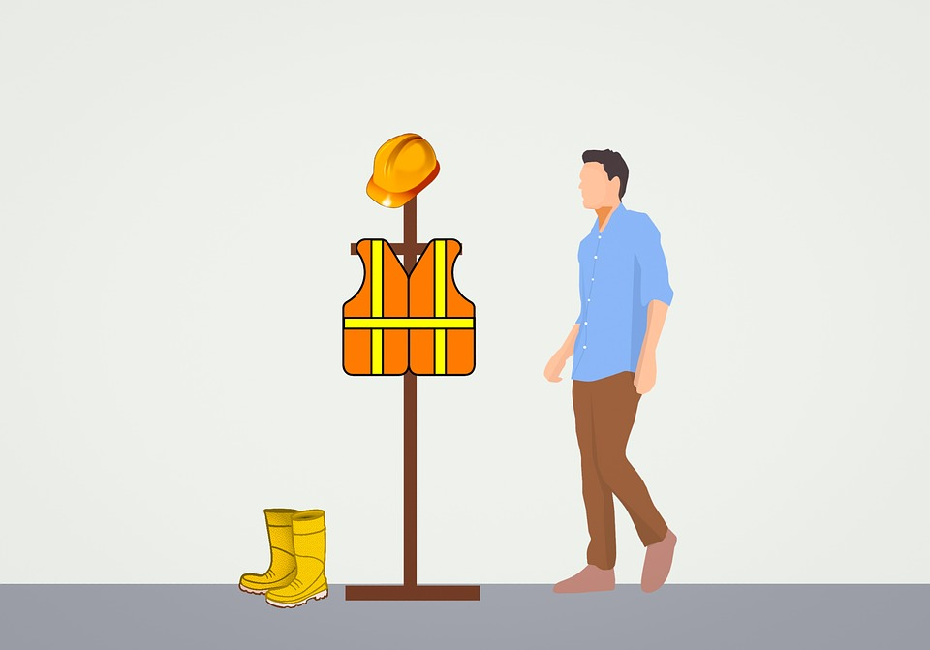

To: Instructor
From: Name Goes Here
Course: Stand-Alone
Date: Thursday, October 31, 2022
Belize City
ITVET Campus

PV System Maintenance and Operations
Fall 2023
Safe Work Procedure Isolate AC Circuit

OBJECTIVES:

- To create a safe work procedure.

- To remove an outlet receptacle from a campus classroom.

- To identify possible safety concerns.

- To identify PPE requirements.

- To use Lockout / tagout.

DISCUSSION:

Every job performed by a worker requires a work plan. The plan defines who does the work, what the scope of the work is, the tools required, the sequence of tasks to be performed, and the safety issues that may be encountered. This lab will allow the learners in groups of two, to create a work plan. The plan will include a safe work procedure.
This lab will have the group of two remove and reinstall an outlet in a campus classroom. The classroom must be empty during this lab activity. Each group is required to find an outlet on a separate circuit. This allows each group to perform a lockout / tagout isolation on a different circuit breaker.
Each group is required to write up the work order for this lab.
The work order is to include who does the work, what the scope of the work is, the tools required, the sequence of tasks to be performed, and the safety issues that may be encountered.
A template is to be used for the lab. The template is to be designed by the class in a classroom session. A template is included at the end of this lab report as a guide.
This lab introduces the concept of documenting a work plan that includes a safe work procedure. The activity of simulating the changing out of a receptacle is much like going to a client’s location and changing out a part of a renewable system.
In this lab the learner is expected to have an idea of the work steps required. “Remove a receptacle from the outlet and then, replace the receptacle with a new one”. This job has many more steps that need to be identified to actually perform this job, than the few simple steps described above.
The work plan starts with a call from the client to the person in charge of receiving work requests. Then the job is documented and assigned to a worker to perform this job at a specified time.
The job is given to a worker or more, in this case two workers.
The workers are then tasked with creating the work plan.
The work plan starts with estimating the number of hours that will be required to complete the job. The time that the workers are to arrive at the client is required to be scheduled around the client’s availability. (As when the classroom is free for the group to work on the outlet.)
This will be placed on the work order documentation. Next is arranging for transportation to and from the client’s location at the time scheduled with the client. A list of tools required to perform the task and their availability for the scheduled work. Securing the equipment that is to be replaced also will need to be sourced before the scheduled time of the job.
So far, the date and time to leave for the work site is established along with an estimate for the duration of the job and with equipment scheduled to be on hand before job day.
Next is for the workers that are performing the task, to communicate any details that they are unsure of with a supervisor or expert. If they are comfortable knowing the job task procedure, then a discussion about safety concerns is had. The discussion will translate into a safe work procedure. The safe work procedure will become a step-by-step task list. Each numbered task will include PPE, tools, and the actual work performed at the step. If isolation of equipment is required for a step, it shall be performed before the work is performed. If lockout / tagout is required, it will be assigned to the step. The required locking device and how many will be secured / acquired before heading to the client. This includes breaker locking devices, locks, tags, or other devices used to prevent the source from becoming a safety hazard.
The steps continue until the task has become completed and the lockout / tagout is surrendered and the client informed that the work plan is completed. This work plan can have many steps but are divided into common groups.

Groups can include:
Arranging transportation
Ordering and tracking of equipment
Grouping of tools and safety equipment
PPE management
Task specific steps

The work plan and safe work procedure require to be documented and often a signature or initial as each step is completed.
For the remaining labs in this course this work plan design will be implemented and documented.

INSTRUMENTS AND COMPONENTS:

Multimeter (ohm and volt)
Paper copy of work plan
PPE
Tools
Lockout / tagout devices

PROCEDURE

- Build a template for a work plan and a safe work procedure for this lab activity. (Instructor approved)

- Locate the circuits for the classroom selected for the lab activity.

- Locate and verify the disconnecting means (breaker) for the circuit that each group will require to be de-energized. (Instructor verified)

- Write up each step required for the work plan. (Instructor approved)

- Schedule time to perform this lab with the campus scheduler.

- During the appropriate scheduled lab time, perform the work plan, execute the safe work procedure. Initial each step as it is completed.

- Remove the receptacle and bring it to the instructor for validation.

- Reinstall receptacle and re-energize. Test receptacle for operation.

- Surrender the lockout / tagout safe work procedure to the instructor.

- Inform campus scheduler that the job is complete, and the classroom can be scheduled for use.

- A complete write up of this lab is required.

Blank Template:

Date
Client
Work title
Scope of work
Schedule
Worker(s)
Transportation
Equipment
Tools
PPE
Safe Work Procedure
Steps

Each one of these can be many lines of instruction or comments.

Add a box for initials across from the task that requires validation that the task was completed.

