Lab #2 General Site Assessment
PV Maintenance & Operations

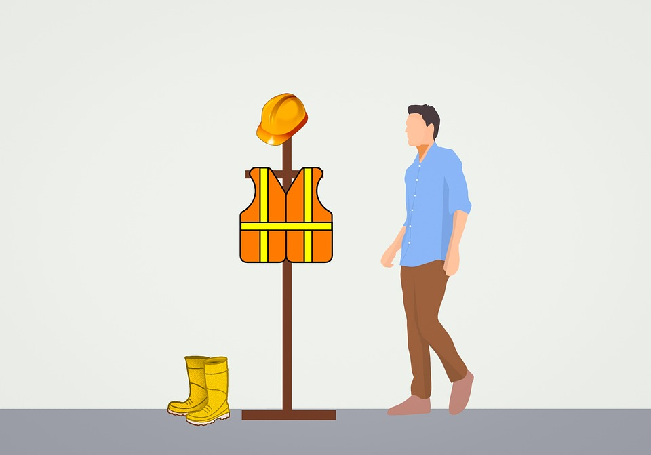

To: Instructor
From: Name Goes Here
Course: Stand-Alone
Date: Thursday, October 31, 2022

Belize City
ITVET Campus

PV System Maintenance and Operations
Fall 2023
General Site Assessment

OBJECTIVES:

- To simulate going to a client’s location.

- To document a general site assessment.

- To observe general safety concerns.

DISCUSSION:

Lab #1 introduced a detailed method for planning a site visit to perform an activity. Including a safe work procedure.

Once the work plan has been developed the crew will head to the site. Upon arrival a “general site assessment” is performed to identify any hazards and an idea of what equipment may be required. The work plan will have a document to record these conditions and findings (General Site Assessment at end of this lab).

Grouped in pairs, find a location on the campus grounds that has the space / area for a PV array to be built. The idea of this is to simulate a general site assessment. If there is another location in walking distance (gas station, or other business) then they become a viable site to assess.
Draw / sketch the location complete with buildings, vegetation, and a PV array.

Each group is required to write up the General Site Assessment form for this lab.

INSTRUMENTS AND COMPONENTS:

Paper copy of the General Site Assessment form.
Compass or Solar Pathfinder.
Camera
PPE

PROCEDURE

- Sketch the site that you selected on paper complete with details required.

- Go to site and perform the general site assessment.

- Fill in each of the spaces on the form.

- Present a list of recommendations that would be required to perform maintenance based on your findings.

- A complete write up of this lab is required. Including the recommendations and finding.

General Site Assessment
Client’s Name
Location |  | Any Town / address
Date |  | 2023-04-19
Crew / Personnel |  | Name
Crew / Personnel |  | Name
Task | Observations |  | Initials
Quick Safety Observations
What are the site hazards
Clutter, garbage, or other material
Machinery
Hot surfaces
Animals
Is working from heights a consideration?
Basic Site Observations
Look for obvious shading.
Is this shading part of the maintenance procedure?
New growth / object or was it always there?
Check the tilt and orientation of the array.
Look as if the tilt or orientation changed?
Roof penetrations watertight?
Check and ensure roof drainage
Are the roof drains clogged?
Check for signs of water pooling in the vicinity of the array
Check for vegetation growth or other shade items that will affect the performance of the array.
Is ground erosion near the base / footings of a ground mount array evident.
Signs of animal / bird infestation under or on the array
Check for debris from under or around the array, can it be removed?
Any other observations?

