LAB #3 Combiner and Junction Boxes
PV Maintenance & Operations

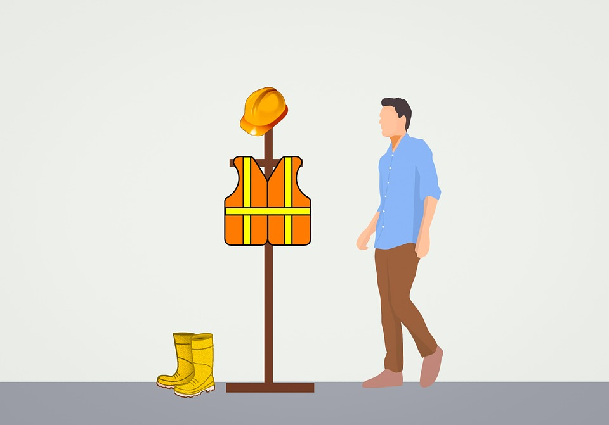

To: Instructor
From: Name Goes Here
Course: Stand-Alone
Date: Thursday, October 31, 2022
Belize City
ITVET Campus

PV System Maintenance and Operations
Fall 2023
Testing Combiner and Junction Boxes

OBJECTIVES:

- To create a safe work procedure.

- To build a combiner box circuit.

- To safely perform maintenance on combiner box circuit.

- To safely perform maintenance on a dc junction box.

DISCUSSION:

Lab #1 introduced a detailed method for preparing a work plan to visit a job site to perform a maintenance activity.
In this Lab #3 the activity is to perform maintenance on a combiner box and a junction box. These maintenance steps are very common activities.
Once the work plan has been developed the crew will head to the site. Upon arrival a “general site assessment” is performed to identify any hazards and an idea of what equipment / tools may be required. The work plan will have a document / form to record these conditions and findings.
After the general site assessment, the next inspection is on the array and the racking.
In this lab, the maintenance is on the combiner and any dc junction boxes which requires this inspection.
Look for signage that details the Voc and Isc. If this signage is found record the information.
You can never assume that the metal parts of the PV system (any part of) has a working bond to ground.
The first check is a visual look at the equipment grounding conductor. Is it intact, any damage?
Some small low voltage systems do not provide an equipment grounding conductor. In this case, as in any time you encounter a PV system, use the voltmeter to check for voltage to ground. Check both dc and ac voltages.
The assumption is that the racking system has an equipment grounding conductor. After measuring 0 volts dc and ac, the continuity test from the PV frame through to the racking, any combiner or junction boxes, and back to the disconnection means and finally back to the common grounding point. If a high resistance connection is found, it will need to be repaired.

If there is a voltage present, and especially above 30 volts, the system needs to be isolated to find what the source of this voltage is.
Depending on how the system is configured, each source needs to be isolated and tested for voltage to ground. It is not unusual to measure dc voltage at the frame of a PV panel. There can be leakage current from a cell(s) to the frame. The fix is to ground the frame and racking to ground. If there is no ground electrode on site, one can be installed. This is called a self derived grounding system.

Once the array is deemed safe to work on by having the metal components bonded to ground or at less than 30 volts for ungrounded systems.
All sources of voltage must be removed from the combiner or junction box. This may require a lockout / tagout permit. After these sources have been removed it is safe to perform the maintenance.
Now the combiner or junction box can be opened.
Be prepared for finding moisture, rodents, insects, or vegetation.
Clean any of these from the box. If there is moisture find the source or opening and apply silicon caulk or equivalent to seal.
The maintenance is to ensure that the wiring is free of nicks, chew marks or deformation of the insulation. Look for areas where the wire may be against sharp surfaces and free them from this.
Check the strain relief connectors that they are tight but not too tight to deform the insulation.
Any connectors that are used need to be checked for tightness and corrosion. Replace if necessary.
If there is overcurrent protection it needs to be checked. Breakers need to be operated and verify the resistance of the connection in both the open and closed state. Fuses need to be removed and checked. The terminals of the fuse holder(s) need to be checked for resistance. After these steps have been performed then the sealing gasket needs to be checked and replaced if necessary.

INSTRUMENTS AND COMPONENTS:

Multimeter (ohm and volt)
Paper copy of work plan
PPE
Tools
Lockout / tagout devices

PROCEDURE

- Build a template for a work plan and a safe work procedure for this lab activity. (Instructor approved)

- Using the trainers in the lab, perform the steps in the discussion part of this lab. Assume the trainer is out at a client’s location.

- Perform a lockout / tagout procedure. (Instructor approved procedure)

- Document each step of the maintenance performed. (See form at bottom of lab)

- Surrender the lockout / tagout to instructor.

- A complete write up of this lab is required.

General Site Assessment
Client’s Name
Location |  | Any Town / address
Date |  | 2023-04-19
Crew / Personnel |  | Name
Crew / Personnel |  | Name
Task | Observations |  | Initials
Quick Safety Observations
What are the site hazards
Clutter, garbage, or other material
Machinery
Hot surfaces
Animals
Is working from heights a consideration?
Basic Site Observations
Look for obvious shading.
Is this shading part of the maintenance procedure?
New growth / object or was it always there?
Check the tilt and orientation of the array.
Look as if the tilt or orientation changed?
Roof penetrations watertight?
Check and ensure roof drainage
Are the roof drains clogged?
Check for signs of water pooling in the vicinity of the array
Check for vegetation growth or other shade items that will affect the performance of the array.
Is ground erosion near the base / footings of a ground mount array evident.
Signs of animal / bird infestation under or on the array
Check for debris from under or around the array, can it be removed?
Any other observations?

Combiner / Junction Box Maintenance
Client’s Name
Location |  | Any Town / address
Date |  | 2023-04-19
Crew / Personnel |  | Name
Crew / Personnel |  | Name
Task | Observations |  | Initials
Signage that details the Voc and Isc
Visual look at the equipment grounding conductor. Is it intact, any damage?
Voltmeter to check for voltage to ground. Check both dc and ac voltages.
If voltage is present continue to perform isolation steps below.
If ok, perform continuity checks
Each PV Panel to rack resistance.
If any high resistance and identify which ones.
Corrective actions.
Rack resistance to the equipment grounding conductor.
If any high resistance and identify which ones.
Corrective actions.
Resistance checks back to common grounding point. Include any junctions / connections
If any high resistance and identify which ones.
Corrective actions.
If voltage was measured, isolate sources.
Isolate PV panels until the faulty one is found.
If another source is providing the voltage to ground, isolate it and continue with maintenance.
Is a lockout / tagout permit required?
If “Yes”, perform and sign.
Open Combiner or Junction box cover.
Any moisture, rodents, insects, or vegetation
If yes clean
If moisture find the source or opening and apply silicon caulk or equivalent to seal
Conductor insulation check
Check wiring is free of nicks, chew marks or deformation of the insulation.
Observations and actions.
Terminal / Connector checks
Strain relief / box connector check.
Overcurrent Protection checks
Terminal tightness
Operation resistance open / close
Fuse condition
Cover gasket condition.
Surrender lockout / tagout.

