Flooded Lead Acid Monthly Maintenance
Battery Based PV Installations

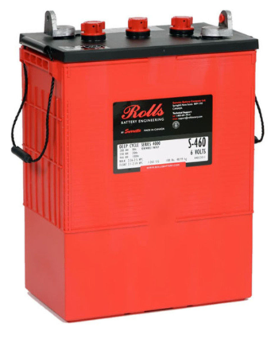

To: Instructor
From: Name Goes Here
Course: Stand-Alone
Date: Thursday, October 31, 2022

Belize City
ITVET Campus

Battery Based PV Installations
Fall 2023
Flooded Lead Acid Monthly Maintenance

OBJECTIVES:

- To perform basic monthly maintenance for a flooded lead acid battery

- To measure parameters of a flooded lead acid battery.

- To determine the SoC of the battery.

- To record measured readings.

- To write a report / log of the battery.

DISCUSSION:

Maintaining a flooded lead acid battery is a full-time job for the renewable industry. It takes a trained person to maintain these types of batteries. Understanding the safety requirements is the first step to performing maintenance. The battery manufacturer provides a safety data sheet (SDS). This sheet needs to be read and understood before proceeding to working near batteries.
The area that the batteries are located needs to be well ventilated.
Debris and garbage need to be removed as well as any tripping hazards. The batteries need to be on a rack above the floor for easy access.
The battery should not be charging (float charge is ok) when doing any maintenance due to hydrogen off gassing.
The battery needs to be cleaned of any contamination or dirt with a damp cloth to start.
There needs to be a logbook that has the history of maintenance performed on the batteries. The date and time need to be entered into the logbook. The cell voltage, temperature and hydrometer readings are also recorded.
When doing maintenance, the torque of the terminal connections is checked. With no load on the battery, the terminal connection is loosened and retorqued.

If maintenance has been performed in the past, the logbook is checked to see if any cells have a lower specific gravity or voltage.
If so, pay particular attention to these cells for trending values.
If the specific gravity or cell voltage is significantly low the decision to perform an equalize charge is made. The cell with the lowest specific gravity and or voltage is selected as the test cell for monthly maintenance. All cells are checked for voltage. For this lab, all cells are checked for specific gravity.

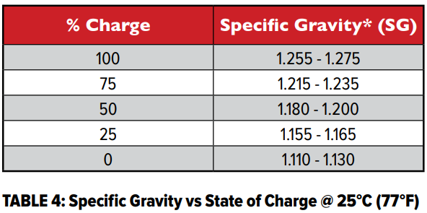

INSTRUMENTS AND COMPONENTS:

Safety Data Sheet and Installation Manual.
PPE: Apron, face shield, gloves.
12 volt Flooded Battery
Hydrometer and holder.
Distilled, de-mineralized water.
Voltmeter
Log sheet / book
Baking Soda

PROCEDURE

- Read Safety Data Sheet for the flooded lead acid battery.

- Locate the logbook for the battery the maintenance will be performed on. Determine what cells have been performing well and the ones that are not performing well.

- Wear the PPE as per instructor instructions.

The list of maintenance items is listed below:

MONTHLY:

- Measure and record resting/loaded voltage.

- Check electrolyte levels and top up with distilled water as necessary.

- Test and record specific gravity measurements in Float charge.

- Record ambient temperature where the batteries are installed.

- Inspect to ensure temperature sensor is securely attached.

- Inspect cell integrity for corrosion at terminal, connection, racks, or cabinets.

- Check battery monitoring equipment to verify operation.

- Update logbook and include and comments before initialing.

