Flooded Lead Acid Quarterly Maintenance
Battery Based PV Installations

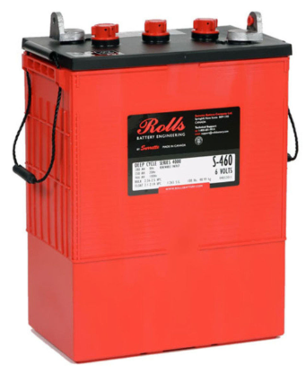

To: Instructor
From: Name Goes Here
Course: Stand-Alone
Date: Thursday, October 31, 2022
Belize City
ITVET Campus

Battery Based PV Installations
Fall 2023
Flooded Lead Acid Quarterly Maintenance

OBJECTIVES:

- To perform the quarterly maintenance checks for a flooded lead acid battery.

- To observe battery room / area for functionality.

- To record measured readings.

- To write a report / log of the battery.

DISCUSSION:

Maintaining a flooded lead acid battery is a full-time job for the renewable industry. It takes a trained person to maintain these types of batteries. Understanding the safety requirements is the first step to performing maintenance. The battery manufacturer provides a safety data sheet (SDS). This sheet needs to be read and understood before proceeding to touch the battery.
The quarterly maintenance is focused on the area surrounding the batteries such as ventilation, close look at connections for corrosion and resistance including grounds. Monthly checks are quick for look but quarterly is a more detailed visual inspection. Cap are checked for build up of dried electrolyte and cleaned if necessary. The assumption that people have been in the vicinity of the batteries and may have been in contact with them or after 3 months the ventilation has stopped working. Taking the time to look for garbage, or other objects that may have been placed in the battery area.

The list of maintenance items is listed below:

QUARTERLY:
• Test Ventilation
• Check terminals/connections, remove corrosion and properly re-torque
• Check for high resistive connections
• Check cabling for broken or frayed cables
• Verify Charge Output, Bulk/Absorption voltage of Inverter/Charge Controller
• Check cells for cracks or indication of a possible leak
• Check Ground connections

The battery needs to be cleaned of any contamination or dirt with a damp cloth to start.
The date and time need to be entered into the logbook.
A quarterly sheet with the items to be checked is used and findings are recorded.

INSTRUMENTS AND COMPONENTS:

Safety Data Sheet and Installation Manual.
PPE: Apron, face shield, gloves.
12 volt Flooded Battery
Hydrometer and holder.
Distilled, de-mineralized water.
Voltmeter / ohmmeter / multimeter
Log sheet / book
Baking Soda

PROCEDURE

- Read Safety Data Sheet for the flooded lead acid battery.

- Locate the logbook for the battery the maintenance will be performed on. Check for entries from last quarterly report and determine if recommendations have been completed.

- Wear the PPE as per instructor instructions.

- QUARTERLY:

- • Test Ventilation
- • Check terminals/connections, remove corrosion and properly re-torque
- • Check for high resistive connections
- • Check cabling for broken or frayed cables
- • Verify Charge Output, Bulk/Absorption voltage of Inverter/Charge Controller
- • Check cells for cracks or indication of a possible leak
- • Check Ground connections

- Complete the maintenance by filling out the report indicating any anomalies or deficiencies noted. Also, any corrective action performed or recommended to be completed.

CLEANING VENT CAPS:
You might notice a sticky dark gray residue on the inside of the standard 1/4-turn bayonet, R-Caps or Watermiser vent caps on Flooded battery cells.
This buildup of dirt and dried electrolyte is fairly common and may clog the vent holes, preventing the release of hydrogen off-gas during charge.
Inspect the caps and clean using a neutralizing baking soda and water solution as necessary.

CLEANING STEPS:
1. Clean the caps by soaking in a solution of water and baking soda (100g per litre) in a bucket or small bowl. Let the vents sit overnight to neutralize and break down any electrolyte in the caps.
2. Flush the caps clean by forcing water through the vent holes. Water should drip freely. A trickle of water should flow from all vent holes, indicating the cap is clear of debris.
3. Allow the vents to dry completely. Once dried, shake recombination caps to make sure the condensing beads on the inside of the cap rattle slightly. If you do not hear the beads, let the cap dry for an additional 12 hours or repeat the process above.

