LAB #4 Maintenance Trouble Shooting
PV Maintenance & Operations

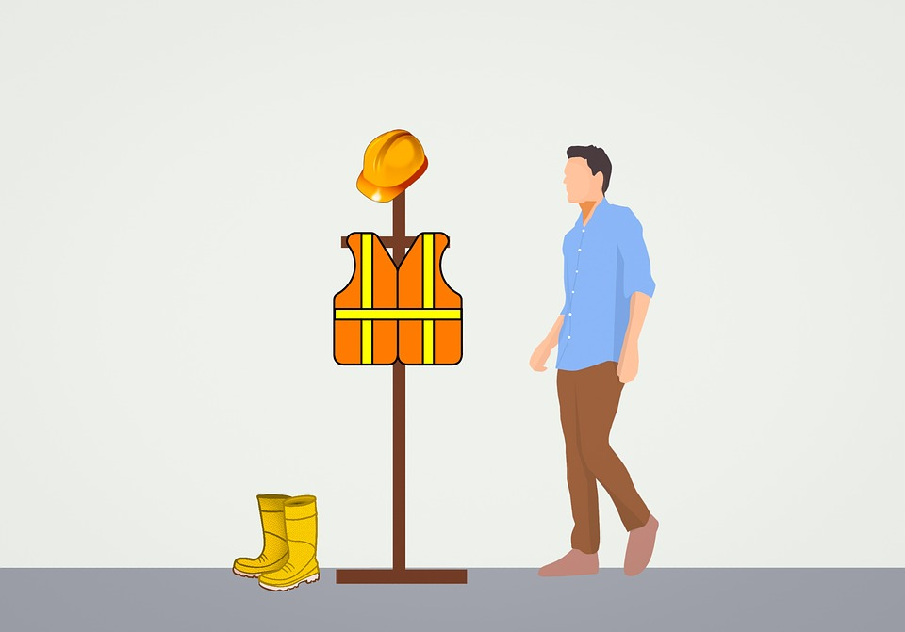

To: Instructor
From: Name Goes Here
Course: Maintenance
Date: Thursday, October 31, 2022
Belize City
ITVET Campus

PV System Maintenance and Operations
Fall 2023
Maintenance Trouble Shooting

OBJECTIVES:

- To simulate arriving at client’s location to do maintenance.

- To conduct maintenance and document.

- To provide documentation to client.

- To adjust / repair any issues found.

DISCUSSION:

This lab is to simulate arriving at a client’s location and perform maintenance and providing the client with your documentation from the maintenance visit.
Upon arrival a “general site assessment” is performed to identify any hazards and an idea of what equipment / tools may be required. The work plan will have a document / form to record these conditions and findings.
Conduct the complete maintenance assessment.

INSTRUMENTS AND COMPONENTS:

Multimeter (ohm and volt)
Paper copy of work plan
PPE
Tools
Lockout / tagout devices

PROCEDURE

- Create all documentation as if you are performing maintenance at a client’s location. (Instructor approved)

- Perform a lockout / tagout procedure if required. (Instructor approved procedure)

- Document each step of the maintenance performed. Use documents from previous labs.

- Surrender the lockout / tagout to instructor if one was required.

- A complete write up of this lab is required.

