LAB DOD Calculation
Stand-Alone

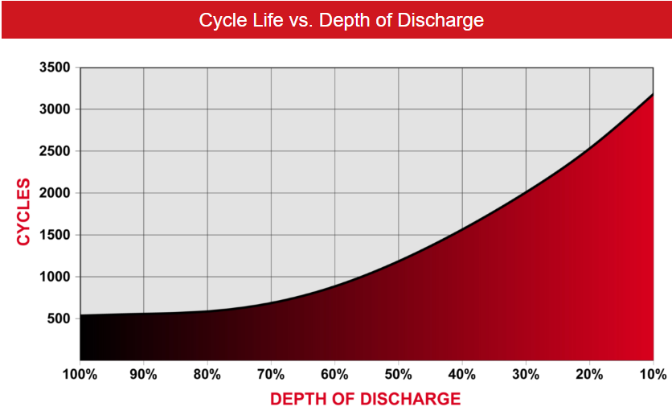

To: Instructor
From: Name Goes Here
Course: Stand-Alone
Date: Thursday, October 31, 2022
Belize City
ITVET Campus

Stand-Alone
Fall 2023
DOD Calculation

OBJECTIVES:

- To measure the Depth of Discharge (DoD) and State of Charge (SoC) of the solar trainer batteries.

- To control the discharge rate and calculate the time the battery will discharge.

- To measure the performance of the solar trainer battery against factory specifications.

- Make a written procedure for testing the state of charge (SoC).

DISCUSSION:

The battery on the solar trainer can be at any SoC. The objective is to measure the SoC and then to discharge the battery at a controlled rate. The rate of discharge is measured and compared to the discharge rate given by the manufacturer. The load needs to be calculated at one of the rates given (C-20 is best). To help with finding this load the battery will be connected to the 600Watt inverter and an AC load is connected to the inverter. The DC ammeter and voltmeter will be used to measure the draw on the battery.
Start the discharge when the battery at rest is at 12.65V (100% SoC) or less. Collect readings every minute to ensure the rate of discharge is predictable.

INSTRUMENTS AND COMPONENTS:

FULLRIVER DC105 AGM manual.
FULLRIVER DC105Ah AGM 12volt battery.
Solar Trainer
Clip on DC ammeter
Voltage meter
600 Watt inverter
Resistive load 60 Watt incandescent light bulb.

PROCEDURE

- Measure the battery voltage and establish the SoC.

- Read the manual to get the required information to calculate the load at a specified C-rate (C-20 is best).

- Connect the inverter (600Watt) to the battery and measure SoC.
- Apply the load to the inverter. 5.3A is C-20 rate, 12.6 x 5.3 = 67Watts. Therefore a 60 Watt incandescent light bulb should work as the AC load.
- Measure the current and voltage at the battery.
- Record readings every minute.
- After a few minutes calculate what the battery voltage will be in an hour.
- Every ten minutes calculate the rate of discharge and compare to your original estimation of SoC.
- After an hour remove the load and inverter from the battery.
- Wait a further 15 minutes and measure the SoC.
- Write a procedure that will allow someone to measure the SoC of a battery.

