LAB FXR Inverter
Stand-Alone

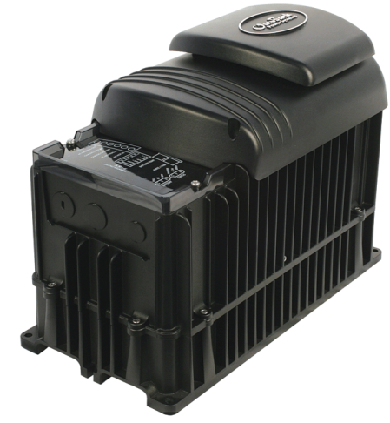

To: Instructor
From: Name Goes Here
Course: Stand-Alone
Date: Thursday, October 31, 2022
Belize City
ITVET Campus

Stand-Alone
Fall 2023
FXR Inverter

OBJECTIVES:

- To Program the FXR inverter for a 48V battery for a stand-alone set-up.

- To assemble the inverter and battery system.

- To apply AC loads to the FXR inverter.

- To measure the battery voltage and current when connected to the AC loads.

DISCUSSION:

The FXR inverter is a top-quality inverter capable of operating in many modes. This lab will use the “Generator” mode to make it a stand-alone producer of AC power. The inverter will need to have batteries connected before it can be programmed to go into “Generator” mode. This lab is designed to provide a stand-alone application. The lab is broken into three main parts. The first part is to assemble the system with the 4 batteries from the trainers being connected in series to provide the 48Vdc required by the inverter. The second part is to program / set the parameters of the inverter. The third part is to apply a resistive AC load and monitor the AC output and battery input voltage and current. After the resistive load is removed, apply a motor driven load. This load will be inductive. The reactive component will come from the inverter and not the batteries. This will be measured and calculated.

INSTRUMENTS AND COMPONENTS:

Q.PEAK 395 Data Sheet and Installation Manual.
4 Q.PEAK 395 Watt Panels.
FULLRIVER DC105 AGM manual.
FULLRIVER DC105Ah AGM 12volt battery.
Solar Trainer
Resistive load
Inductive load
Clip on DC ammeter
Voltage meter
Handheld pyranometer

PROCEDURE

- Read the FXR inverter manual and have it handy when performing this lab. Break into four groups.

- Along with the instructor, verify the FXR inverter is mounted to a wall or similar structure as per installation manual. Ensure the inverter is connected to the campus ground. Connect the ON – OFF toggle switch, move the jumper as per manual and put it on just one pin so the inverter requires the toggle switch to operate. Do not connect a fan to the inverter. The AC HOT OUT, AC NEUTRAL OUT, CHASSIS GROUND/PE need to be wired out to a receptacle. Preferably through an overcurrent protection device (breaker) which also serves as a disconnection means. This activity needs to be under the supervision of the instructor.

- Ensure the four batteries are connected in series and using the proper torque specs. Connect the negative of the 48V battery bank to the inverter as per manual. Run the DC ground to the same ground as the AC ground. Connect the positive to a breaker and it will also serve as a disconnection means. Run positive and negative cables through the same knockouts and conduit. This activity needs to be under the supervision of the instructor.

- To start a single-inverter system:

- Close the main DC circuit breakers from the battery bank to the inverter. Confirm that the system display is operational if present. (MATE 3)
- If a system display is present, perform all programming for all functions. These functions may include AC input modes, AC output voltage, input current limits, battery charging, generator starting, and others.

- Prepare to use the Mate3s to set up the home screen.

- The FXR Operating Manual will be accessed before the inverter is turned so the proper parameters can be programmed into the inverter.

- The inverter will not have any AC input sources for this lab.

- The inverter will not use the battery charging function for this lab.

- The inverter will not be stacked or connected to any other inverters for this lab.

- The inverter will not have GRID Support for this lab.

- Familiarize yourself with the Troubleshooting section. The warning and error messages are explained in this section.

- Table 25 FXR Menu Items for 48-Volt Models, this table has the menu items that can be programmed.

- As a group the students will draw up a table with the parameter values they wish to use.

- Prepare to use the Mate3s to complete the parameter settings.

- Turn on the inverter using the system display (or external switch, if installed). The inverter’s default condition is Off. Do not turn on any AC circuit breakers at this time.

- Measure the current and voltage at the battery.
- Record the indicator lights throughout the process and indicate if and when they change status.

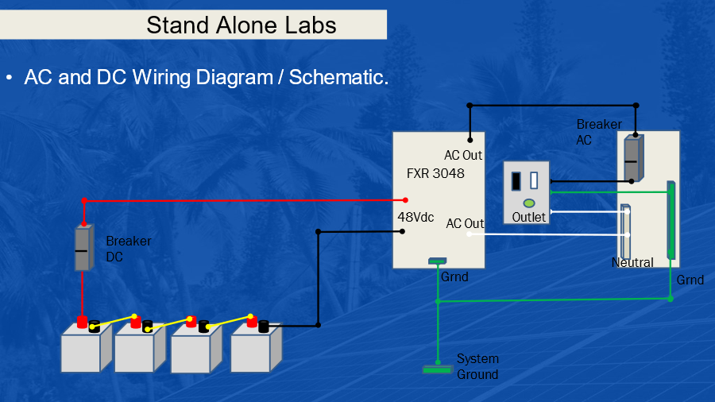

AC Wiring Diagram for FXR Inverter
