LAB Inverter + Charge Controller
Stand-Alone

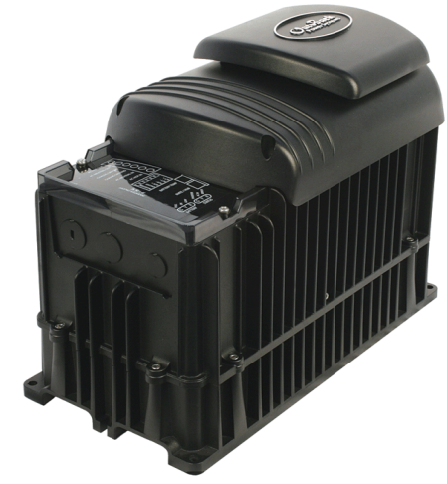

To: Instructor
From: Name Goes Here
Course: Stand-Alone
Date: Thursday, October 31, 2022
Belize City
ITVET Campus

Stand-Alone
Fall 2023
Inverter + Charge Controller

OBJECTIVES:

- To Program the FLEXmax charge controller for a 48V battery bank and PV input for a stand-alone set-up.

- To connect the charge controller to the battery bank and PV array.

- To commission the charge controller.

- To write a procedure for commissioning this system.

DISCUSSION:

The FLEXmax charge controller is made by OutBack and is meant to work with the FXR inverter. The set up from the previous lab is going to be used for this lab. The addition of the charge controller is basically putting it into parallel with the battery bank. Just like the inverter the charge controller needs to be programmed. It is easy to do from the screen but the Mate3 can also be connected to do it as well. This lab puts together a complete stand-alone PV system. The commissioning of the system is to break the system into systems and verify that they are performing as expected. The heart of the system is the battery bank. The charge controller manages the energy from the PV array and keeps the batteries charged. This charge controller does not have a low voltage disconnect, but it does have an auxiliary relay to use. By using the handheld pyranometer the available PV current can be calculated. Depending on the stage the charge controller is in and the SoC of the batteries the current from the array may not be used. This lab will have you measure the current flow and calculate the SoC at different situations. There will be a load added to the inverter to allow for a C-20 rate discharge. At this AC load, the battery performance can be measured. The PV array current can be measured while this AC load is on the inverter. The charge controller can allow this PV current to go to the battery / inverter as it try’s to keep the battery bank at the stage. The load can rob the batteries from getting the correct amount of charge in the Bulk stage.

INSTRUMENTS AND COMPONENTS:

Q.PEAK 395 Data Sheet and Installation Manual.
4 Q.PEAK 395 Watt Panels.
FULLRIVER DC105 AGM manual.
FULLRIVER DC105Ah AGM 12volt battery.
FLEXmax manual
FLEXmax Charge Controller
FXR Inverter manual
FXR Inverter (3048)
Solar Trainer
Resistive load
Clip on DC ammeter
Voltage meter
Handheld pyranometer

PROCEDURE

- Read the FLEXmax installation and operation manuals and have it handy when performing this lab.

- Along with the instructor, verify that the PV array is wired for 2 strings of 2 panels in series and combined in the combiner box.

- Ensure the four batteries are connected in series and using the proper torque specs. Connect the negative of the 48V battery bank to the inverter as per manual. Run the DC ground to the same ground as the AC ground. Connect the positive to a breaker and it will also serve as a disconnection means. Run positive and negative cables through the same knockouts and conduit. This activity needs to be under the supervision of the instructor. Same as last lab.

- Mount the charge controller next to the inverter. Connect the charge controller to the batteries using a breaker. Have instructor check the connections.

- Bring the wire in from the solar trainers that have the PV array (include the ground wire). Attach them to the charge controller, but do not power them up until after the charge controller has been programmed and the charge controller is powered up by the batteries.

- The charge controller needs to be powered from the batteries, turn on that breaker only, do not power up the inverter yet.

- Use the on-board screen or the Mate3 to program the parameters into the charge controller that you have from class.

- Once the FLEXmax is programmed, take the SoC of the battery bank.

- Turn on the PV breaker feeding the charge controller. The FLEXmax will start looking for the MPPT range. Then it will start to charge the batteries.

- Take recordings of the PV and battery. Use the clamp-on ammeter and voltmeter to verify the readings.

- What stage is the charge controller in? How can you tell?

- When the charge controller’s reading make sense and there the recorded reading are predictable, remove the Mate3 and place it on the inverter.

- Turn on the inverter without any AC loads on it.

- At the battery is the sum of the currents of the charge controller and the inverter (loads and inverter). There are three places to measure these three different currents.

  - At the battery terminal
  - At the inverter input
  - At the charge controller output.
- Measure the current and voltage at these places.
- Describe these amperages, is the battery charging?
- The inverter should be drawing 34Watts from the charge controller and / or battery. (~0.7A to power up the inverter)
- Connect 200Watts of incandescent bulbs or equivalent to the inverter. This will draw another 4 Amps from the battery, almost the C-20 rate for discharge.
- Keep this load on and record the three amperages again. How much of the PV current is going to the battery now? Explain the numbers now? Is there enough PV current to charge the batteries?
- Record the indicator lights throughout the process and indicate if and when they change status.
- Write a procedure that you would use when commissioning a system like this.

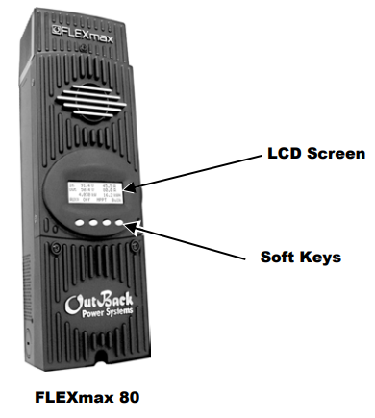

Complete Wiring Diagram for FLEXmax, FXR Inverter and PV array.
Note that the PV array in this diagram is wired in series, the lab requires two strings of two modules in parallel wired to combiner box.

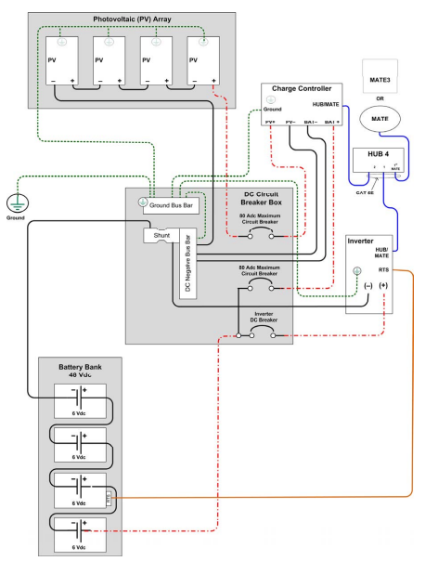

A complete schematic for the lab showing the equipment.
