

**Training Delivery and Assessment Plan (TDAP)**

**Course #42 Energy Efficiency Monitoring and Verification**

**ITVET Belize City**

**1.0 COURSE ADMINISTRATION:**

**Qualification CODE: XXXXXX**

**Qualification TITLE:** **Energy Efficiency Monitoring and Verification**

**PROGRAMS: Renewable Energy and Energy Efficiency Program (REP)**

**TRAINING CYCLE:**

**Class Meeting Times: Tuesday and Thursday mornings**

**Class Venue:**

**Program Instructor:**

**Consultation hours: By Class schedule**

**Telephone: ITVET Belize**: **(501) 203-4027**

**Personal cell: (501) 000-0000**

**E-Mail Address:** [**xxxxxxx@zzzzz.com**](mailto:xxxxxxx@zzzzz.com)

**Class Hours / Term: 48**

**Weeks / Term: 12**

**Classroom:**

**New Lab:**

**Course Description**

This course will introduce the learner to the tools and processes required to assess buildings and systems and recommend upgrades for energy efficiency optimization utilizing industry standards for monitoring and verification of projects. Students will learn how to identify and collect relevant energy consumption data using equipment such as the Solar Pathfinder, thermal, power and energy meters. Remote data collection systems and capacity are identified for monitoring energy consumption in residential, small commercial and large industrial buildings. The energy consumption data collected will be assessed using Excel linear regression and cumulative sum (CUSUM) calculations in relation to climate data and efficiency upgrades to determine baseline model comparisons and the financial feasibility of the recommended upgrades. Students will model a baseline of an energy efficiency project with data collected to determine financial payback forecasts of related efficiency upgrades with an international industry standard software such as RETScreen Expert as part of the final group assignment.

**Rationale**

Assessing buildings and systems for an energy consumption baseline and recommended energy efficiency upgrades, provide skills that will prepare learners for work in the energy efficiency sector of industry and climate change mitigation through the reduction of energy use and related emissions.

**Assessment**

Tests – 20%

Individual Project – 30%

Group Projects -40%

Employability Skills - 10%

**Course Tasks:**

* (Task 1) Understand how to capture and interpret critical data using industry standard tools.
* (Task 2) Identify common types of data collectors and software used in industrial, commercial and residential applications in Belize and North America.
* (Task 3) Understand methods for remote monitoring of energy systems.
* (Task 4) Identify baseline energy use in buildings.
* (Task 5) Employ industry-accepted Measurement and Verification (M&V) Protocol to evaluate the performance of an Energy Conservation Measure (ECM) and Energy Management System (EMS)

**2.0 PROFILE OF THE TRAINEE:**

1. Responsible
2. Dependable
3. Punctual
4. Proficient
5. Analytical
6. Enterprising
7. Self-confident
8. Team player
9. Technologically Oriented
10. Resourceful

**3.0 PROGRAM POLICIES AND REGULATIONS:** Trainees are expected to (by the date specified):

1. Complete and submit all assessments, assignments, reports and tests on time.
2. Abide by the rules and regulations as stated in the trainee handbook, workshop rules, and online class.
3. Practice professional and ethical behavior at all times.
4. Exercise competency in all practical evaluations, examinations, tests and or quizzes.
5. Be on time for each class. If you will be late for class, please inform the instructor via e-mail, telephone, or text message.
6. Attend all scheduled class periods and online sessions in the Google Classroom assigned.
7. Show personal interest and exhibit class participation.
8. Complete all Reading Assignments prior to class/lab sessions.
9. In order to prevent plagiarism, all references used while conducting research must be cited. The American Psychological Association (APA) guidelines are the recommended format. This will be provided as a separate document and there are a number of websites that provide information on the APA format, such as [Purdue Owl](https://owl.purdue.edu/).

**4.0 TECHNOLOGY REQUIREMENTS**:

Each trainee is required to have access to a laptop or desktop, CD or flash drive, MSWord, Excel, and PowerPoint software, a free version of RETScreen Expert, internet access and an up-to-date email address (Gmail account).

**5.0 PORTFOLIO OF THE TRAINEE:**

At the end of each unit, each trainee must produce a portfolio containing copies of tests, projects, employability skills evidence, reflection on their learning per unit and /or cluster, and practical assessments. In addition, for trainees to be promoted to the next level, he/she must have a **completed portfolio**. An outline of the portfolio will be provided by your instructor.

**6.0 MODES OF INSTRUCTION:**

In this program, we will utilize both face-to-face and online learning (blended learning) in Google Classroom using the following methodologies: Lecture (traditional and PowerPoint methods), small and large group discussion; individual and group presentations, slide shows, video presentations, interactive presentations, blogs, tutorial, a community of inquiry (COI), expert teaching, and guided practice. Furthermore, you will be expected to use email and WhatsApp to respond to the course instructor and peers about assigned topics.

**7.0 INSTRUCTIONAL METHODS:**

**Face to Face Contact:**

**1.**

1. Lecture,
2. Videos
3. Practical demonstration
4. Discussion
5. Guided practice
6. Independent practice
7. Cooperative learning activities
8. Textbook and computer-based information

**2. Online Contact:**

1. Google Classroom Platform
2. Zoom
3. Microsoft Office
4. Tutorials
5. PowerPoint with voice lessons
6. Videos on concepts
7. Online quizzes and tests
8. Discussion
9. Cooperative Learning Activities

**8.0 RESOURCES:**

1. Specification sheets, industry standard software for modeling building and system loads such as RETScreen Expert (free version), Handouts, and PowerPoint Slide Lectures.
2. RETScreen E-Learning video tutorials embedded in the RETScreen Expert software link to YouTube.

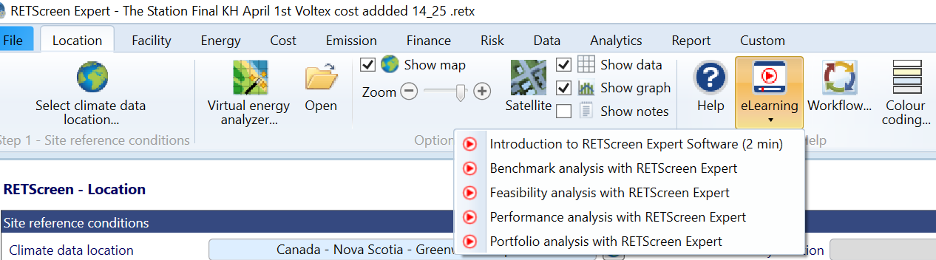

1. Example practice files using the case study exercises in RETScreen Expert.

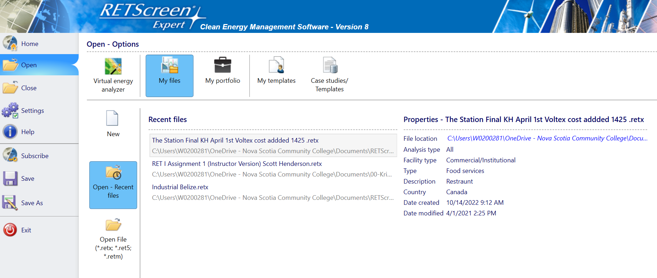

**Underpinning knowledge and Skills**

**Knowledge of:**

• Tools used to collect data in an energy assessment of a building or system

• Monitoring systems appropriate for building or system size and function

• Power, energy and the difference

• Relevant data required to model a baseline building

• Data analysis to determine a baseline and appropriate efficiency upgrades

• Efficiency ratings for mechanical systems, where to find them

• Nameplate information, and how to calculate energy consumption from the nameplate

• Schedules for building or system use (used to calculate energy from nameplate information)

• RETScreen Expert software use for modeling a building and analyzing base model and recommended upgrade results

• Technical report writing and presentation of findings, including baseline consumption and recommended upgrades, resulting

efficiency impact and related cost savings

**Skills**

The ability to:

• Assess a building or system’s energy consumption using tools and software to create a baseline.

• Recommend efficiency upgrades for building components or systems.

• Provide recommendations based on energy efficiency, cost savings and payback of capital costs over time.

• Create a report and communicate findings to the building owner, facility manager, system owner, and operations and

maintenance staff.

* 1. **DELIVERY SCHEDULE**

| **Date** | **Element of Competency** | **Description** | **Instructional strategies** | **Readings, Assignments and Due Dates** | **Resources** |
| --- | --- | --- | --- | --- | --- |
| **Week 1**  **Tuesday**  **08:10-10:10**  **Thursday**  **08:10-10:10** | Module 1:  Introduction to Data Collection   * Course deliverables overview * Mark distribution overview * Task 1 | -Introduction/ Orientation  -Housekeeping (rules & expectations)  -Course Outline review  -Using Google meet and classroom  -Begin Slide Lecture  C-42 Feb. 10, 2023, Slide Lecture C-60 | -Discussion  - PowerPoint Lecture  - Videos  - Exercise 1  Class discussion, identify sources of emissions and sequestration systems.  Review example calculations in Exercise 1 and use the template for energy data collection in the classroom. | **Create a list of “New Terms that I understand”.**  **Identify at least two sources of emissions and two sources of carbon sequestration in your daily lives. Write them down in your field notebook and bring them to the next class for discussion.**  **Exercise 1** Excel Template Example for homework, calculate your classroom energy use in kWh from P=IV, P(W)* t /1000=kWh  **Due week 3** | -Course outline  -PowerPoint presentations  - Handouts  - Computer  -Excel template for personal energy use collection  Use a classroom that includes computers, lighting, fans, etc. |
| **Week 2** | Assessing Loads  **Task 1** | C-42 Feb. 10, 2023, Slide Lecture C-60 Wrap Up  Group Work: Calculate energy use of lighting using GE spec sheets on lighting and controls. Using the classroom schedule to calculate usage with various light models. | Discuss energy use and emissions observations.  What fuel stock is used to generate electricity used at the College?  How efficient is the generation? (compare solar to biomass/fossil fuels) | Determine location of electrical generation station and fuel used (solar, coal, crude oil, natural gas, etc.) to generate electricity in Belize City. | GE Technical specification sheets on lighting and controls |
| **Week 3** | Data Collection  **Task 1** | Review energy use exercise and discuss methods to reduce energy consumption. Step 1, reduce use, Step 2, use more efficient appliances, Step 3, use renewable electricity generation! | Discuss how to:  -Reduce consumption  -Improve Efficiency  -Reduce environmental impact (clean generation) | Add steps to reduce consumption to Exercise 1.  Test 1 In Google Drive:  C42>Resources>Tests>  **Test 1** |  |
| **Week 4** |  |  |  |  |  |
| **Week 5** |  |  |  |  |  |
| **Week 6** |  |  |  |  |  |
| **Week 7** |  |  |  |  |  |
| **Week 8** |  |  |  |  |  |
| **Week 9** |  |  |  |  |  |
| **Week 10** |  |  |  |  |  |
| **Week 11** |  |  |  |  |  |
| **Week 12** |  |  |  |  |  |

* 1. **PRACTICAL GRADING CRITERIA**

|  |  |
| --- | --- |
| RATING | DESCRIPTOR |
| **5**  **Competent**  Can perform the task with initiative and adaptability to the problem situation. | Mastery of technical skills; can perform the task demonstrating mastery, autonomy, responsibility and control in a wide range of working conditions. Trainee applies and extends the key concepts, processes and skills. Works independently and can support the learning of others. |
| **4**  **Competent**  Can perform the task proficiently without assistance and/or supervision. | Proficient in technical skills; can perform tasks in a wide range of working conditions, demonstrating good working knowledge and application of the key concepts, processes, skill, initiative, and adaptability to problem situations. Ability to work independently. |
| **3**  **Competent**  Can perform the task satisfactorily but requires periodic assistance and/or supervision. | Satisfactory technical skills: can perform the task demonstrating sufficient knowledge of the key concepts, processes, skills, and an ability to operate satisfactorily displaying some initiative and adaptability to problem situations. Works with some support. |
| **2**  **Not Yet Competent**  Can perform some parts of the task but requires considerable assistance. | Insufficient technical skills: can perform limited parts of the task but not to required standards. Trainee is well below the course level expectations and performance is inconsistent even with support. |
| **1**  **Not Yet Competent**  Cannot perform the task but has some knowledge of the task. | Inadequate evidence of attainment of competence, processes, and skill on which a judgment can be made. |

**11.0 THEORY GRADING CRITERIA**

|  |  |
| --- | --- |
| RATING | DESCRIPTOR |
| **90-100 Excellent**  Can insightfully and creatively apply an in-depth understanding of learning standards in complex situations. | Mastery of the related knowledge and attitude; trainee develops a sophisticated understanding of the concepts and competencies relevant to the expected learning. |
| **80 -89 Very good**  Can transfer understanding of learning standards to both predictable and new situations. | Proficient in the related knowledge and attitude; trainee demonstrates a complete understanding of the concepts and competencies relevant to the expected learning. |
| **70 -79 Satisfactory**  Can understand the learning standards in basic or familiar situations. | Satisfactory level of the related knowledge and attitude; trainee demonstrates a partial understanding of the concepts and competencies relevant to the expected learning. |
| **57-69 Unsatisfactory**  Can demonstrate some progress towards the learning standards. | Insufficient knowledge and attitude; trainee demonstrates an initial understanding of the concepts and competencies relevant to the expected learning. |
| **Below 57 Insufficient**  Progress is not shown. | Has not demonstrated sufficient knowledge and attitude on which a judgment can be made |