**GENERAL INFORMATION: SECTION (A)**

|  |  |  |  |  |
| --- | --- | --- | --- | --- |
| **Job / Task Name:** | | **Facility and Location** | | **Developed by:** |
| **SWP #:** | **Creation Date:** | **Review Date:** | **Version #:** | **Supervisor Approval:** |
| **Notes:** Before performing this task, students must be trained by the instructor, demonstrate operational competency and have received pre-operating approval by an instructor of the Program. Students must wear the personal protective equipment recommended below and must be familiar with the location of the nearest exit, emergency shower/ eyewash station, emergency pull station, first aid kit and fire extinguishers. | | | | |

**HAZARDS PRESENT: SECTION (B)**

|  |  |  |  |
| --- | --- | --- | --- |
| 1. | 2. | 3. | 4. |
| 5. | 6. | 7. | 8. |

**PERSONAL PROTECTIVE EQUIPMENT REQUIRED: SECTION (C-1)**

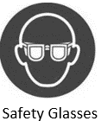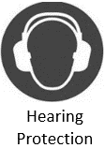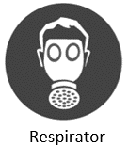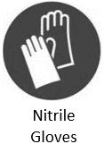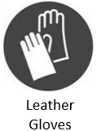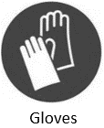

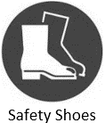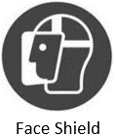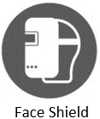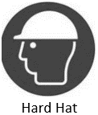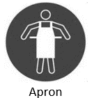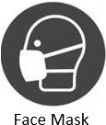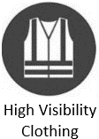

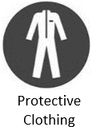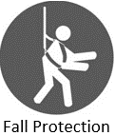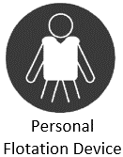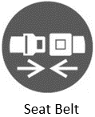

**REQUIRED PRECAUTIONS: SECTION (C-2)**

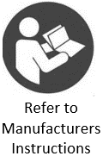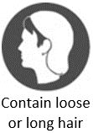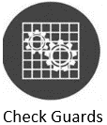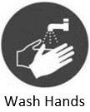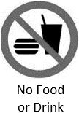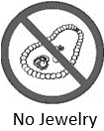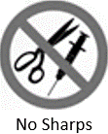

**SAFE WORK PROCEDURE: SECTION (D)**

|  |
| --- |
| 1. Perform a job hazard assessment. Do not use damaged equipment. Ensure: |
|  |
|  |
|  |
|  |
|  |

**SWP INSTRUCTION SIGN OFF: SECTION (E)**

|  |  |  |
| --- | --- | --- |
| Name: | W# | Date: |
|  |  |  |
|  |  |  |
|  |  |  |
|  |  |  |
|  |  |  |
|  |  |  |
|  |  |  |
|  |  |  |
|  |  |  |
|  |  |  |
|  |  |  |
|  |  |  |
|  |  |  |
|  |  |  |
|  |  |  |
|  |  |  |
|  |  |  |
|  |  |  |
|  |  |  |
|  |  |  |
|  |  |  |
|  |  |  |
|  |  |  |
|  |  |  |