Sample Site for General Site Assessment

This is a Google Earth view with a Sun Seeker (App) overlay.

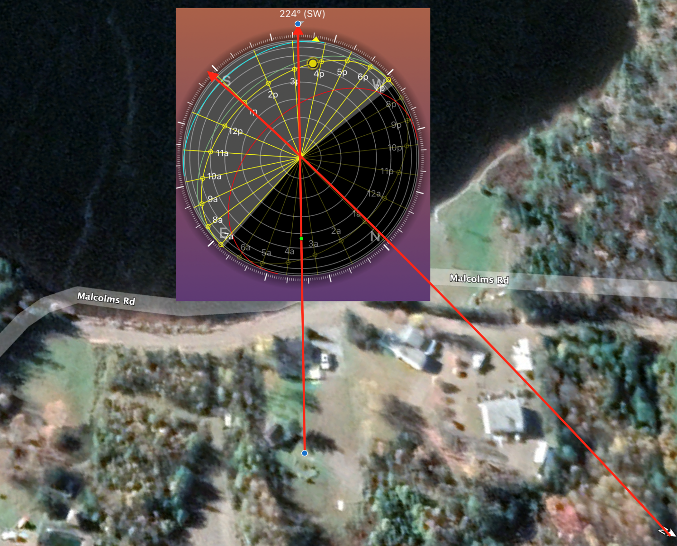

Looking from the South the panels be placed on the Southside of this home.

This is the South facing side of the roof. Need a ladder or scaffolding.

Tree to left might cause shade.

Looking North, you can see the tree is going to cause shade.

East side of the house, see hip style roof, not much space for panels.

Looking at West side of house.

|  |  |  |  |
| --- | --- | --- | --- |
| General Site Assessment | | | |
| Tyler | | | |
| Location | | Albert Bridge | |
| Date | | 2023-04-19 | |
| Crew / Personnel | | Gordo | |
| Crew / Personnel | | Name | |
| Task | Observations | | Initials |
|  |  | |  |
| Quick Safety Observations |  | |  |
| What are the site hazards | Soft ground | | G |
| Clutter, garbage, or other material | None near building | | G |
| Machinery | None | | G |
| Hot surfaces | Roof | | G |
| Animals | None seen | | G |
| Is working from heights a consideration? | On roof yes | | G |
| Basic Site Observations |  | |  |
| Look for obvious shading. | A tree next to the house may need to be trimmed | | G |
| Is this shading part of the maintenance procedure? | Advise client that it can be | | G |
| New growth / object or was it always there? | Continuing to grow, never been touched | | G |
| Check the tilt and orientation of the array. | Looks like 30 degrees and due South | | G |
| Look as if the tilt or orientation changed? | No signs of it | | G |
| Roof penetrations watertight? | Yes watertight (This is a simulated report) | | G |
| Check and ensure roof drainage | No pooling water | | G |
| Are the roof drains clogged? | None installed | | G |
|  |  | |  |
| Check for signs of water pooling in the vicinity of the array | None, but ground is soft | | G |
| Check for vegetation growth or other shade items that will affect the performance of the array. | None, just tree | | G |
| Is ground erosion near the base / footings of a ground mount array evident. | N/A | | G |
|  |  | |  |
| Signs of animal / bird infestation under or on the array | none | | G |
| Check for debris from under or around the array, can it be removed? | none | | G |
| Any other observations? | Nothing stands out | | G |
|  |  | |  |