Project – Build and Test a Solar Hot Water Collector With Storage

It will be your team’s job to construct and test a solar hot water collector using a metal absorber with a storage tank. The objective is to find what the efficiency of this collector system is and how it operates.

The materials that will be used to construct the solar collector include:
- Flexible Pex tubing
- Pex T (2)
- Black background
- Insulation rigid Styrofoam
- Glass cover
- Wooden box to house the collector
- Wooden support to angle the box
- Metal absorber (AC condensing unit from vehicle)
- Container to house water with an open top.
- Wooden platform to hold container

The testing apparatus includes:
- Measuring cup / pail
- Two digital thermometers
- Handheld pyranometer
- Stopwatch

INSTRUCTIONS
You have a few weeks to research simple solar hot water collector designs that incorporate a storage tank. During the 2-hour laboratory classes you will construct and test the system to determine its effectiveness. You will measure the efficiency of this solar collector design as well.

Week 1
You have this week to research simple solar hot water collector designs that incorporate a storage tank. This includes homemade designs from YouTube. During the 2-hour laboratory class take measurements of the box, the metal absorber, storage tank, supply and return lines, thermal wells, and sketch how they will be mounted into the collector system design. Keep the box size very close to the absorber area. If needed add wood partition to do this.
Explain the expected outcome from the design. Follow the sketching principles you have learned in drawing class. Your sketch should have a border and a title block. This sketch is to be kept clean and is to be attached to your final report.
Also, you will need to design a method for testing the collector system.
Research how the performance of solar collector with a storage tank is measured. You will be expected to explain any assumptions and the actual performance of the collector system.

Week 2
Insert the metal absorber into the box (c/w insulation, black covering for wood, and glass top). There needs to be four wells to insert the temperature probes. This is where the two Pex Ts are used for the collector. Three T wells are required in total. One at the top of the collector (absorber), second one at bottom of collector (absorber), the third at the bottom of the storage tank (make it watertight). The fourth temperature reading is at the top of the water surface in the storage tank. A way of sealing the probes so water does not leak from the Pex.
The top outlet from the metal absorber is piped to the storage tank at the top of the water level in the tank. The bottom outlet is to be plumbed to the bottom of the storage tank.

Begin measuring & testing:

- The collector surface needs to be covered to keep it at ambient temperature (not affected by the irradiance).

- Measure the amount of water required to fill the metal absorber (do this before now). Fill the absorber (still covered) and take the temperature of the water and record it when the temperature stabilizes (might not take long).

- Add water to the storage tank to have it ¼ full. Measure this amount of water. Record the water temperature at the top of the water level and at the bottom well of the tank, they should be the same. Now remove the covering at the collector.

- Take the handheld pyranometer outside along with the stopwatch. Record the irradiance every minute. Each minute record all of the water temperatures. Do this for 60 minutes.

- At the end of 60 minutes use the recorded readings to calculate the efficiency of the collector system.

- The Energy that the water receives is calculated with Q=MxCx(ΔT) this is unit of energy in Joules. The irradiance recorded is in Watts per meter squared.

- This time, there are two energy measurements to make. The first Q to measure is of the solar collector energy in Joules, M = mass of the water in the solar collector only, C = 4186J/liter for water, ΔT is the difference in water temperature at the top and bottom of the collector for each reading. The top and bottom temperatures should be different. This is the energy of the system collected from the sun.

- The second Q to measure is in the tank. This is the energy given by the collector to the tank water. This energy is in Joules, M = mass of the water in the tank only, C = 4186J/liter for water, ΔT is the difference in water temperature from one reading to another. It is the average of the top and bottom tank temperatures. The top and bottom temperatures should be different in the tank. The average is used because total energy is spread over all of the tank water. Explain why there is a difference.

- The area of the solar collector divided by 1 square meter is the multiplier for how many watts were hitting the Solar collector.

- The Wattage is Joules per second, by taking the average irradiance and dividing it by the seconds for each minute it will result in Joules. Delivered to an area of 1 square meter.

- Take the multiplier and apply it to the joules calculated from the irradiance. This is the amount of Joules that were exposed to the solar collector.

- Efficiency is Q out / Q in expressed as a fraction. The solar collector is the only source of energy gain(Q in), it however heats up the larger mass of the water in the tank (Q out).

- Repeat steps 1 – 8, this time filling the storage tank to ½ capacity (may need more time).

- Repeat steps 1 – 8, this time filling the storage tank to 3/4 capacity (may need more time).

- Repeat steps 1 – 8, this time putting the filling in the storage tank to full capacity (may need more time).

Week 3
This week is to use the comprehensive set of data collected. Explaining how the amount of water in a storage tank affects the system performance.

FINAL REPORT
The form of the report is an extended lab report. You will state the objective and you will write a procedure that describes what your group did with the data collected and the performance of the solar hot water collector system and how you tested it. Explain differences between the Pex loop collector and the metal absorber collector. Explain the roll the storage tank as the volume is varied. Follow the traditional instructions for the rest of your lab report.

Tabulate your data.

In the discussion:
- Explain with data collected and calculations and how each the storage tank water volume affected the performance of the solar collector system.
- What would you do to improve the solar collector system?
- Indicate ways that the process for this project / lab could be improved.

AC condensing unit from a vehicle.

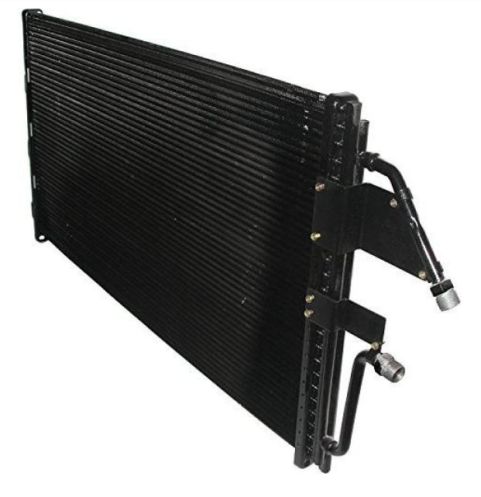
AC condensing unit from a refrigeration unit.
