Solar Hot Water Test # 2

What are the signs of solar hot water system is over heating?

* The temperature in the collector is causing the working fluid to boil or build pressure.
* The storage tank temperature is too high.
* The expansion tank is not able to control the pressure of the system.

What causes pressure to build as the water heats up?

* Water gains energy and that energy pushes the water molecules further apart needing more space.
* Water does not compress like air.
* The water needs to go somewhere.

What is used to absorb the pressure?

* An expansion tank

Overheated systems tend to shorten the life of?

* Pumps
* Storage tanks
* Expansion tanks
* Heat transfer fluids
* The collectors

What piece of equipment is located at the highest point in a loop?

* Air Bleed Valve

What must have a safety line connected to it so if it operates the hot fluid will not blow into someone?

* Pressure Relief Valve is a safety device

What is the purpose of Anti-Scald Valves?

* Solar hot water systems are capable of producing very hot water under normal operating conditions. Because of this, an anti-scald valve is required on the output to the domestic water system.
* This protects occupants from scalding hot water.

What is an added benefit to having an Anti-Scald Valve?

* An added benefit to having the valve is that the higher the temperature in the storage tank, means that more energy can be harvested.

Name two methods are available for freeze protection.

* Add antifreeze solution normally glycol to the collector circuit.
* Use a drain back system

What is the word that hard water forms deposits that clog plumbing is called?

* "scale“

The build-up of scale restricts the flow of what?

* Water in working fluid circuit.

If the solar pipes enter the building through the roof what needs to be added?

* Flashing needs to be added to seal the roof against leaks.

If the solar pipes enter through a wall what needs to be added?

* A caulk or sealant should be used to keep water from entering the building.

If the storage tank is below the collectors and the collectors become cooler than the storage tank, what can happen?

* The hot water will thermosiphon up to the collectors.
* The cooler water at the bottom of the collector will move to the bottom of the tank and will cool the storage tank water.

To prevent this from happening what is placed at the bottom of the storage tank?

* A check valve

Name two types of check valves.

* Swing and Spring

Describe the concept of a differential controller.

* A self-contained unit that controls a pump to start and stop at a given temperature difference to move the heated fluid.

EPDM (Ethylene Propylene Diene Monomer), is a form of?

* synthetic rubber insulation.

Why use EPDM?

* Very good at the high temperatures in a solar hot water system.

What is better to thermosiphon, a side port or top port tank?

* Side port tank.

What type of system is this?

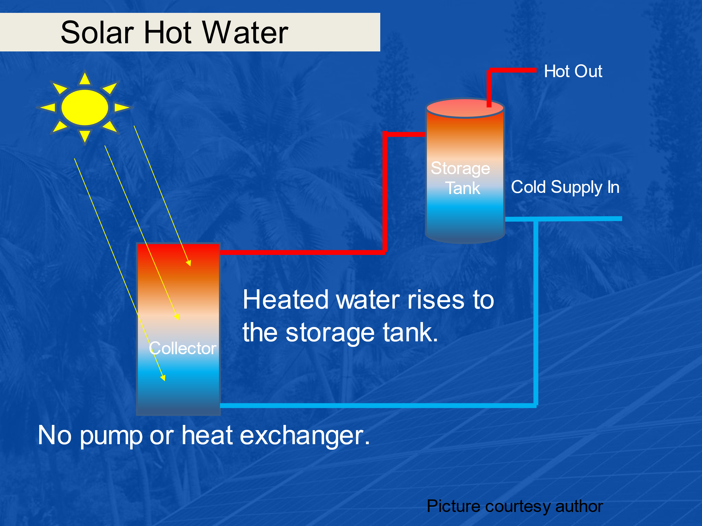

* Passive Direct

With a passive indirect system where does the storage tank go?

* Higher than the collector.

In a solar pool heating application with an open loop. What does open loop indicate?

* No heat exchanger

What two factors contribute to the heating load of a swimming pool?

* Based on the volume of water and ambient temperature.

Describe physically the serpentine flat plate collector.

* Where the absorber tube is bent in an “S” shape and weaves back and forth as it climbs to the top of the collector.

Describe physically the Harp flat plate collector design.

* It has two headers and T connections at the absorber strips.

The serpentine design has a higher xxxxxx than the Harp.

* Pressure drop

In a serpentine collector the fluid is designed to move slower (lower pressure drop) and thus:

* Heats to a higher temperature.

The Harp design has a lower pressure drop and the fluid can?

* Move quicker.

On a small system with just a couple of collectors both systems produce

* about the same energy and temperatures.
* Serpentine generates more energy and temperature
* Harp generates more energy and temperature

When systems get larger a single string of collectors can create?

* A large pressure drop.

What are the different types of dip tubes for direct open loop storage tanks?

* Direct open loop tanks have three different dip tubes:
* Cold Main Dip Tube
* Solar Return Dip Tube
* Solar Supply Dip Tube

Describe the cold main dip tube:

* The cold main dip tube goes all the way down to the bottom of the tank and allows cold water to flow to the bottom of the tank.

Describe the solar return dip tube:

* The solar return dip tube is a shorter tube that is connected at the top of the tank.

Describe the solar supply dip tube:

* The solar supply dip tube is longer and allows for the water to be drawn by the pump up to draw from the cold water and take it up to the solar panels.

What is the first step to determine a plumbing retrofit method to be used if conventional water heater tank (electric or gas) is used.

* Basic first step is it easier to add a second tank just for the solar as a preheated water tank.

If the retrofit is not adding a second tank, what considerations need to be addressed on the existing storage tank?

* If tank has top ports, then a pump is required to move solar water into tank.
* If tank has side ports, then no pump as long as the tank is higher than the collectors.

Name 3 advantages of using copper pipe:

* Copper Plumbing Pipes Are Durable.
* Copper Piping Does Not Contaminate Water.
* Copper Pipes Are Lightweight.
* Copper Piping is Less Harmful For the Environment.
* Copper Plumbing Pipes Are Fire Resistant.

The actual outside diameter (OD) of rigid copper type is always xx inch larger than the nominal size, or what the pipe is called.

* 1/16
* **1/8**
* 3/16
* 1/4

Any outdoor tubing insulation needs to be what?

* UV resistant