Solar Hot Water Test # 3

System start-up will include filling a passive direct system and getting it working. Name the steps involved. (Judgement is required for any missed steps)

* Fill the storage tank with cold water.
* Keep the hot outlet valve closed.
* Open the pressure relief valve to purge air from tank.
* After the storage tank is filled open cold inlet valve to collector.
* Air will purge from the pressure relief valve.
* When air stops and water is coming out of the relief valve close it.
* Open the air bleed valve and wait for water only to be coming out.
* After the system starts to heat up, open the air bleed valve and ensure no air is trapped in the system.
* Open the storage tank hot water valve and draw off water until no air is in the storage tank.

System shutdown will include the following: Name the steps involved. (Judgement is required for any missed steps)

* To shut the system down and empty the fluids.
* The first fluid to drain first is the collector loop.
* At the lowest part of the system, use the valve to release the pressure and fluid.
* A hose is required to keep the hot fluid from causing burns and damage.
* The hose shall empty into a drain.
* Power if any is also removed from the system.
* Manufacturers should be consulted for this process.

Describe pump type centrifugal.

* Centrifugal pulls fluid into centre of the impeller.
* This causes a 90-degree direction change in the fluid.
* The pump can be dead headed (shut valve off) to the input or output side without damage.
* The fluid moving out of centrifugal pumps is a varying flow rate based on pressure.
* Centrifugal pumps have a spinning impeller that draws the fluid into the pump and forces it out of the outlet point at an increased velocity.

Describe pump type positive displacement.

* Positive displacement pumps draw fluid into a cavity, or displace the fluid, and then force the fluid out of the cavity through suction.
* Positive displacement pumps maintain a constant flow rate, even as pressure changes.
* Positive displacement pumps can have gears, a lobe or use vanes to move the fluid.
* Positive displacement pumps draw fluid into a cavity, or displace the fluid, and then force the fluid out of the cavity through suction.

Why is a safety relief or safety valve on the discharge side of the pump is necessary?

* If a positive displacement pump is operating against a closed discharge valve it will continue to produce flow.
* This will happen until the pressure in the discharge line has increased until the line bursts or the pump is severely damaged - or both.

Pumps come with a “Pump Curve”. Describe what a pump curve is.

* This is a graphical presentation of how it pumps performs based on head (pressure) produced by the pump and fluid flow through the pump.
* Flow rates depend on pump speed, impeller diameter, and head.

What is heap when it comes to pumps?

* Head is the height to which a pump can lift water up.

Total Dynamic Head (TDH) is?

* TDH = Static Height + Static Lift + Friction Loss

Static Lift is the height the water?

* Will rise before arriving at the suction side of the pump.

Static Height is?

* The maximum height reached by the pipe on the discharge side of the pump.

Friction Loss (or Head Loss) are?

* The losses due to friction in the pipe at a given flow rate.

AC is most common in today's controllers / systems. What is their drawback?

* If the utility power is lost stagnation can happen.
* Costs money to run them from the utility.

DC pumps operate on power from solar PV panels. Name two benefits of using this type of DC pump.

* When the irradiance is highest it coincides with the most heat available at the collector.
* The extra power produced by the PV panel can be used to increase the speed of the pump.
* No extra cost associated from running this pump from the utility.

A boiler drain valve is a high temperature rated valve. What is their purpose?

* They are used to drain water and sediment from boilers in heating systems for more efficient operation.

An isolation valve in any fluid system / loop are used to? (Two answers)

* Stop the flow of fluid into a particular area of the system.
* They are also sometimes used to manually control the flow of the fluid.

A pressure gauge is used to show?

* The pressure at the point in the system that it is installed.

A pressure relief valve operates to?

* Open and reduce the pressure of the loop or vessel.

Name the type of valve and indicated what the highlighted parts are:

* A temperature-pressure relief valve.

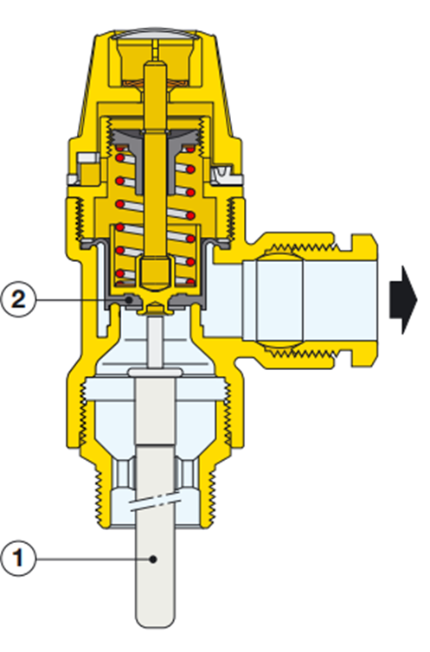

1. Temperature sensor
2. Pressure sensor

Describe how the electricity controls a solenoid.

* By putting power to the coil of the solenoid it creates a strong magnetic field that pulls or pushes a valve stem to either open or close the valve.

Describe who a diverter valve is used in a solar pool heating system.

* It usually has three ports.
* The incoming fluid can go to either port depending on the conditions.
* Pool heater calls for heat and the pool water is diverted to the solar collectors.