LAB PWM Charge Controller
Stand-Alone

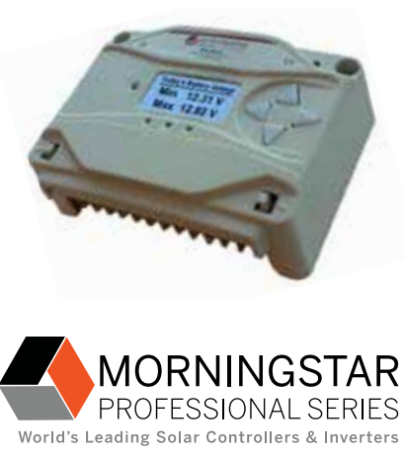

To: Instructor
From: Name Goes Here
Course: Stand-Alone
Date: Thursday, October 31, 2022
Belize City
ITVET Campus

Stand-Alone
Fall 2023
PWM Charge Controller

OBJECTIVES:

- To connect a PWM (Pulse Width Modulated) charge controller to a battery and PV panel.

- To set the dip switches for configuration of the charge controller.

- To measure the performance of the PWM charge controller.

- Make a written procedure for commissioning the charge controller.

DISCUSSION:

This is the first lab that uses a charge controller to charge the battery from a PV panel. The PWM efficiency needs to be measured with respect to PV output voltage. The battery SOC (State of Charge) should be in the 50% range. This allows the battery to take on full current from the charge controller. The PWM charge controller is an off – on controller. The PV panel(s) to be used are the 36 cell 120Watt and the 395W 96 cell panel. There are just two of the 36 cell panels, so for two groups will start with this panel and the other groups can start with the 395-Watt panels. One objective is to measure the efficiency of the PWM charge controller with respect to the voltage output of the PV module. There also needs to be a written commissioning procedure written to allow someone to verify the operation of the charge controller. A document to prove the performance of the system is required for every installation.
INSTRUMENTS AND COMPONENTS:

Q.PEAK 395 Data Sheet and Installation Manual
Q.PEAK 395 Watt Panel
BlueSun BSM120-36 Panel
MORNINGSTAR ProStar PS-30M Installation Operational Manual
FULLRIVER DC105 AGM manual.
FULLRIVER DC105Ah AGM 12volt battery
Solar Trainer
Clip on DC ammeter
Voltage meter
Handheld pyranometer

PROCEDURE

- Mount the solar panel to the solar trainer (the 120W or the 395W).

- Read the manuals to get the required information to configure the PS 30M charge controller.

- Put a load on the battery or charge it to 50% SoC. Battery voltage close to 11.6V.
- Roll the solar trainer outside into the sun and measure the irradiance.
- Turn on the charge controller and connect it to the PV panel.
- Measure the current and voltage at the battery.
- Record the indicator lights throughout the process and indicate if and when they change status.
- Using the pyranometer reading, compare the wattage actually going into the battery.
- Continue taking readings and establish the efficiency of the PS 30M.
- Connect the other panel either the 120W or 395W and repeat the same steps.
- Describe the efficiencies of the PS 30M with the different panels.
- Write a procedure that will allow someone to ensure the charge controller is working properly.

Model: SGP-120
Cells size (mm): 9*4
Cells per module: 12*6
Module size (mm): 1482*676*35
Power tolerance: +/-3%
Nominal peak power(WP): 120
Nominal voltage(V): 17.2
Nominal current (A): 6.98
Open circuit voltage (Voc): 21.80
Short cirsuit current(Isc): 7.68
Conversion efficiency: 13.60%
Operating temperature: -40 to+85 degree
Max system voltage: 1000V DC

