Synchronizing Test #1

Utility generators have main components, what are they?

* They have rotating magnets and a stationary set of windings.

The generator’s induced voltage depends on?

* The induced voltage depends on the magnetic field's strength, speed of the magnets and the length and number of turns of the wire in the magnetic field.

What is the minimum number of poles a generator can have?

* The minimum number of magnets the generator can have is two.

How fast does a 60hz generator turn with 144 poles?

* The generator frequency is equal to the speed of the generator in revolutions per minute times the number of magnetic poles then divided by 120
* 120 x 60 / 144 = 50rpm

What are the basic differences between a synchronous generator and an induction generator?

* Synchronous generators have a separate system to create the magnetic field that spins on the rotor.
* When connected to a grid this type of generator will stay in sync with the grid and keep its speed / frequency locked to the grid.
* Induction generators rely on the magnetic field in the stator to create the magnetism in the rotor.
* When connected to a grid this type of generator will have a slip frequency.
* When it is supplying power to the grid it will spin slightly faster.

Describe the incoming generating device.

* Incoming is the source connecting to an already running unit or grid.

Describe the three steps to synchronizing the generator.

* An incoming unit if a generator type will physically come up to almost the running frequency.
* The voltage will then be established and adjusted to that of the running source.
* Then the speed will be adjusted to align with that of the running source.

Name two instruments that are used to manually synchronize generators to a running source.

* Synchroscope
* Three lights method

Describe what is happening in the following picture.

The incoming generator is spinning faster than the running source and the incoming voltage is approximately 50 degrees ahead of the running source. Not a good time to connect them together.

When using the 3-bulb method to synchronize, what does it mean if they do not all go bright and dark together?

* If the bulbs do not all go bright and dark at same time it indicates the phase is wrong or the unit is turning in the wrong direction.

Describe the following voltage waveforms.

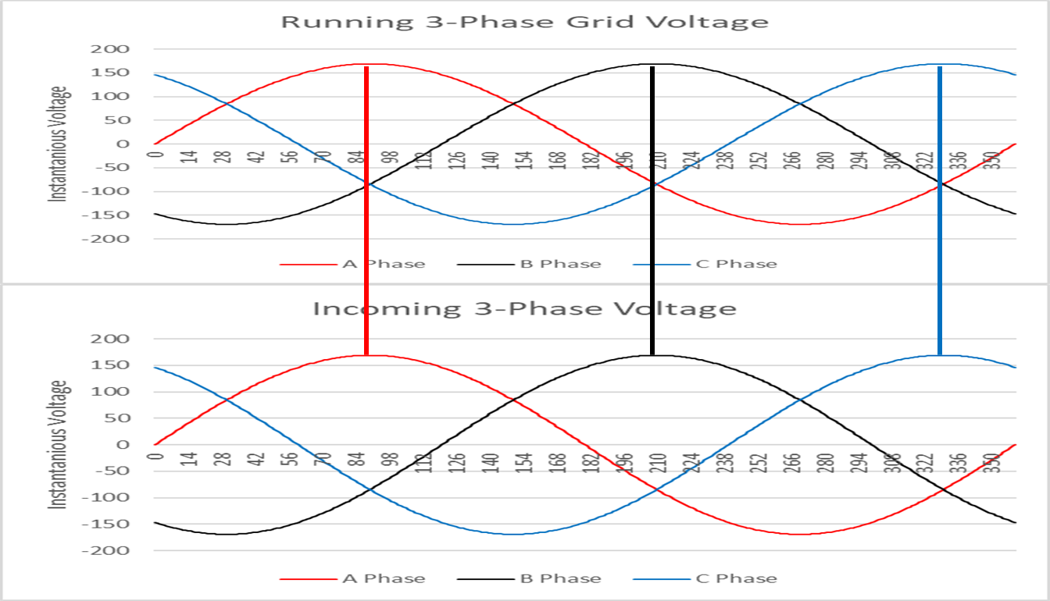

3-Phase generator ready to synchronize to the running source. In phase and sequence and matching voltage levels.