LAB Where Does the Current Go?
Stand-Alone

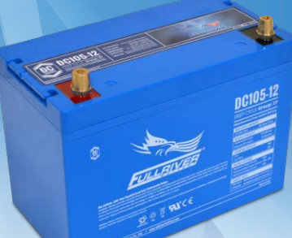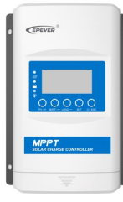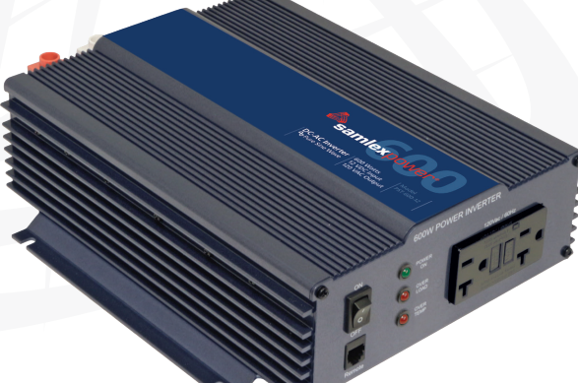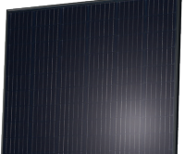

To: Instructor
From: Name Goes Here
Course: Stand-Alone
Date: Thursday, October 31, 2022

Belize City
ITVET Campus

Stand-Alone
Fall 2023
Where Does the Current Go?

OBJECTIVES:

- To measure the operation of a charge controller.

- To indicate what stage the charge controller is in.

- To measure the current from the solar panel into the charge controller, battery, and load.

- Make a written procedure for testing the operation of a charge controller when connected to a load, battery, and solar panel.

DISCUSSION:

A charge controller is a major component in any stand-alone PV system. To ensure it is performing correctly, and meeting the manufacturers specifications, this lab will have you measure the current and voltages at the various inputs and outputs. This lab simulates what you do if called by a client to verify the operation of a basic stand-alone system. You will start at the battery finding the SoC. Then go to the solar panel to verify if it is providing the energy at the measured irradiance. Then you will measure the performance of the charge controller.

INSTRUMENTS AND COMPONENTS:

FULLRIVER DC105 AGM manual.
FULLRIVER DC105Ah AGM 12volt battery.
Q.PEAK 395 Data Sheet and Installation Manual.
Q.PEAK 395 Watt Panel.
EPEVER Charge Controller
EPEVER Installation Manual.
Solar Trainer
Clip on DC ammeter
PV shorting jumper
Voltage meter
Handheld Pyranometer
600 Watt inverter
60 Watt incandescent bulb.

PROCEDURE

- Read the datasheets for the PV panel, charge controller and battery.

- Disconnect the PV panel, inverter, and Battery from the system. Wait a few minutes before measuring the battery voltage and establish the SoC.

- Check all of the breakers and fuses for to see if any have operated.

- Measure the short circuit current and Voc at the panel and compare with handheld pyranometer. Check for performance.
- Connect the charge controller to the battery. Measure for current and voltage at the battery, note any changes from the reading earlier.
- Connect the inverter to the charge controller load output and turn it on without any loads. Is the inverter drawing what you anticipated (~7Watts)? Is the battery performing as expected? Record the voltages and currents at the charge controller (load and battery values). Remove the inverter from the load output at the charge controller.
- Connect the PV to the charge controller. Measure the current and voltage at the charge controller.
- By knowing the SoC and the fact that the charge controller just got solar input, verify that the system is charging in the correct phase (Bulk, Absorb or Float)
- Connect the inverter to the load out put on the charge controller and put a small load (under 100Watts) on the inverter. Measure all three currents and voltages.
- Continue to measure these values every 5 minutes until you are sure that the system is working properly and to the spec sheets from the PV module, Charge Controller and Battery.
- Write a procedure that will allow someone to verify the operation of this type of system.

